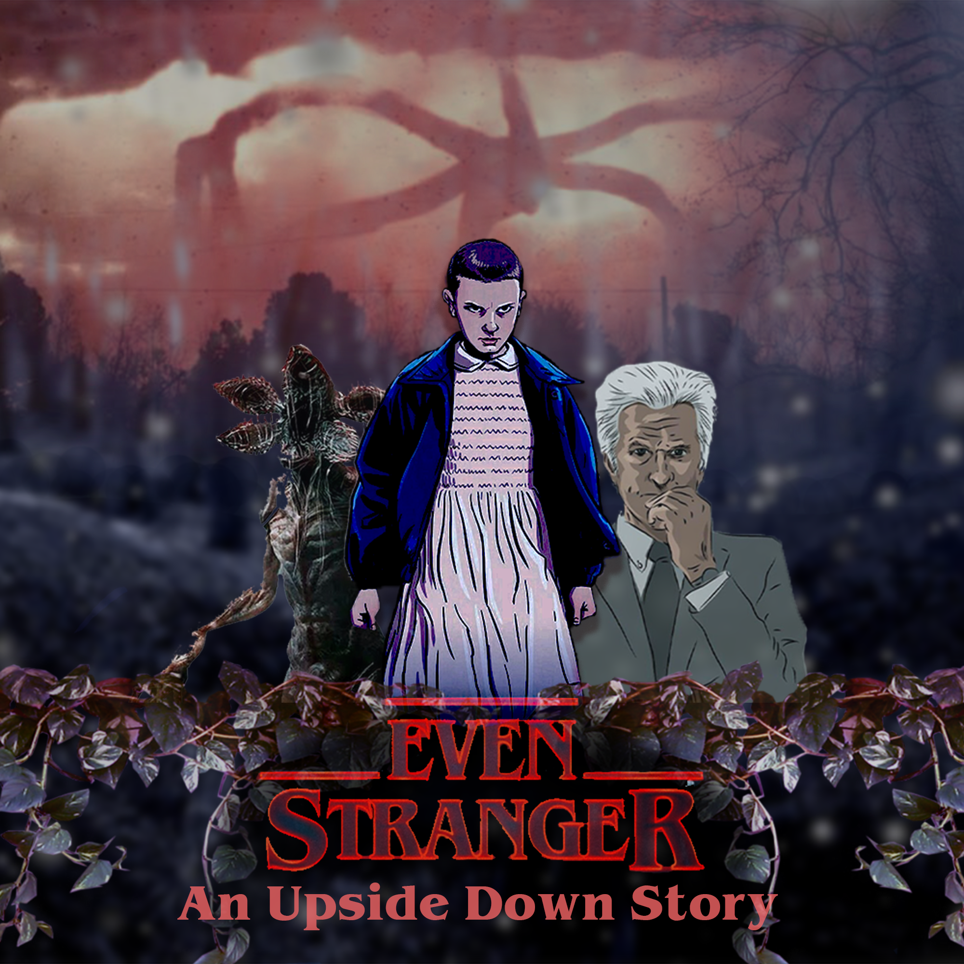

Level 6 - Will’s House

Game and Level design Document

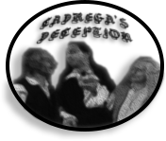

**Cadrega’s Deception Team:**

Davide Bagnato - 957844 [davide.bagnato@studenti.unimi.it](mailto:davide.bagnato@studenti.unimi.it)

Federico Porteri - 945812

[federico.porteri@studenti.unimi.it](mailto:federico.porteri@studenti.unimi.it)

Angelo Maurizio Alfano - 945769

[angelomaurizio.alfano@studenti.unimi.it](mailto:angelomaurizio.alfano@studenti.unimi.it)

## INDEX

**INDEX** **1**

**Revision History** **6**

**Part 1 - Game Design Part**

**High Concept** **10**

**Settings** **11**

**Synopsis** **12**

**Story flowchart** **15**

**Themes** **16**

**Characters** **17**

**World diagram** **30**

**World Map** **31**

**Goal outline** **33**

**Gameplay Mechanics** **35**

**Items and gameplay elements** **36**

**Abilities** **38**

**Skills** **41**

**Skills Chart** **45**

**Corruption** **50**

**Eleven base Stats** **54**

**Enemies** **59**

**Combat Mechanics** **61**

**Part 2 - Level Design Part**

**Area and Structure** **66**

**Story of the Level** **68**

**Scope of the level** **86**

**Event Diagram (Impact - Timeline)** **87**

**Level Diagram** **88**

**Level Goal Outline** **89**

**Area 6.1 - Surrounding Forest** **90**

**Area 6.2 - Will’s Garden** **101**

**Area 6.3 - Will’s House - Internals** **113**

**Level 6 - Enemies details** **128**

**Level 6 - Battles** **157**

## Revision History

|  |  |  |
| --- | --- | --- |
| **What** | **When** | **Who** |
| Document created | 23/10/2019 | Davide |
| High concept | 24/10/2019 | Davide |
| High concept | 25/10/2019 | Davide, Federico, Angelo |
| Goal Outline | 25/10/2019 | Federico |
| Settings | 26/10/2019 | Davide, Angelo |
| Themes | 29/10/2019 | Davide, Angelo, Federico |
| World Map | 5/11/2019 | Davide |
| Synopsis | 5/11/2019 | Davide |
| Characters | 6/11/2019 | Angelo |
| World diagram | 6/11/2019 | Federico |
| Characters | 7/11/2019 | Angelo |
| Story flowchart | 7/11/2019 | Federico |
| Circumplex, Maps of rel. | 7/11/2019 | Davide, Angelo |
| Table of storytelling | 7/11/2019 | Davide |
| Level 6 - Will’s House | 17/11/2019 | Davide |
| Level 6 - Settings, structure | 19/11/2019 | Davide |
| Level 6 - Level flowchart | 20/11/2019 | Federico |
| Level 6 - Story | 22/11/2019 | Davide |
| Level 6 - Surrounding forest | 23/11/2019 | Davide |
| Dialogues - Surrounding forest | 23/11/2019 | Angelo |
| Level 6 - Will’s Garden | 24/11/2019 | Davide |
| Dialogues - Will’s Garden | 24/11/2019 | Angelo |
| Level 6 - Will’s House | 26/11/2019 | Davide |
| Dialogues - Will’s House | 26/11/2019 | Angelo |
| Level 6 - Level Details  Document Update | 29/11/2019 | Davide |
| Level 6 - Impact Diagrams | 1/12/2019 | Davide |
| Surrounding Forest - Plant | 2/12/2019 | Davide, Federico |
| Surrounding Forest - Objects | 3/12/2019 | Davide, Federico |
| Surrounding Forest - Legend | 3/12/2019 | Davide |
| Surrounding Forest - Area Description and Flowcharts | 4/12/2019 | Davide |
| Will’s Garden - Details | 5/12/2019 | Davide |
| Will’s Garden + Shed - Plant | 6/12/2019 | Davide, Federico |
| Will’s Garden - Area description and Flowcharts | 7/12/2019 | Davide, Angelo |
| Will’s House Internals - Details | 9/12/2019 | Davide |
| Will’s House Internals - Plant | 10/12/2019 | Davide, Federico |
| Will’s House Internals - Area description and Flowcharts | 10/12/2019 | Davide, Angelo |
| Will’s House Internals - Puzzle Description | 11/12/2019 | Davide, Federico |
| Surrounding Forest, Will’s Garden, Will’s House - Color Palette, Sounds, Music, Lighting | 11/12/2019 | Angelo |
| Document Update and check | 12/12/2019 | Davide, Federico, Angelo |
| Gameplay Mechanics- Objects | 16/12/2019 | Davide |
| Gameplay Mechanics- Abilities and skills | 20/12/2019 | Davide |
| Gameplay Mechanics - Combat mechanics | 22/12/2019 | Federico |
| Gameplay Mechanics - Skill charts | 29/12/2019 | Davide |
| Gameplay Mechanics - Enemies chart | 30/12/2019 | Davide |
| Gameplay Mechanics - Skill Stats and Graphic charts | 2/01/2020 | Federico |
| Gameplay Mechanics - Mikey | 3/01/2020 | Federico |
| Level Enemies - Stats | 3/01/2020 | Federico |
| Level Enemies - State Diagrams | 4/01/2020 | Angelo |
| Level Enemies - Descriptions | 5/01/2020 | Angelo |
| Level Battles - Descriptions and Loot | 7/01/2020 | Davide |
| Level Battles - Examples and Battlefields | 9/01/2020 | Federico |
| Document update, check and corrections | 11/01/2020 | Davide, Federico, Angelo |
| Battles and State diagrams corrections | 15/01/2020 | Davide, Federico |
| State Diagrams corrections | 17/01/2020 | Angelo |
| Final check | 19/01/2020 | Davide, Federico, Angelo |

Notice

This document must not be considered as the final document for a public game, all its content is property of ***Cadrega’s Deception*** team. Works and materials of other brands / properties will always be declared and mentioned.

Before reading the content of this document we really suggest you to read the *Dungeons & Dragons Stranger Things Special Edition* rules document on which this one is based and to which it will refer.

A lot of elements (especially on *Stats* and *Combat Mechanics*) will be omitted as the reader should had read that rules before. Images, characters, enemies and other references to Stranger Things will always be present in the game.

Stranger Things is a television-format series created by The Duffers Brothers. It was released as a Netflix original series on July 15, 2016 and is currently (January 2020) under production for its fourth season.

The project is currently stored both on Google Drive and a Github repository:

Google Drive Folder:

<https://drive.google.com/drive/folders/1rGV3bN--Oxax6MMm1diybQiPeDe1DmAH>

Github: <https://github.com/davidebug/EvenStrangerCD/>

Owner: Davide Bagnato (Github name: davidebug).

Part 1 - Game Design Part

## Story, Characters and Gameplay Mechanics overview

## High Concept

“Even Stranger: an Upside Down story” is a single player Rpg-Adventure game with a top down graphics and a D&D-like combat system. The game tells about the journey of a young girl without her memories. The story takes place in the Upside Down, a dark and strange world, full of monsters and other creatures.

Finding herself in a school, the young girl feels a sense of anger and violence growing in herself that keeps her thinking it’s better to destroy and kill everything and everyone. The path to retrieve her memories, full of obstacles, enemies and temptations from an evil force that rules the Upside Down, will lead her, with the help of a woman (her mother), to discover that she is Eleven, an orphan grown in a lab to develop strange psychic powers. Despite this she feels different from these memories, she is not feeling any happiness or empathy with people: she is feeling as a bad copy of Eleven. To discover the cause of this feeling she will have to reach the place where all began, the lab where she has grown. On the path to this lab she will have to overcome enemies and solve puzzles counting only on her retrieved powers.

In the ending, based on what she chose during the game, a persuaded bad Eleven can join the force with the evil or a more sensible one can try to overcome her anger with an unexpected conclusion.

## Settings

The story is set in 1983 in the fictitious city of Hawkins in a world called “The Upside Down”. This world is a darker copy of the real one, full of monsters and strange creatures.. In the Upside Down everything is rotten and covered by organic matter and vines, the air is nearly unbreathable.

The organic matter is linked with an evil force, the Mind Flayer, that controls both flora and fauna. The city is surrounded by woods and includes the same places of the real Hawkins: a school, a police office, the Hawkins National Laboratory and several houses including Will and Mike’s one, some important characters of Eleven’s memories. The real world is linked with the Upside Down through special portals in different places of the city, called Gates (or Rifts), although some people and monsters can see and interact with the Upside Down without reaching these Gates.

## Synopsis

Act 1 : Introduction

In a dark and strange world, The Upside Down, a girl without memories wakes up in and apparently abandoned school.

Inside herself there is a strange sense of anger that keeps her to think is better to destroy everything and everyone.

After following another girl (the real Eleven, *Stranger Things 02x1*) that soon disappears inside a rift on a wall, she tries to escape too but the rift closes too fast. Alone and still in the Upside Down she has soon to fight strange enemies and solving some puzzles in order to escape using the main door of the school.

Outside the school there is a white haired man, her father, that doesn’t tell her who she really is but will help her to find it out reaching the place where all began, the Hawkins Lab. Guided by her fictitious father the girl reaches the Hawkins’ forest. Here the girl has a vision of a woman that does not reveal her identity but tells her that if she want to retrieve her true memories she shouldn’t listen her father but reach several places in Hawkins.

Act 2 : Retrieve your memories

At this point, the girl can choose to follow the father to the lab (Go to Act 3.B) or the woman’s advice. If the girl follows the second option, she can choose what place to visit first: the Police Station, Will’s House or Mike’s House.

This part of the game is the most long and dense of gameplay (optional quests), every place visited will give different lost memories and forgotten powers to the girl but only few places will truly enrich the story. On the path to these places she will meet a friendly Demodog, similar in appearance to the enemies, but different in behavior. He is not an enemy and will soon be her first friend, she calls him “Mikey” (as a reminder of the other girl screaming “Mike” in the school) and will follow her through all the journey. After retrieving all her memories the girl finds out that she is Eleven, a girl grown up in lab developing strange psychic powers. Despite this she feels different from Eleven’s memories, she feels as a bad copy of her. To find out the reason of this sense of anger she must reach the lab with her father.

Act 3.A : Conclusion (With memories, Canon Ending)

The girl, identified now as Eleven and more powerful than before thanks to the exploration she has done, must reach the lab to find the reason of these “faulty” memories. In the lab, after several enemies and puzzles, she will find out that she is a bad copy of the real Eleven that can live only in the Upside Down, generated by a superior being from the anger of the real Eleven against the Demogorgon after destroying him. Having been created by the Mind Flayer, she is also partially a part of him but with Eleven’s mind.

After reaching the Rift, Bad Eleven finds out that her father is controlled by the Mind Flayer and can choose to follow him (*bad ending*, see 3.B) or to defeat him. If she chooses the second option, after a cruel battle, the Mind Flayer is defeated but Bad Eleven is exhausted and due to the fact that she was also part of the Mind Flayer, she cannot live anymore in the Upside Down. In fact after seeing the real Eleven through the Rift, Bad Eleven tries to reach her but disappears just when she was crossing the Rift.

Act 3.B : Conclusion (Without memories, Bad Ending)[1]

Without her memories the girl doesn’t know anything about her past and she keeps thinking about destruction and death.

Guided by her father to the lab, after several puzzles and enemies, she will soon reach the Rift, a portal between the Upside Down and the real world. Here she will find out that her father it’s controlled by a creature called Mind Flayer, a superior being that rules the Upside Down. Lost and without memories the girl can only choose to follow the Mind Flayer and to help him to defeat another girl, the real Eleven, that is trying to close the Rift to the Upside Down from the real world.

The real plan of the Mind Flayer was in fact to use the power of the generated Bad Eleven to keep the Rift opened and contrast the real Eleven.

After a cruel battle against the powers of the real Eleven, the Mind Flayer and Bad Eleven will lose and they will merge together and form a more powerful being in order to revenge in the future.

*Both the two endings of the game perfectly reconnect to the Stranger Things S2 ending, making this game suitable to be canonical.*

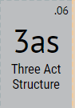

The three act structure is ideal for this story: the first act is the introduction in which characters are presented and the scope of Bad Eleven journey is defined. The second act has a main role: retrieving your memories visiting different places and unlocks an optional ending in the third act, the conclusion of the story in the Hawkins Lab.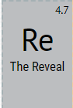

The reveal of Eleven past plays a main role in the story, it’s the scope of all the second act, she is not the real Eleven but just a copy of her. Another reveal is the Father’s one: he reveals to be entirely controlled by the Mind Flayer.

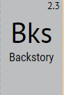

Real Eleven’s backstory is important to know better the main characters, especially the Woman and the Father.

Hints and memories of Real Eleven’s backstory will be given during all the game especially during the second act.

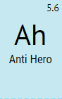

The protagonist is an anti-hero, created by the anger of Eleven against the first Demogorgon when killing him, all she feels is rage and contempt. Despite this she want to change her world, first retrieving her memories, then attempting to destroy the Mind Flayer if she refused to join him.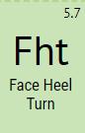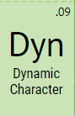

She is a full dynamic character, bad at the beginning, good when she restores her memories and bad or good at the ending based on what she chose. Can be both a Face Heel Turn and a Heel Face Turn at the ending by joining the Mind Flayer.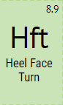

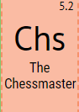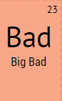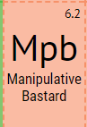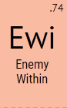

The main antagonist is the Mind Flayer, he wants to conquer the real world and to do this must keep the Rift opened. He needs Bad Eleven to contrast the real Eleven from the other side of the rift.

To persuade Bad Eleven he uses her Father that is fully controlled by him. He is both a Chessmaster, has the control of the events in the Upside Down and a Manipulative Bastard because he can also control other people.

The biggest enemy for Bad Eleven is the anger inside herself, she must overcome it and not yield to the temptations of the Father and Mind Flayer, that’s why Bad Eleven is also an Enemy Within.

## Story flowchart

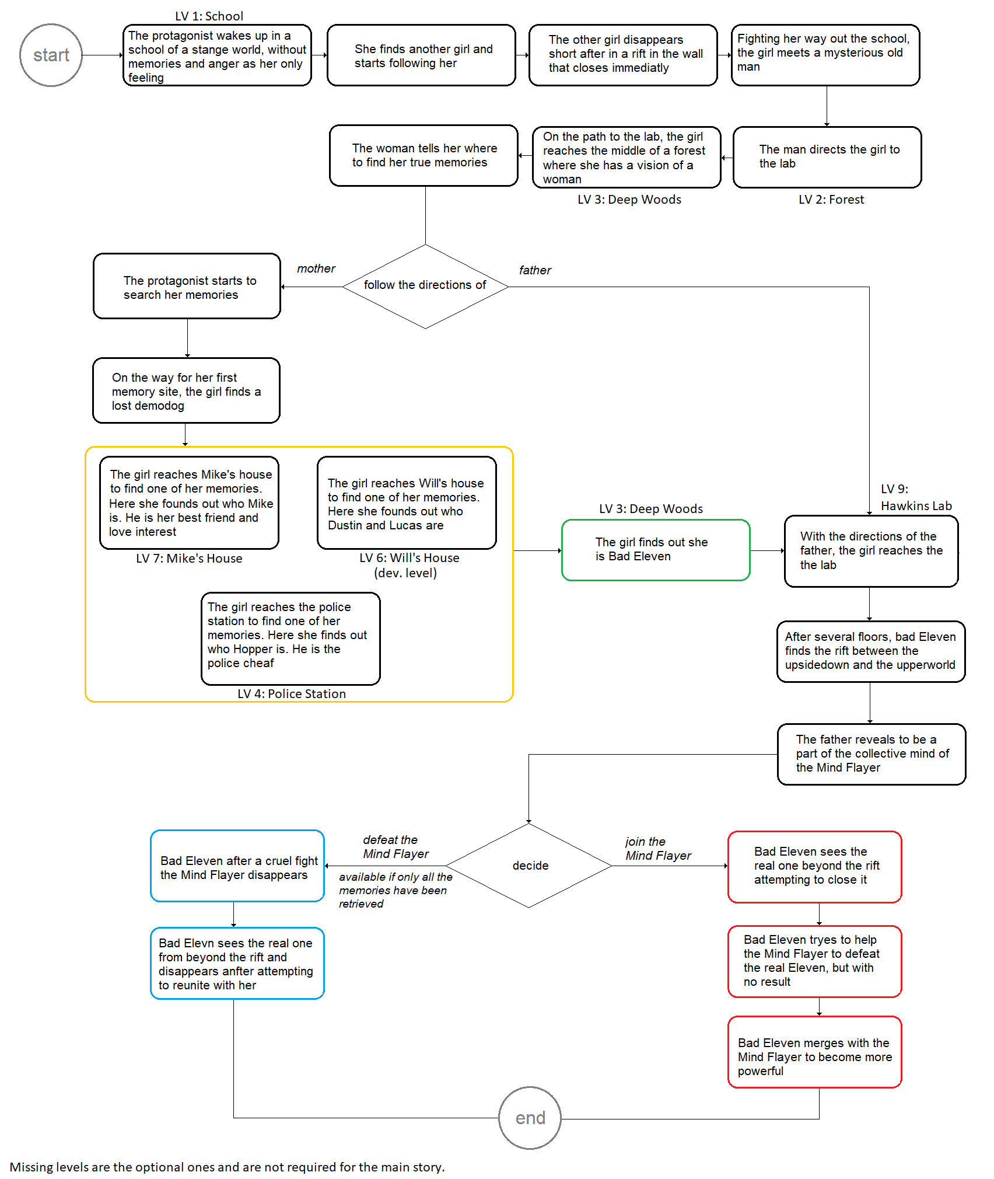

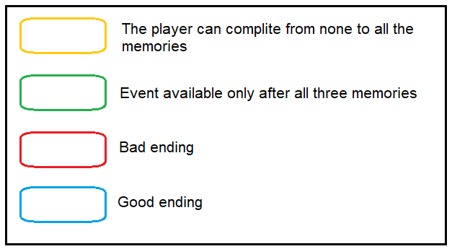

## Themes

# The struggle between good and evil

At the beginning the protagonist has no memories, she is confused and feels a strong sense of anger. She must choose to follow it or find out who she really is.

# The importance of memories

The path to retrieve herself will lead the protagonist to discover that the value of positive memories is one of the main elements of stability, a shelter against anger and darkness.

# The ease of yielding to the impulses of anger

In the game evil forces will persuade the protagonist to use her powers against others. These temptations are enhanced by the sense of anger that she feels during all the game.

# Accept yourself and make the difference

After having restored her memories the protagonist will have to accept herself and try to give a change to the world before leaving it.

## Characters

## Bad Eleven

**Description**

Bad Eleven is a young woman that was generated after the original Eleven killed the monster in the school. She is an evil copy of her without any memories. She has short hair, a paler skin, deep red eyes and a vacant stare. At first she has almost no emotions, can’t feel pain, can’t feel joy or love, she just has a strong feel of anger coursing through her veins. But deeply in her soul lay old memories of her friends, that will help her during the adventure to find who she really is. 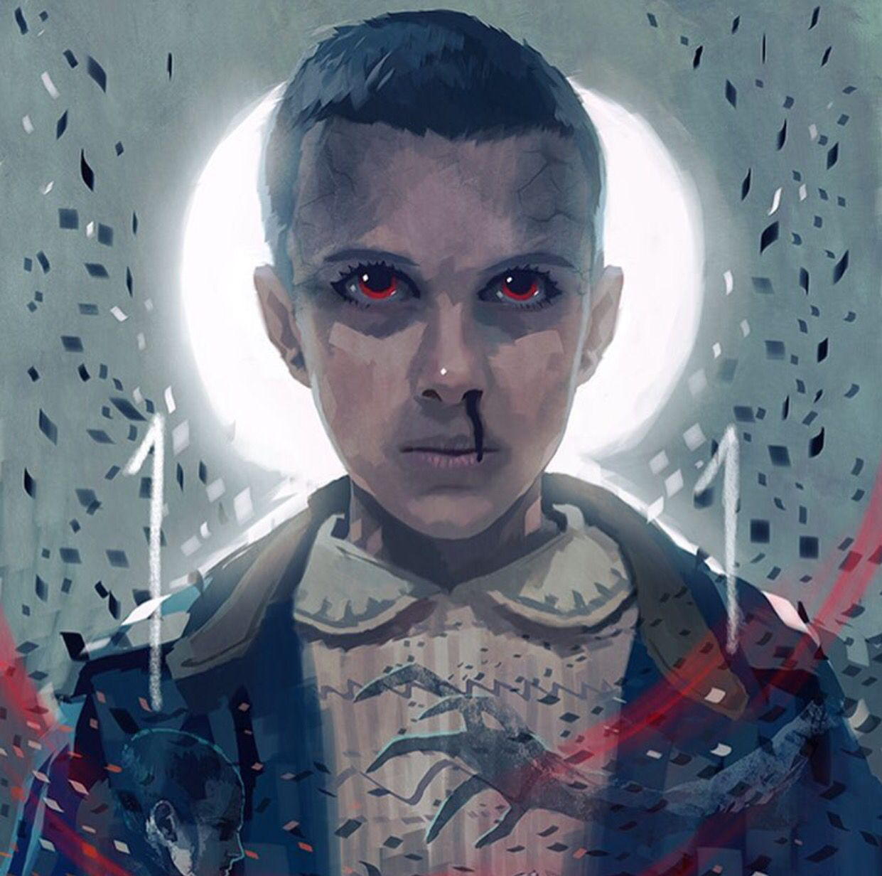

**Backstory**

The original Eleven was kidnapped and raised in Hawkins National Laboratory, where she was experimented on for her inherited psychokinetic abilities. After escaping the lab, she was found by her friends Mike, Lucas, and Dustin. While she was in the lab, during an experiment she made contact with a mysterious creature, opening an interdimensional gate. To protect her friends, Eleven faced and destroyed this monster in a battle at Hawkins Middle School, vanishing in the process.

## Bad Eleven’s Circumplex

## 

## 

## Bad eleven’s Map of relationships

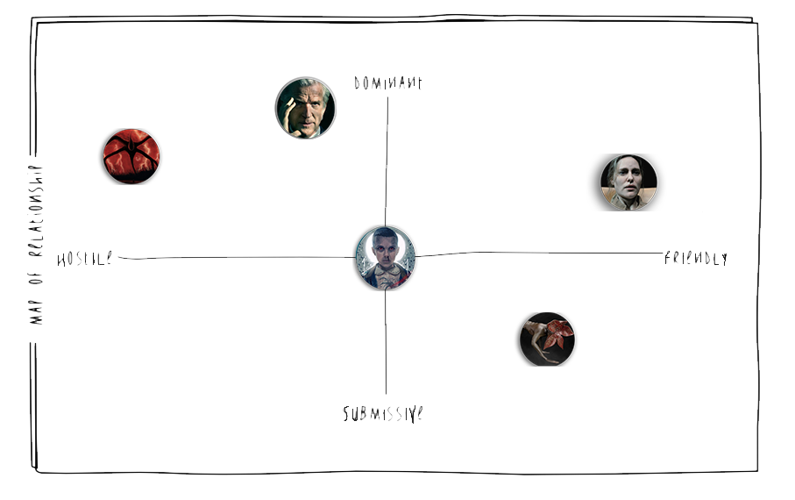

After father’s reveal and Bad Eleven loyalty to Mind Flayer: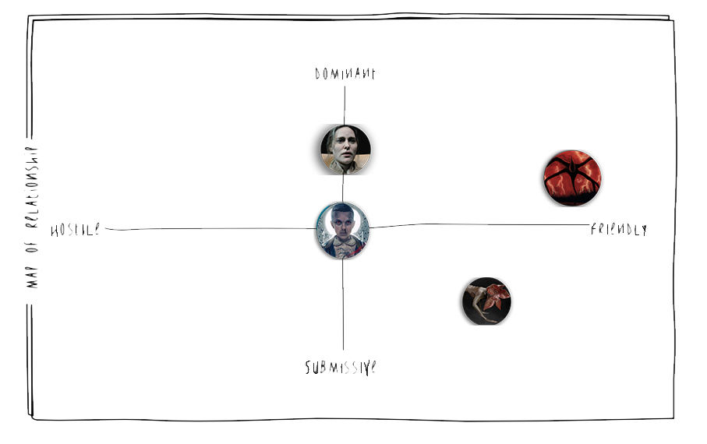

## Mind Flayer

**Description**

The Mind Flayer is a malevolent entity that rules the parallel dimension known as the Upside Down. He is a powerful being of unknown origin. He handles supreme control of the Upside Down, as well as the Demogorgons and other creatures. He is a very tall entity, the body appears to be entirely composed of minuscule particles, giving him a misty appearance. The creature has multiple limbs, some of which branch into several smaller appendages; these limbs visually resemble the vines present in the Upside Down. He seems to have an elongated, flame-shaped head that sprouts from the central body that bears no visible facial features. His presence is often accompanied by unnatural red lightning. With murderous and evil intents, he repeatedly attempts to corrupt both Hawkins and the world. Through his telepathic link, the Mind Flayer can directly control additional entities and beings.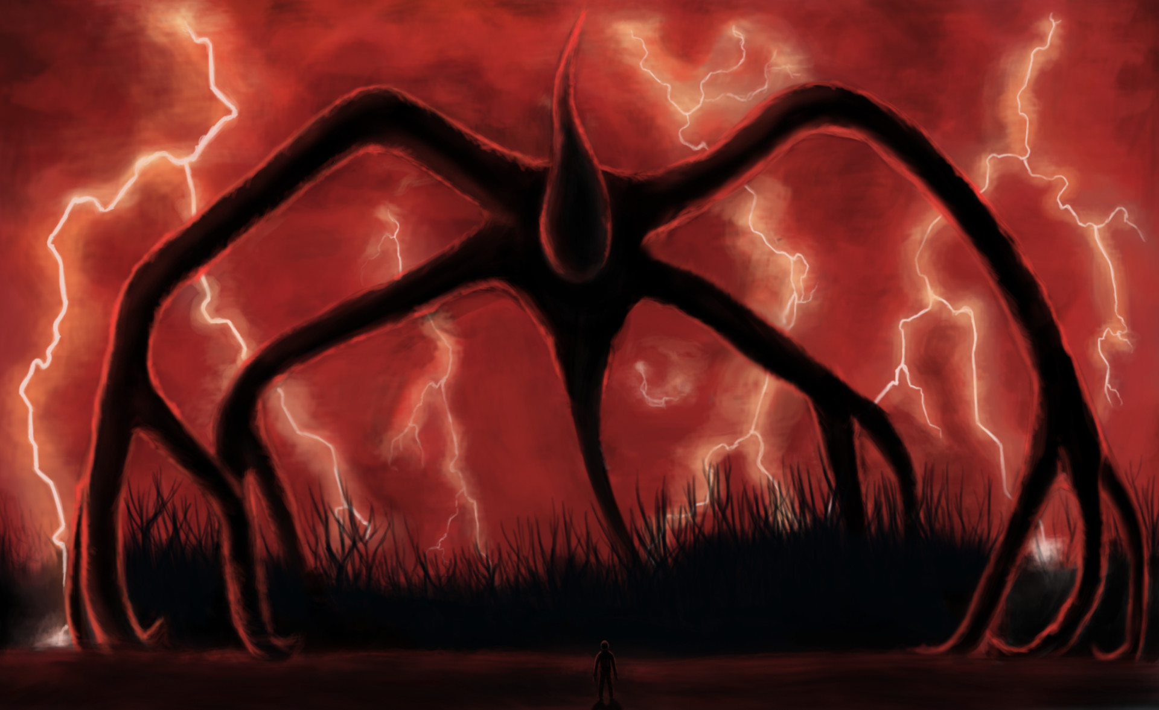

**Backstory**

The history of the Mind Flayer remains a mystery. Exactly how long he had existed for, and how and why he came to inhabit the Upside Down, is unknown. The Mind Flayer's ultimate goal and why he constantly tries to enter our world is also unclear.

## Mind Flayer’s Map of relationships

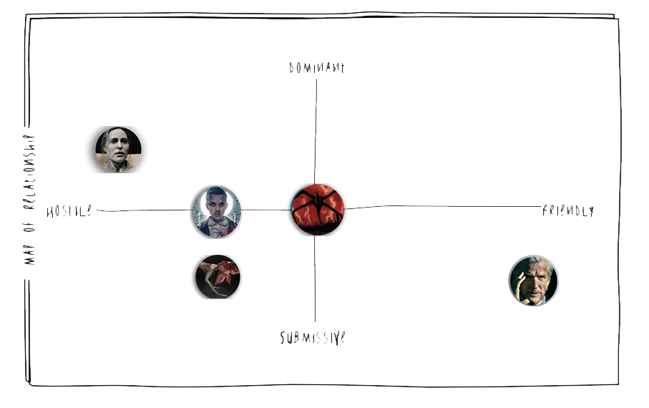

After Father’s reveal and Bad Eleven loyalty to Mind Flayer:

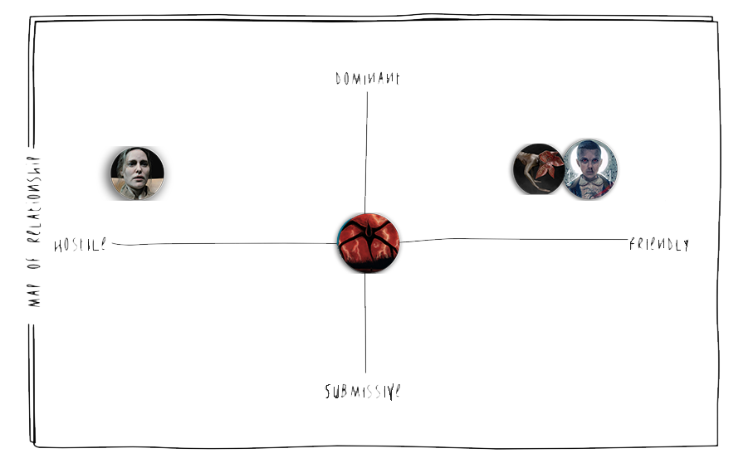

## Mind Flayer’s Circumplex

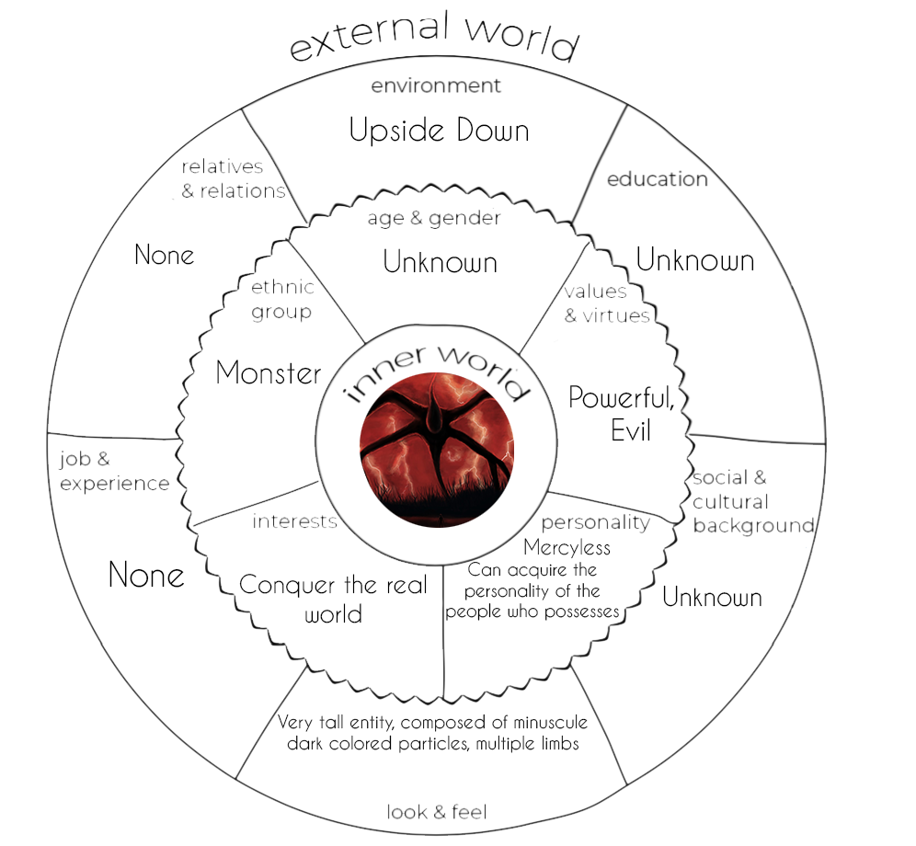

## 

## Father (Mind Flayer)

**Description**

After being attacked by the Demogorgon, he is now controlled by the Mind Flayer. He acts as a guide for Bad Eleven, but he hasn’t got good intentions, as he is an evil entity. He has grey hair, always well dressed in a suit and has great persuasion skills.

**Backstory**

Dr. Martin Brenner was a senior research scientist and the director of Hawkins National Laboratory. He raised Eleven in the lab, testing and pushing the limits of her psychic abilities through various experiments.

## Father’s Map of relationships

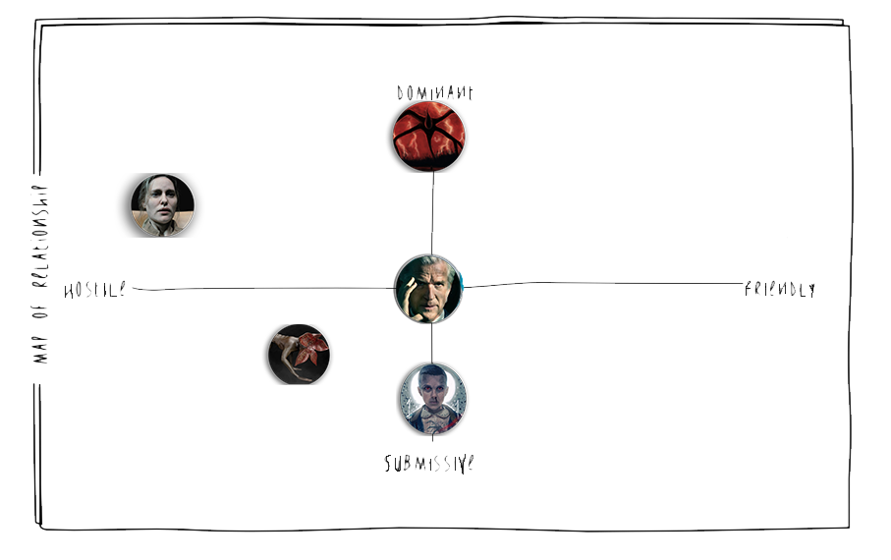

## Father’s Circumplex

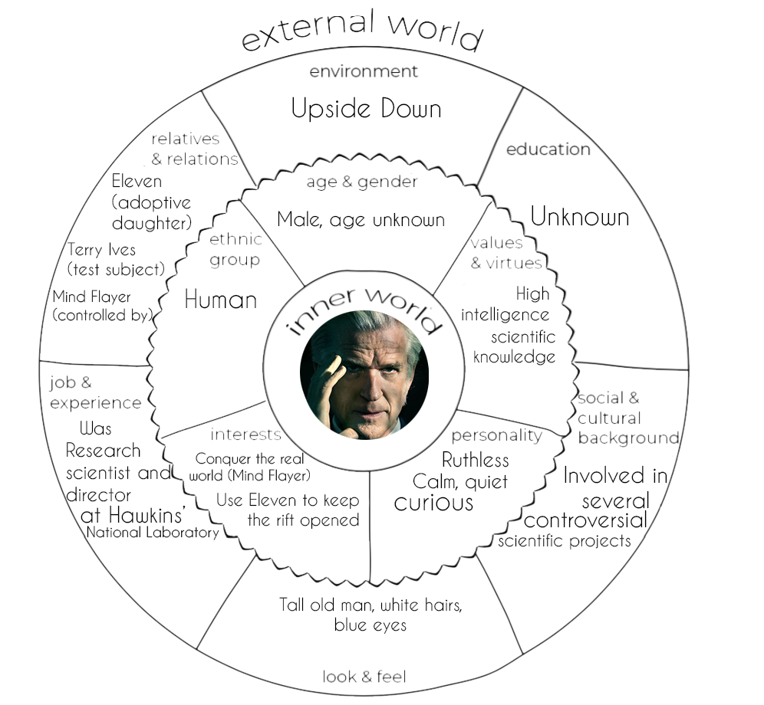

## The Woman (Mother)

**Description**

She is the biological mother of Eleven and retains all the good qualities of her. She will try to put Bad Eleven in a good path, since she sees her like a daughter, in order to reveal the good side of her. She can talk to Bad Eleven in her visions because of her psychic powers.

**Backstory**

While in college, Terry Ives took part in Project MKUltra. Under the supervision of Dr. Martin Brenner at Hawkins National Laboratory, she was subjected to experiments involving the intake of mind-altering, psychedelic drugs and becoming sensorily deprived.

**Mother’s Map of relationships**

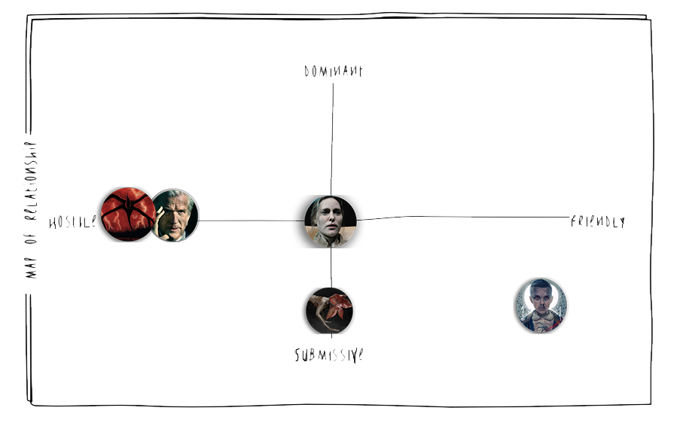

**Mother’s Circumplex**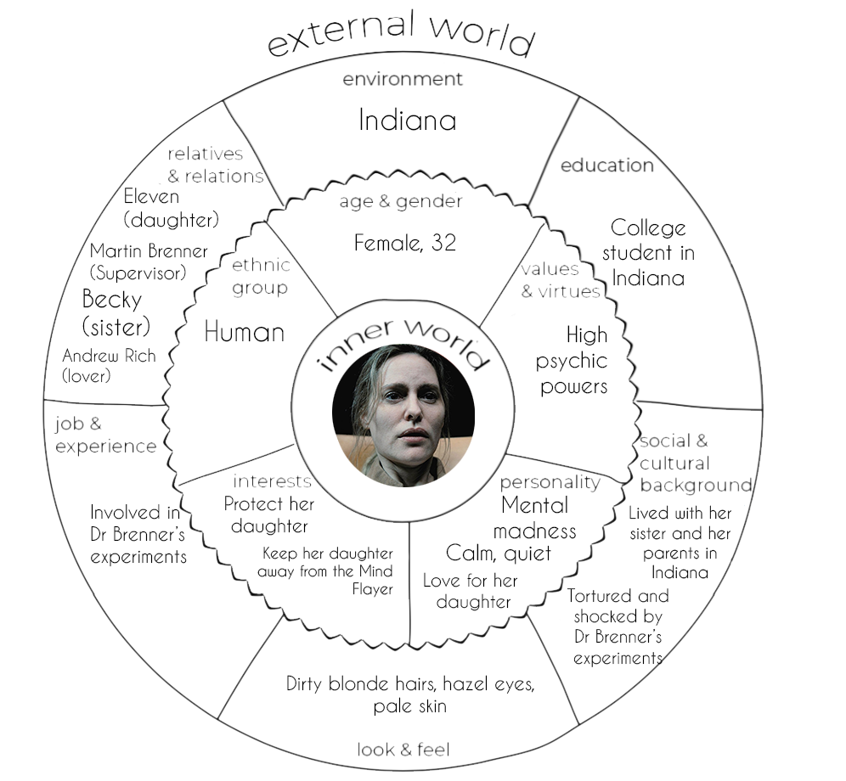

## Mikey (Demodog)

**Description**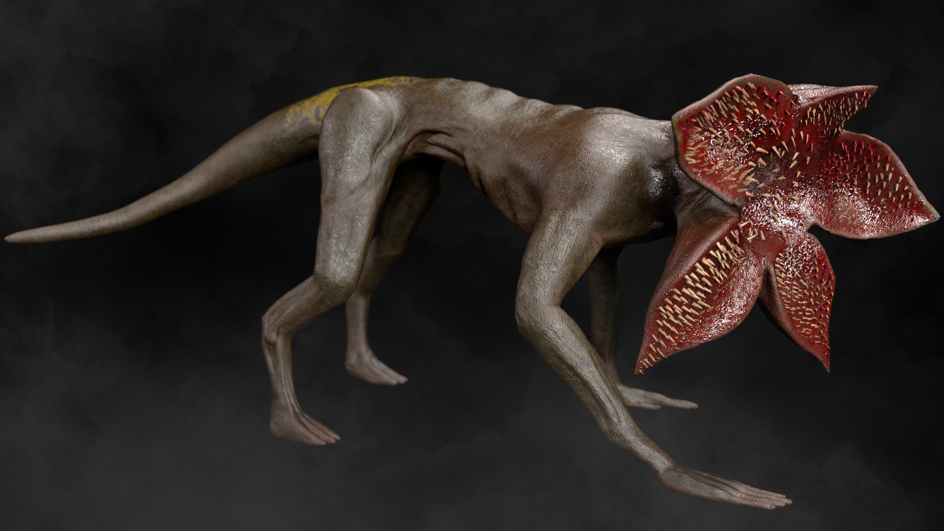

Demogorgon species are predatory creatures that obey the Mind Flayer: under his influence, Demodogs are murderous, violent and have limited intelligence. Unlike the others, “Mikey”, is a Demodog that lost the connection with the Mind Flayer so he’s become friendly and not violent at all. He will be Bad Eleven’s adventurous friend and will have a strange connection with her, similar to the one he had with the Mind Flayer. He walks on four legs like a dog, he has no face, just a flower petal-like mouth full of teeths. Bad Eleven can understand what he says because of this strange connection between them.

Called “Mikey” by Bad Eleven in memory of the name “Mike” she heard in the school when she woke up.

**Background**

The real Demogorgon was originated from the parallel dimension known as the Upside Down. When Eleven made interdimensional contact with it, a gate between dimensions opened at the lab. The creature passed through, terrorizing Hawkins for approximately a week. It abducted various residents and took them back to the Upside Down, usually killing them.

## 

## 

## Mikey’s Map of relationships

Since Mikey is always attached to Bad Eleven, his map of relationships is similar to hers.

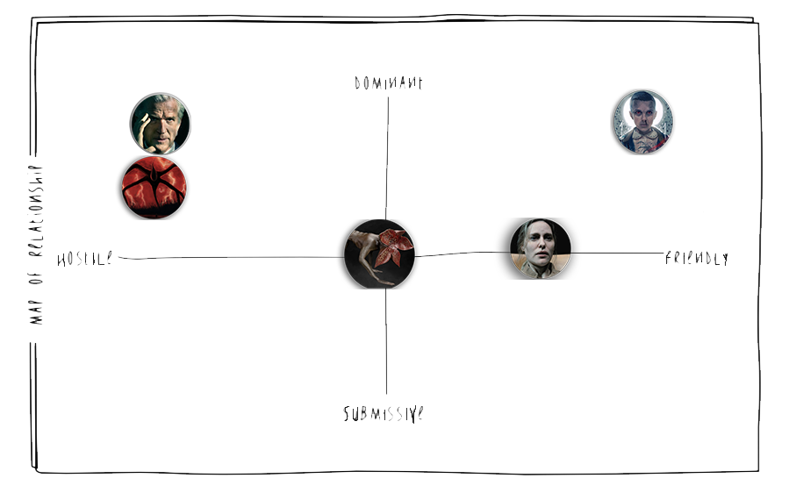

After Father’s reveal and Bad Eleven loyalty to Mind Flayer: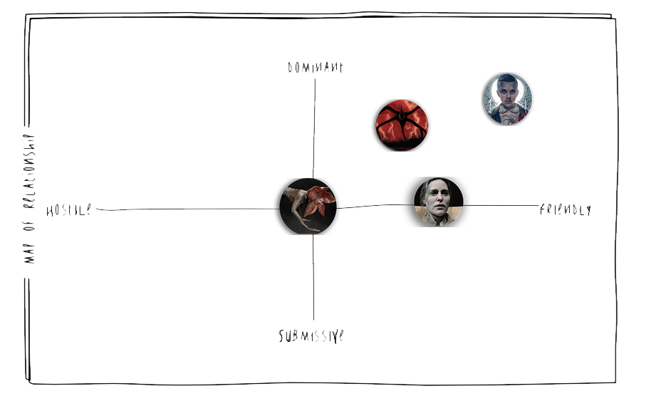

## Mikey’s Circumplex

## World diagram

## 

Deep Woods acts like an Hub Area: here the player will often return to visit the other places of the world and can find some interactions with the Father.

Connection areas can contain optional enemies, items and secrets.

For more informations about the access to Level 5 and the *Trial of Corruption* see Corruption.

## World Map

## 

Act 1 Act 3

* Hawkins School (1) - Hawkins Lab (9)
* Forest (2)
* Deep Woods (3)

Act 2

* Deep Woods (3)
* Will’s Castle (5)
* Will’s House (6)
* Mike’s House (7)
* Police Station (4)
* Lake (8)

Scope

The game is about 9-10 hours long, it strongly depends on which way the player choose to follow and how much time the combats last.

|  |  |
| --- | --- |
| Level | Estimated Scope |
| 1 - Hawkins School | ~ 30 min |
| 2 - Forest | ~ 1 h |
| 3 - Deep Woods | ~ 30 min |
| 4 - Police Station | ~ 1 h |
| 5 - Will’s Castle | ~ 30 min |
| 6 - Will’s House | ~ 1:15 h |
| 7 - Mike’s House | ~ 1:30 h |
| 8 - Lake | ~ 1h |
| 9 - Hawkin’s Lab | ~ 2 h |

## 

## Goal outline

In this Goal Outline are specified main objectives only, for more info about the designed level see the Level Goal outline.

1. Follow the girl **1 - School**
2. Exit the upside-down
   1. Exit from the rift
   2. Find the exit of the school
   3. Find a way to free the main door
   4. Free the door from the vines
3. Defeat the demodogs **2 - Forest**
   1. Speak to the man (father)
   2. Destroy the remaining dog or follow the man advice (absorb him)
4. Reach the Deep Woods
   1. Talk with the father. [Gives Will’s Castle quest]
   2. Follow the woman in the vision **3 - Deep Woods**
5. Retrieve your memories [Facultative]

[Player can choose what area between 4-5-6-7 visit first and then return to Deep Woods].

* 1. Go to Will’s house
     1. Find a point of interest
     2. Solve Will’s puzzle **6 - Will’s House**
     3. Defeat or Absorb the Brood Mother
  2. Go to Mike’s house
     1. Find a point of interest **7 - Mike’s House**
     2. Eliminate the spores in Mike’s basement
     3. Make use of your new found power
     4. Defeat or Absorb the Great Bulb
  3. Go to the Police station
     1. Find a point of interest **4 - Police Station**
     2. Free Hopper’s office from the dogs
     3. Make use of your new found power
     4. Defeat or Absorb the Lost Special Forces
     5. Talk with the Special Forces survivor [Unlocks Lake’s quest]
  4. [Optional] Free the Demodog (Mikey) from the Demogorgon and escape.

[ Available only after 1 memory is retrieved ] **3 - Deep Woods**

* 1. Return to the Deep Woods [After all the three memories are retrieved]
     1. Find a way to contact the woman. **3 - Deep Woods**
     2. Find a pond and contact the woman.

1. [Optional] Reach the Will’s Castle.
   1. Open the door of Will’s Castle [At least level 5 of corruption needed] **5 - Will’s Castle**
   2. Unlock your new power. [Unlocks special skill tree]
2. [Optional] Find the Special Forces Chief at the lake of the quarry. **8 - Lake**
   1. Find human traces at the lake.
   2. Follow the traces.
   3. Find the Special Forces’ Chief in the cavern..
   4. Defeat or Absorb the possessed Chief.
   5. Talk or kill the Special Forces’ Chief. (Drop: Exclusive Equipment)
3. Go with your father to the lab **9 - Hawkins Lab**
   1. Find an entrance to the lab
   2. Defeat or Absorb the Demogorgon
   3. Find a way to the Rift
   4. Defeat [available if only all the three memories are retrieved] or Join the Mind Flayer (Father).

## Camera and Graphics

In the entire game (exploration mode) the camera is top down and follows the player. In combat mode the camera continues to be top down but is fixed on one point as the player must have the whole battlefield under control. Graphics can be either 2D or 3D (Given prototype is 2D).

## 

## Gameplay Mechanics

Even Stranger: an Upside Down Story is an RPG-Adventure game with Metroidvania-like exploration elements and turn based D&D-like combat mechanics.

**Exploration Mode (Free roaming)**

The exploration of the game levels is a crucial aspect of the game: the player can freely explore the areas of the levels to retrieve objects, secrets,new skills or enemies. Unlike the Combat Mode (see Combat Mechanics) exploration is not turn based.

Some of the areas of the game are connected between each other with skill gates (a certain Skill is required to proceed), level gates (a certain progression level is required to proceed) and object gates ( a certain object is required to proceed).

If the player chooses to go straight to the Hawkins lab (the final level of the game) he will not find any of these gates but the main obstacle will be the battle against the *Demogorgon* at the entrance of the lab. This battle can be considered as a gate: at the beginning of the game the Demogorgon will be nearly unbeatable, only an highly skilled player that knows the game well can manage to defeat him.

During exploration the health of the player will be automatically restored.

**RPG-like elements**

The customization of the character through items, objects and weapons that can be found in the different areas, make this game to look like an RPG despite the character is not fully customizable. The player can choose to play in different ways, for example he can choose to not use his powers but only the weapons found in the game, he can choose to not absorb the enemies and to not increase the level of Corruption (See Gameplay Mechanics - Corruption) or for example he can decide to absorb every enemy in the game.

**Combat mode**

The combat mode is the other main aspect of the game: we described it more accurately in Combat Mechanics.

## Items and gameplay elements

In the game there are several consumable items, equipment (weapons and armor for example), and a series of elements that enrich the gameplay in the game. For a description of the items of the created level such as Equipment or Uniques, see Level 6 Details.

**Consumable items**

Consumable items are items that can be used only once. They can be found through all the game and they are not unique.

* **Roots**

Roots are the main consumable items of the game, they are lost Mind Flayer Roots and part of the Upside Down.

They can be found in almost all the levels of the game but

with different capabilities: **Minor** Root (Act 1 of the game), **Root** (Act 2 of the game), **Great Root** (Act 3 of the game).

They can have different shapes and colours based on what skill of the player they enhance:

* ***Healing Root***

Healing roots basically do what their name says: they heal the player during combats. The healing can be stronger if they are of the type *Healing Root* or *Great Healing Root*.

* Minor healing root: heals 5 hit points
* Healing root: heals 10 hit points
* Great healing root: heals 20 hit points
* ***Rage Root***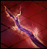

Rage Roots temporarily increase the powerof the player. They can be used in combat to defeat more easily the enemies.

The increase is stronger if they are of the type *Rage Root* or *Great Rage Root.*

* Minor Rage root: adds 1 to every hit and damage rolls for 2 turns
* Rage root: adds 2 to every hit and damage rolls for 2 turns
* Great Rage root: adds 2 to every hit and damage rolls for 3 turns
* ***Meditation Root***

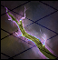

Meditation Roots restore Skill Cooldowns(See Skills for details). They can be used in Exploration too.

* Minor Meditation Root: Decrease the cooldown of a used skill by 2 turns.
* Meditation Root: Decrease the cooldown of a used skill by 5 turns.
* Great Meditation Root: Decrease all the cooldown of a used skill (Except *Armageddon*)
* ***Nimble Root***

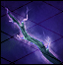

Enhances the *Agility* of Eleven, it can be used in combat to increase the number of “*Steps*” that the player can do to reach the enemies.

The increase is stronger if it’s a *Nimble Root* or a *Great Nimble Root.*

* Minor Nimble root: gain 10 ft. to movement speed, gain 2 new action points
* Nimble root: gain 15 ft. to movement speed, gain 2 new action points
* Great Nimble root: gain 10 ft. to movement speed, gain 3 new action points

**Other consumables**

* ***First Aid Kit***

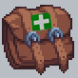

First Aid Kits *heal the player* completely and restore all his *cooldowns* during combats.

* ***Catnip Demon blood vial***



Left by someone to control the numerous Catogorgons and Demodogs in the Upside Down, these vials contain the blood of the Catnip Demon. This can be used by Bad Eleven in two ways: in exploration can be consumed to increase the *Corruption Level* by an half of the actual Corruption bar; in combat it can be used to *charm the Catogorgons and Demodogs* and make them allies for the entire battle (DAR ST 12).

* ***Skill Point (Object)***



Skill Points are rare objects that can be found in the game by exploring. They can enhance one of the skill trees of the player by a range of 1 to 5 points. (See Skills for details).

## Abilities

Like in D&D there are six main abilities in total, they can influence one particular stat of Bad Eleven or Enemies.

These main abilities all start from 10 for Bad Eleven.

Usually everytime one of them gains 2 levels, a modifier + is added.

In the game Ability modifiers can be added **only** increasing the level of **Corruption** (See Corruption for details).

Example: STR 12 = STR+1

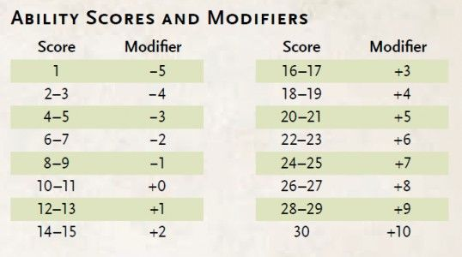

**Strength - STR**

It influences the damage and the chance of a successful hit using a melee weapon. It will raise the physical resistance against knockdowns.

**Constitution - CON**

Establishes the Health points. The higher it is the higher is the resistance against poisons.

**Dexterity - DEX**

Establishes the Armor class. It influences the damage and the chance of a successful hit using a ranged weapon. It will raise reflexes against abilities that affects an area.

**Intelligence - INT**

Establishes the Knowledge points. It influences the damage and the chance of a successful hit using a certain Skill that does not use any physical weapon.

**Wisdom - WIS**

Establishes the Perception points. It influences the damage and the chance of a successful hit using a certain Skill that does not use any physical weapon.

**Darkness - DAR [Charisma in D&D][2]**

It influences the damage and the chance of a successful hit using a certain Skill that does not use any physical weapon. It also influences the change of controlling or being mentally controlled (mental control skills).

**Secondary abilities and Stats**

These stats can be modified by the main abilities when a new modifier is added.

**HP - Hit Points**

This number describes the life status of Eleven or enemies.

**AC - Armor Class**

To successful hit someone, this number must be surpassed by the attacker, only then he can damage health points.

**MS - Movement Speed**

Establishes how distance (in feet) Eleven or enemies can move in that particular turn.

**KN - Knowledge**

Some objects need a certain amount of knowledge to be used.

**PER - Perception**

Some objects can be found only if this parameter is high enough, otherwise the player cannot see them on the map.

Notice:

For a complete description of enemies Stats for the level done, see Level 6 - Enemies.

## Skills

Skills are active and passive abilities that Eleven can unlock during the game. They are one of the main gameplay elements of the game.

Some of these skills can be used both in combat and in exploration to reach or unlock secret areas.

There are some base skills that eleven possesses from the beginning of the game.

Bad Eleven possesses a large Skill Tree formed by several Skill Branches. Skill branches can be unlocked by ***Sources of Power,*** rare interactions that can be found through all the game. Every Skill Branch refers to one specific Skill and can be enhanced by ***Skill Points***. Skill Points can be obtained by *killing* Major Enemies, Bosses and Mini Bosses or by finding the object “Skill Point” that gives a bonus in a range from 1 to 5 points based on what level the player is playing. The player can choose what Branch to enhance by inserting skill points in it.

**Skill Cooldowns**

Every Skill available in combat has a specific cooldown. A cooldown is a number of turns that the player must wait to reuse that skill. When the player concludes a fight, cooldowns will not be restored and they will be brought also in the next battles.

**Skill Tree, Charts and Descriptions**

The Skill Tree of the game can evolve in different ways based on what branch the player chooses to enhance.

These are the ***Base Skills***, Skills that the player will automatically unlock during the introduction act in the school and the forest. This specific Skill Tree won’t require any Skill Point initially but, for every skill, the player may spend a Skill Point to upgrade one of them. Any effect is described in the Skill Tree Diagram below.

|  |  |  |  |  |  |  |
| --- | --- | --- | --- | --- | --- | --- |
| Icon | Name | Action cost | Skill point cost | Ability to Hit / Saving Throw | Cooldown | Range (feet) |
| Base Skills | | | | | | |
|  | Quick Punch | 0 | 0 | **STR** | 10 | Melee |
| Effect: | Deals 1d4+**STR** bludgeoning damage | | | | | |
|  | Overkill | 2 | 0 | **Weapon’s Ability** | 3 | Weapon’s Range |
| Effect: | Deals damage that equals to (weapons damage dices)x2 + (ability damage modifier)x3 | | | | | |
|  | Mind Blast | 1 | 0 | **INT** | 1 | 30 |
| Effect: | Deals 1d10+**INT** psychic damage | | | | | |
|  | Adrenaline Boost | 0 | 0 | **-** | 5 | Self |
| Effect: | Gain +1 to every *hit* roll and every *damage* roll for the next 2 turns | | | | | |
|  | Ground Stomp | 1 | 0 | **STR** | 6 | Self |
| Effect: | Every enemy within 10 feet of Eleven must pass a **DEX ST** or will be knocked down. | | | | | |
| Source of Power Skills | | | | | | |
|  | Telekinesis | 1 | 0 | **DEX** or **INT** | 6 | 30 |
| Effect: | Move an enemy or an object up to 10 feet. If the target ends the movement in the same place of another obstacle, like an enemy or terrain feature, both of them (monsters only) must pass a **DEX ST** or take 1d6 bludgeoning damages.  Can be used in Exploration Mode. | | | | | |
|  | Astral Vision | 1 | 0 | **-** | 1 | Self |
| Effect: | Eleven can see invisible pathway, bridges and cramped places, can unlock secret passages.  Can be used in Exploration Mode. | | | | | |
|  | Dash | 1 | 0 | **-** | 5 | Self |
| Effect: | Move Eleven up to 15 feet, ignore any obstacle on the way, including gorges. The end square must be empty.  Can be used in Exploration Mode. | | | | | |
| Slash | | | | | | |
|  | Slash | 1 | 0 | **STR** or **DEX** | 5 | Melee |
| Effect: | Deals 1d12+(**STR** or **DEX)**. It can cut the Mind Flayer’s Roots.  Can be used in Exploration Mode. | | | | | |

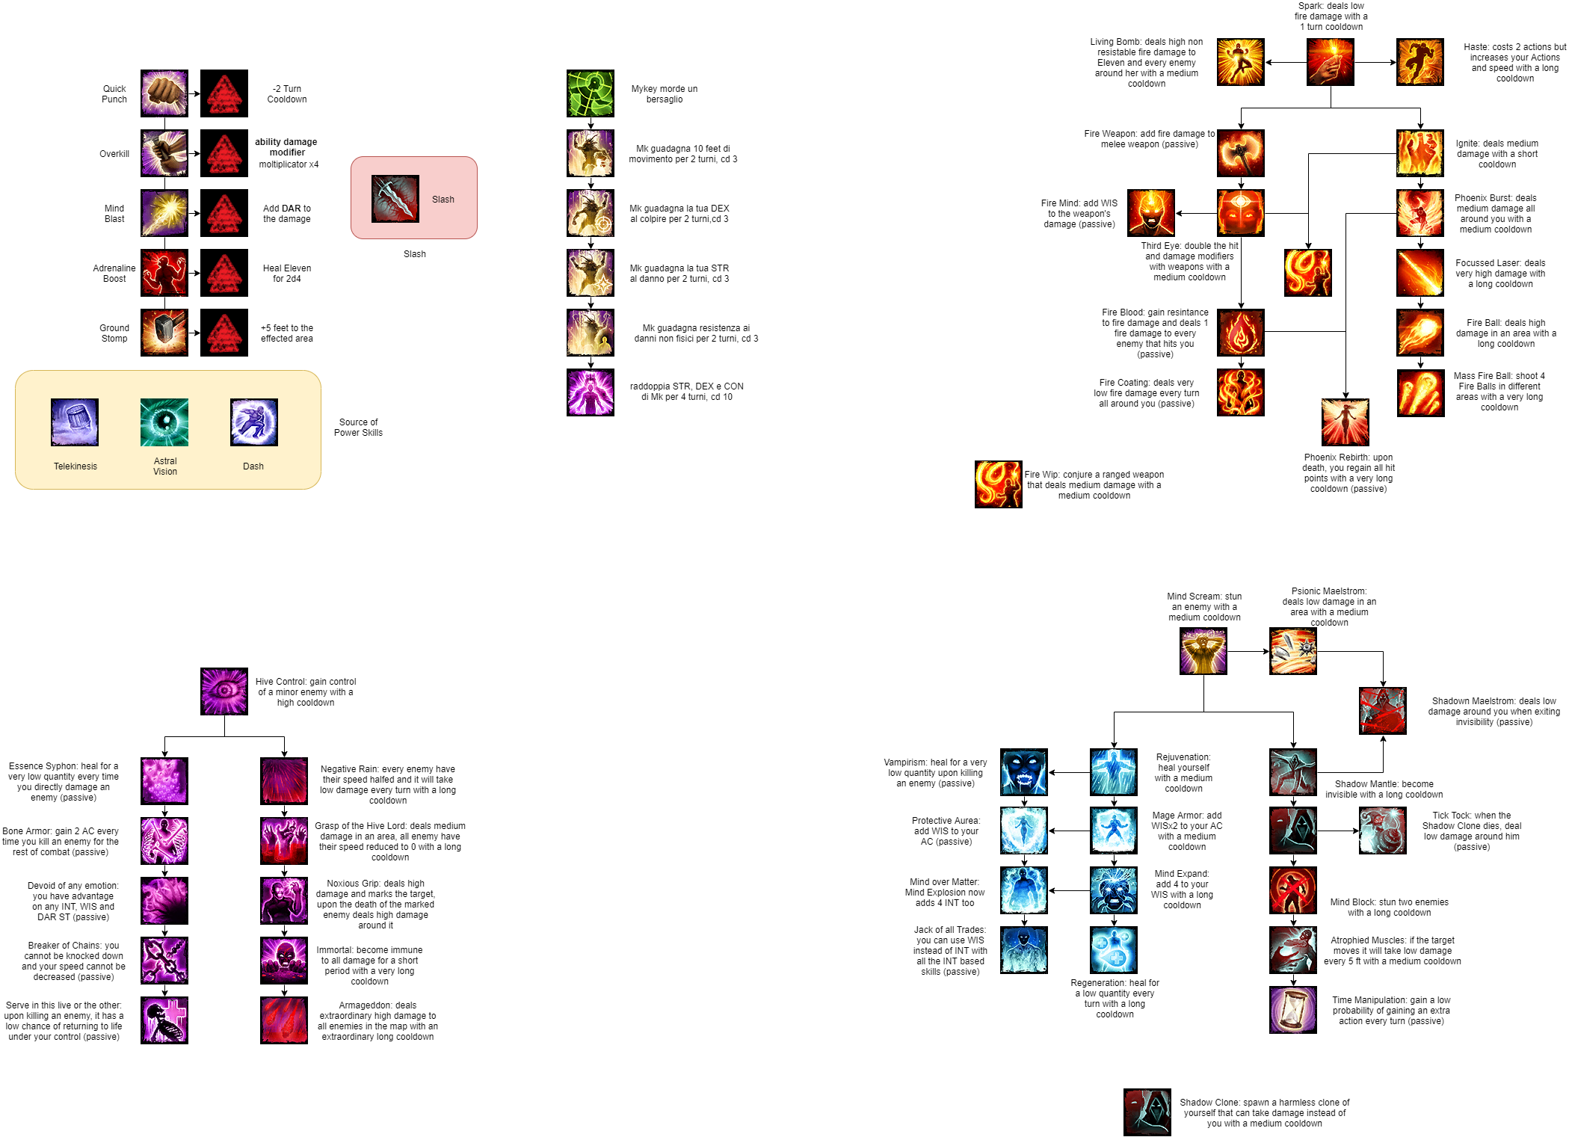

QUICK REFERENCES:

* 1dX: a random number from 1 to X;
* Knocked down: the target will lose an Action Point in its turn;
* **ST**: Saving Throw;
* **Weapon’s Ability**: every weapon needs an Ability to be used, if not specified it’s **STR** for melee weapons and **DEX** for ranged ones;

## Skills Chart

As already said some skills are required to access some levels and to go on with the story (to complete the quest for memories). Not all of them are necessary, most of their uses will unlock secrets and optional paths.

**O → Acquired here**

**X → Used here (Optionally)**

**R → Required to go on**

|  |  |  |  |  |
| --- | --- | --- | --- | --- |
| Level | **Slash** | **Dash** | **Telekinesis** | **Astral Vision** |
| **Level 1**  **Hawkins’ School** |  |  |  |  |
| **Level 2**  **Forest** | **O** |  |  |  |
| **Level 3**  **Deep Woods** | **X** | **X** | **X** | **X** |
| **Level 4**  **Police Station** | **R** | **X** |  | **O** |
| **Level 5**  **Will’s Castle** | **X** | **X** | **X** | **X** |
| **Level 6**  **Will’s House** | **R** | **X** | **O** |  |
| **Level 7**  **Mike’s House** | **R** | **O** | **X** |  |
| **Level 8**  **Lake** |  | **X** | **R** | **R** |
| **Level 9**  **Hawkins’ Lab** | **R** |  |  |  |

**Notice**:

In Hawkins’ Lab despite it’s the final level of the game and the most difficult, only ***Slash*** is required to go on. This solution has been adopted as the player can manage to enter the lab without completing his search for memories and without acquiring the other skills.

## Special Skill Trees

These skill trees (Except *Hive Overlord*) can be accessed after the beginning of the game, in particular after the *Introduction* in Level 1 . They can be buyed and upgraded through Skill Points.

**Cooldowns**

Short: 1-2

Medium: 5-6

Long: 10

Very long: 20

Extremely long: 40

**Damages (AVG)**

Low: 4 - 4.5

Medium: 5.5 - 7.5

High: 10.5 - 13.5

Very high: 18

Extremely high: 28

## 

## Pyrokinesis

Eleven is able to compress the rarefied air with her powers until it reaches a limit point, then a flame will be generated.

The flame can take many forms based on how well Eleven can control it. This Skill Tree is all about dealing damage and capitalize on the Demogorgon species weakness on fire. The right branch focuses on direct damage throw **INT** Skills, the left branch instead focuses on buffing the efficiency of Eleven with melee and ranged weapons.

## Psionic Adept

## This Skill Tree has two very different branches, the left one focuses on self buffing with healings and stat boosting (uses WIS), while the right branch focuses on enemy control and deception throw invisibility, body doubles and mind manipulation (uses DAR).

## 

## Hive Overlord

## This is a very special Skill Tree. Eleven can access this particular Skill Tree only after completing the “*Trial of Corruption*” quest at the *Will’s Castle (Level 5)*. These Skills are extremely powerful, but since the player had to sacrifice a lot of “skill points” to achieve the “trial” she/he wont have enough to unlock all the Skill Tree and have to choose carefully every skill.

**

*\*all icons are taken from Divinity: Original Sin 2™\**

## Corruption

Corruption is one of the main gameplay elements of the game.

Bad Eleven is corrupted, full of anger and generated from the violence by the Mind Flayer. As a part of the Upside Down, she can ***Absorb*** some enemies and increase the corruption inside herself. By Absorbing the major enemies through a gameplay mechanic introduced in the first act of the game, “***Absorption***” : she can increase her ***Corruption Points*** by a number proportional to the power of the enemy she has absorbed. (See Level Battles for details).

To gain a new ***Corruption Level*** the player must fill a ***Corruption Bar*** with Corruption Points.

At the beginning of the game the bar end is set to 1000 points, this end will increase proportionally to the level of Corruption that the player has reached.

Ex: *Corruption Level 0 -> Bar’s End = 1000*

*Corruption Level 1 -> Bar’s End = 2000 ecc.*

**

Example of HUD with Corruption Bar

***When the player gains a new Corruption Level he can increase permanently one of his Main Abilities by 1 modifier point***.

Ex: New Corruption level → *STR+1*

*A popup window will ask the player to apply his new acquired point to one ability.*

*Max modifier points for each ability :* ***+5****.*

***Absorption* is available only for Major Enemies, Bosses and Mini Bosses so the player must choose between obtaining *Skill Points (by killing the enemy)* or *Corruption Points (by absorbing them)*.**

This mechanic inserts variety in the Gameplay as the player can choose to follow the Father’s advices (absorb the enemy to become more powerful) or obtaining more skill points.

**The Trial of Corruption**

Some optional areas of the game can be accessed only if the player has reached a certain Corruption level.

Leven 5 is one of these areas: the player can access it if he’s got at least a **Corruption Level > 5.** Inside this special level there are a lot of puzzles and special enemies that will Eleven’s powers. At the end of the trial eleven will unlock the Hive Overlord skill tree.

**Weapons and Armor**

The Upside Down is a cold and dark place, every equipment that Eleven finds is useful to fulfill her final mission.

During her adventure, Bad Eleven can pick up different weapons and armor which can lighten thanks to her telekinetic powers. Ranged weapons need specific ammunitions to be used, Eleven can find them in several places of the world. Weapons and armor are uniques and their damage/armor given change between each other.

**Base equipment**

**Crowbar:**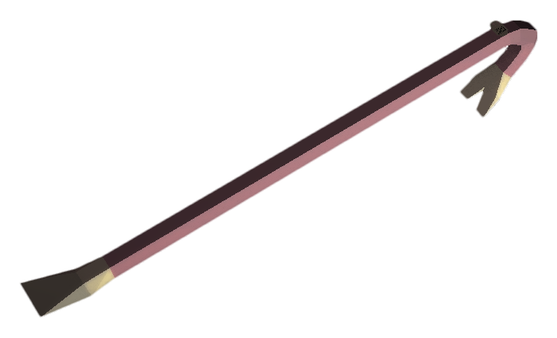

*Melee Weapon Attack*: [STR ATK] to hit, reaches 5 ft., one target. *Hit*: [STR 1D8] bludgeoning damage.

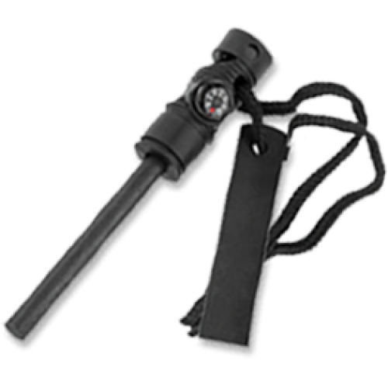

**Fire Striker:**

*Cooldown 5*: range 5 ft., one target, stop the target regeneration for 5 turns.

For more details of the weapons and armor that can be found in the developed level, see the areas in Level 6 Details.

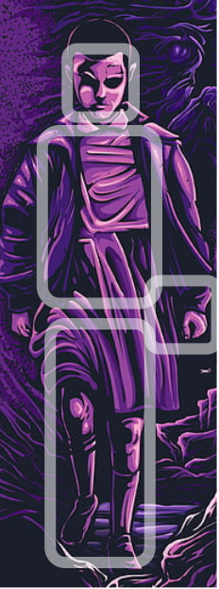

**Armor Set:**

Eleven can wear simultaneously a:

* ***Head gear***, that includes hats,

helmets, glasses and masks

* ***Torso gear***
* ***Hands gear***, that includes gloves

and bracelets

* ***Legs gear***, that includes shoes

and trousers

**Rest**

Every time the player reaches a new Level from a connection area (only the first time he accesses it), the game will ask him if he wants to rest:

“*You are reaching a new Area, do you want to rest first?*”

By resting the player will restore his/her *Skill Cooldowns,* plus the game will be saved.

**Saving**

The game can be saved by accessing the menu and selecting *Save .* The player can save at any moment of the game except if there are enemies nearby (in the same area and in his vision range).

Popup dialog: “*There are enemies nearby, you can’t save here.*”

**Loot**

By defeating enemies they will drop some loot. This loot consist in Upside Down ***Organic Material*** that the player can pick up and give to the Father in Deep Woods in exchange of items, weapons and armor.

The Father will secretly give this material to the Mind Flayer as a source for the creation of new creatures .

**The Father’s shop**

After the first visit in Deep Woods (***Level 3***), if the player returns to it, he will find the Father another time. He will show to Eleven his own loot in the Upside Down and he will also say that he would give it to her if she will bring him some ***Organic Materials.***

As already said, Organic Material is the main loot after battles: its quantity can vary according to the type of enemy defeated.

The Father, being controlled by the Mind Flayer, needs this material to recreate new and more powerful enemies starting from those used as tests and defeated by Eleven.

The player can return to this “shop” as many times he wants.

|  |  |  |
| --- | --- | --- |
| **Item** | **Quantity** | **Cost (Each piece)** |
| Roots (all 4 types) | Limitless | 200 Organic M./ each type (Standard root) |
| First Aid Kit | 3 | 1000 Organic M. |
| Catnip D. Blood Vial | 3 | 1500 Organic M. |
| Tactical Pants | 1 | 3000 Organic M. |
| Bulletproof Vest  (Needs KN +2) | 1 | 3500 Organic M. |
| Tactical Gloves | 1 | 2500 Organic M. |
| Skill Point | 3 | 4000 Organic M. |
| Mikey’s Organic Armor | 1 | 4250 Organic M. |
| ACOG Assault rifle  (Needs KN +4) | 1 | 5150 Organic M. |
| Tactical Laser Shotgun (Needs KN + 2) | 1 | 3950 Organic M. |

## Eleven base Stats

Before starting the game, Eleven will have those base Stats:

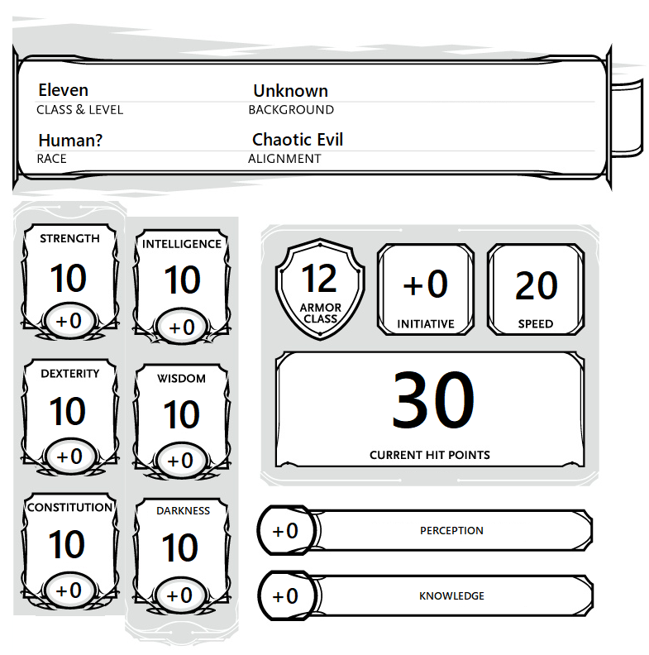

**AC (Armor Class):** 12*Armor Set Modifier +**DEX**

**Initiative: DEX** +Item Modifier

**Perception: WIS** +Item Modifier

**Knowledge: INT** +Item Modifier

**Hit Points:** 30 +(**CON x5**)

At the beginning of game the player **can modify an Ability up or down to a minimum of 8 and a maximum of 12**: for every Ability downgraded to 8, a player can have an Ability upgraded to 12. The player **starts also the game with** **2 ability points more** that can add to which ability he wants. For example before the game has started, he could decide to remove 2 points from WIS (becomes 8) and add them to STR (becomes 12), he adds also the 2 points more to STR making it reach 14. Once the game has started these abilities cannot be modified.

**Mikey mechanics**

At a certain point of the game Eleven will optionally gain a companion: Mikey. Despite Mikey is visible, can be beaten (disabled) by enemies in combat and follows Eleven during the exploration, he doesn’t has its own turn: he shares the turn with Eleven and acts as a new skill tree for her.

The player at the moment of recruiting Mikey will gain two new base skill:

* Mikey’s Movement (The player can move Mikey spending his action points)
* Mikey’s Bite

As the names suggest the first skill will move Mikey up to 30 feet, following the normal rules for movements, the second skill will trigger an attack of Mikey against an enemy in melee range.

Mikey have the following stats line:

(Being a Demodog his stats are similar to them) (*Do not consider the Challenge part*).

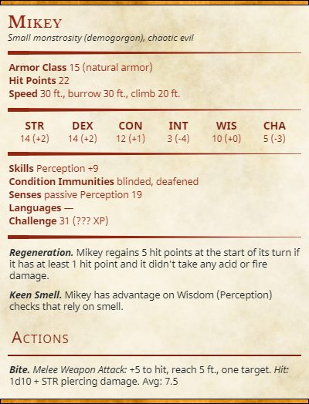

**CHA (Charisma) == DAR (Darkness)**

Other than the two basic skills, the player may learn new skills (with Skill Points) that will interact with Mikey. Each of them won't trigger any action from Mikey, but they will make it stronger adding new actions for few turns.

|  |  |  |  |  |  |
| --- | --- | --- | --- | --- | --- |
| Icon | Name | Action cost | Skill point cost | Cooldown | Range (feet) |
| Mikey Skill tree | | | | | |
|  | Mikey’s Bite | 1 | 1 | 0 | - |
| Effect: | Mikey uses the *Bite* action | | | | |
|  | Evolution:  Legs | 1 | 1 | 4 | 30 |
| Effect: | Mikey gains the *Leap* action and 10 feet of movement speed for two turns | | | | |
|  | Evolution:  Quills | 1 | 1 | 4 | 20 |
| Effect: | Mikey gains the *Quills Shot* action and +2 to its **DEX** for two turns | | | | |
|  | Evolution:  Claws | 1 | 1 | 4 | 15 |
| Effect: | Mikey gains the *Multiattack* and *Claws* actions and +2 to its **STR** for two turns | | | | |
|  | Evolution:  Thick Hide | 1 | 2 | 6 | 30 |
| Effect: | Mikey gains resistance to all damages for 2 turns | | | | |
|  | Apex  Predator | 2 | 3 | 10 | 60 |
| Effect: | Mikey gains the *Cannibalism* action and +4 to its **STR**, **DEX** and **CON** for two turns | | | | |

## 

## Enemies

Even Stranger is a Combat based Rpg-adventure game: during the game Eleven will face several enemies and challenges sent by the Mind Flayer to test and improve her powers.

The real intention of the Mind Flayer is in fact to train Bad Eleven and to make her stronger and madder, in order to face the Real Eleven on the other side of the ***Rift****.*

The challenges given by the Mind Flayer are basically his monsters and during the game they will change in shape, powers and strength. The Upside Down monsters are in fact of different forms, they can evolve into each others and they can learn from the enemy.

Here is a quick look of the monsters that Eleven can face in the entire game, for more details of the monsters in the developed level, see Level Enemies Details.

**Enemies Chart**

**X → Present in the level**

**GREEN → Standard Enemy**

Minor enemy of the level, it can be found several times during the game.

**YELLOW → Major Enemy**

Enemy that can be found few times in the game and is much harder than Standard enemies.

**RED → Mini Boss**

Unique enemy of the level, nearly as powerful as a boss.

**GREY → Boss**

Main boss of the level.

For the developed level enemies chart (with areas distinction) see Level Enemies chart.

|  |  |  |  |  |  |  |  |  |  |
| --- | --- | --- | --- | --- | --- | --- | --- | --- | --- |
| **Enemy** | **Level 1** | **Level 2** | **Level 3** | **Level 4** | **Level 5** | **Level 6**  **DES. LEVEL** | **Level 7** | **Level 8** | **Level 9** |
| Slug | **X** | **X** | **X** |  |  | **X** |  | **X** |  |
| Pollywog | **X** | **X** |  | **X** |  | **X** | **X** |  |  |
| Frogorgon |  | **X** | **X** | **X** | **X** | **X** |  | **X** | **X** |
| Catogorgon | **X** | **X** |  | **X** | **X** | **X** | **X** |  | **X** |
| Catogorgon  Alpha |  | **X** | **X** |  |  |  |  |  | **X** |
| Demodog |  | **X** | **X** | **X** | **X** | **X** | **X** |  | **X** |
| Demodog  Alpha |  |  |  | **X** | **X** | **X** | **X** | **X** | **X** |
| Demodorgon |  |  |  |  |  | **X** |  |  |  |
| Bulb |  |  |  | **X** |  | **X** | **X** | **X** | **X** |
| Catnip Bulb |  |  |  |  |  | **X** | **X** |  |  |
| Catnip Bulb Demon |  |  |  |  |  |  | **X** |  |  |
| Vine Tentacles |  |  |  | **X** | **X** | **X** | **X** | **X** | **X** |
| Great Tentacle |  |  |  |  | **X** |  | **X** | **X** | **X** |
| Demomole |  | **X** |  |  | **X** | **X** |  |  |  |
| Great Demomole |  |  |  |  | **X** |  |  |  |  |
| Drowned Officer |  |  |  | **X** |  |  |  | **X** |  |
| Octopus Tentacles |  |  |  |  |  |  | **X** | **X** | **X** |
| Dark Octopus |  |  |  |  |  |  |  | **X** |  |
| Essence of Mind Flayer |  |  |  | **X** |  |  | **X** |  | **X** |
| Possessed Officer |  |  |  | **X** |  |  |  |  | **X** |
| Mass of Frogorgons |  |  |  |  |  |  | **X** |  |  |
| BROOD  MOTHER |  |  |  |  |  | **X** |  |  |  |
| Strange Cocoon |  |  |  |  |  | **X** |  |  |  |
| LOST SPECIAL FORCES |  |  |  | **X** |  |  |  |  |  |
| GREAT BULB |  |  |  |  |  |  | **X** |  |  |
| POSSESSED CHIEF |  |  |  |  |  |  |  | **X** |  |
| DEMOGORGON |  |  |  |  |  |  |  |  | **X** |
| MIND FLAYER |  |  |  |  |  |  |  |  | **X** |

## Combat Mechanics

Even Stranger has a **D&D turn based style combat**. Enemies are always visible when exploring (unless they’re setting up an ambush) and they do not respawn. If the player gets too close to an enemy (Or the opposite) the **Battle Mode** will start. During combats health won’t automatically recharge.

For this mode the game we referred to is “***The Banner Saga***”: everytime a battle is engaged, the field transforms in achess-like battlefield where enemies and Eleven are positioned in specific squares but unlike *The Banner Saga* the player can control Eleven only and Mikey through his skill tree. Through some items and skills the player can control some enemies too. On the combat area there might be some ambiental objects, these can be used by Eleven and enemies as coverage or as special interactions.

The size of the battlefield **do not resemble the real size of the map in exploration mode** but it’s much bigger and the distances in feet don’t have to necessarily correspond.

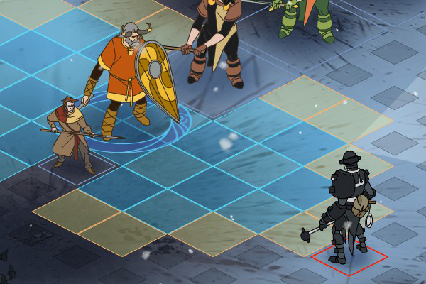

Example of the chess-like battlefield, *The Banner Saga*.

External areas usually have a **19x19** battlefield, while internal or smaller areas can have a **11x11** battlefield, but **this is not a rule** (Brood Mother boss fight for example), see Level Battles for more informations about the battlefields in the developed level.

The initial positioning of Eleven is always at the center of the bottom side of the combat area.

The initial positioning of the enemies is most of the times random, on the top area of the battlefield; sometimes, due to the complexity of some fights (boss fights or major enemies for example) they can have fixed positions on specific squares (one or more than one).

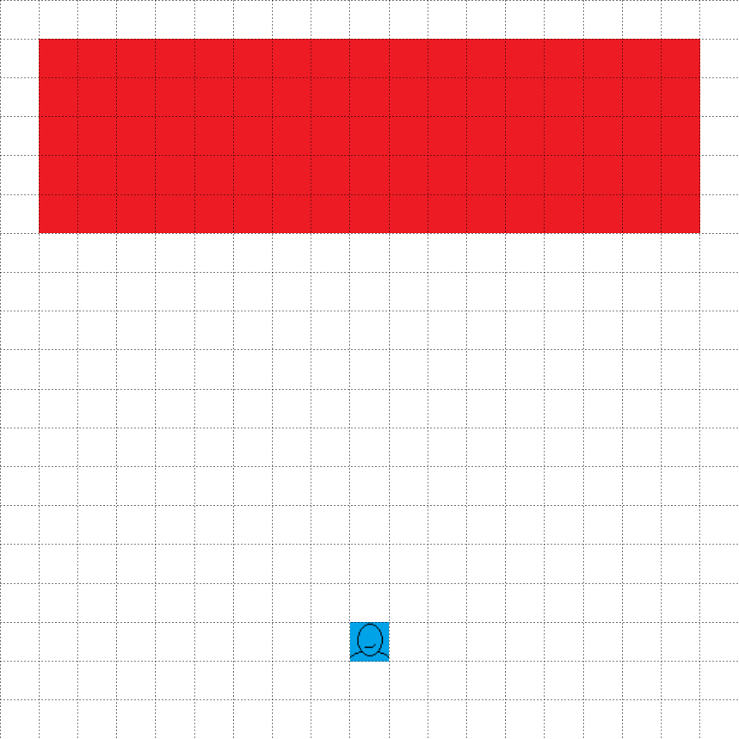

Example of empty combat area with random enemies positioning.

( RED → Enemies area; Character → Eleven position )

The order of the turns is decided by the “**INITIATIVE**” or **INI** for short. The character with the highest **INI** statistic has the first turn automatically, followed by the second highest and so on.

To calculate Eleven’s **INI** it’s required to add the **DEXTERITY** modifier and the **WISDOM** modifier together, and if necessary, any bonuses given by Skills or Equipment.

**Escape from battle**

Player can choose in every moment to escape from the battle and to return in exploration mode. Despite this he will be chased by the enemies in exploration (except in particular cases), their stats will be reset and their positioning will be redone in the next battle.

In a turn every character has **two Action Points** that can be spent to either:

* move
* use an active skill (some of them requires to spend two action points instead of one)
* use an attack (with a weapon in the case of Eleven)
* interact with the environment (if there are any obstacles on the battlefield)

**Movement**

The Movement Speed, measured in feet, defines how long the player can move on the battlefield. **Every square of the chess-like battlefield is 5 feet in length and width** and the active character can pass from one to another. A Move action have to end in the same action, it means that if someone starts to move,

even 5 feet, using a skill or any other action that isn’t moving the remaining feets will result in the loose of the Move action.

Every time the Movement speed statistic of a character is referenced in a text it may or not say “*current*” before it: the difference stands in the temporary stats modifications created by skills or objects.

An example:

Eleven has a base **Movement** speed of 20 feet

*Current speed = 20.*

An enemy uses a *Sticky Spit* to drop her *current speed* by 10 feet.

*Current speed = 10 → (20-10).*

Eleven uses the ***Haste*** skill to double her base speed bringing it to 40 feet.

*Current speed = 30 → ((20x2)-10).*

An enemy uses a ***poison cloud*** to half her *current speed* bringing it to 15 feet.

*Current speed = 15 → (((20x2)-10)/2)*

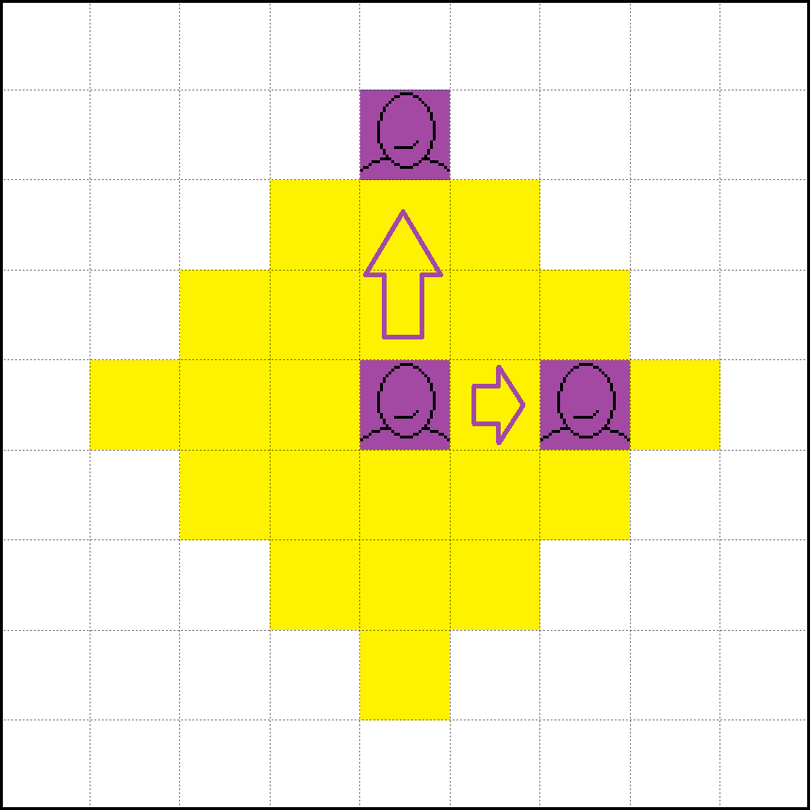

An example with a character with a speed of 15 feet

|  |  |
| --- | --- |
|  | Generic character, it can represent Eleven or an Enemy |
|  | Movement example |
|  | All the squares reachable by the central icon in a single Movement action |

## 

**Attack**

The game follows the “**D20**” system of D&D.

Every time someone wants to hit an enemy with an attack that targets it directly, a virtual random number from 1 to 20 is created, if the random number (1-20) + the hit modifier >= the defence statistic of the target, then the attack results in a successful hit and it proceeds with all his effects like damage or debuff.

Eleven has a default hit modifier of +3.

An example:

Eleven uses the *crowbar* on an enemy with Defence *14*

She has a bonus of +*5* on all her hits

She rolls a 10 as the random number

The attack landed successfully

**Armor Class and Saving Throw**

Just like in D&D, every character has defensive statistics.

The first one is the **Armor class**, or **AC** for short,and it can block direct attack from the enemy, but some ability or secondary effects requires the target to succeed a **Saving Throw**. Everytime a target needs to overcome a **ST** it must roll a virtual **D20** and if the random number (1-20) + statistic modifier >= challenge, then the challenge is passed. A challenge can require to pass a **ST** in any of the six base statistics: Strength (STR), Dexterity (DEX), Constitution (CON), Intelligence (INT), Wisdom (WIS), Darkness (DAR, Charisma in the classic D&D)**.**

An example:

Eleven casts ***Kinetic Milestorm***to create a storm of floating objects

All the enemies caught in the storm must succeeds a **DEX ST** of 15

Everyone that didn’t pass the **ST** will take damage

Other features from D&D that will be implemented in the game:

* Opportunity Attack: NOT fully implemented, only Eleven can have OA.
* Advantage
* Critical Hit
* Difficult Terrain
* **Dodge action**

For more informations about the D&D combat system see **D&D rules of the Special edition for Stranger Things**.

## Part 2 - Level Design Part

Level 6 - Will’s House

Story and Settings

The level takes place in the Area 6 of the game, Will’s House.

This level is part of the Woman’s quest “Retrieve your memories” and can be reached after the player visits for the first time the hub area “Deep Woods”. The player can choose what Level between 4 - 5 - 6 - 7 visit and complete first.

## Area and Structure

The area of the level is composed by a 3 macro areas, two external and one internal.

The external areas are composed by different locations including an accessible Shed . The internal area of the house is composed by different rooms where the player can find the elements needed to proceed in the story.

External 6.1 - Surrounding forest

This area connects the street with the Garden, his function is similar to a connection area but it has more interactions.

In this area is present a shortcut from the Level 5, “Will’s Castle”.

This shortcut is a one-way shortcut and cannot be accessed from here but only from the area of the Castle.

* Narration : in this Area there are some interactions with the Father that is waiting in front of the shortcut from Will’s Castle.

* Gameplay: in this area there are some minor enemies to defeat in order to access the next area and enter the Will’s Garden.

There are some equipment items spreaded in the area.

External 6.2 - Will’s Garden

This area is the external area of Will’s house and surrounds it completely.

In this area there are some major enemies and some puzzle solving related to the main puzzle in Will’s House. From this garden the player can access the Shed where are stored some items and a piece of the main puzzle.

* Narration : In this area there are several narration elements and interactions with Mikey if the player has already unlocked him.

The Father will have another interaction with Bad Eleven before leaving.

Bad Eleven will hear the voice of the Woman.

* Gameplay: The father will try to prevent the access to the house sending to Bad Eleven a mini boss in order to stop her.

Once the player has obtained the Shed Keys he can access the Shed and obtain equipment and a piece of the main puzzle of the House.

Internal 6.3 - Will’s House

This area is divided into several rooms. Every room has an unique aspect and interaction.

Will’s House is damaged, deteriorated and nearly destroyed in the Upside Down, but a lot of items has survived.

Rooms:

* A1 : Living Room [Puzzle main hall]
* A2 : Kitchen
* A3 : Corridor, Bathroom and Rooms 1-2
* A4 : Room 3 [Source of power]
* Narration : In this area there is a puzzle to solve to unlock a memory for Bad Eleven. The solution on the puzzle and the defeat of the Boss will trigger a cutscene with Lucas, Will and Dustin. This vision of the three friends will lead Bad Eleven to remember who they are.

* Gameplay: This area is full of gameplay elements:
* The Puzzle: solve the puzzle to unlock the Boss fight and the memory cutscene.
* Minor enemies: defeat the demodogs and the slugs.
* Source of power: unlock a new power for Bad Eleven.
* Shed Keys: obtain the Shed keys in Room 2.

## Story of the Level

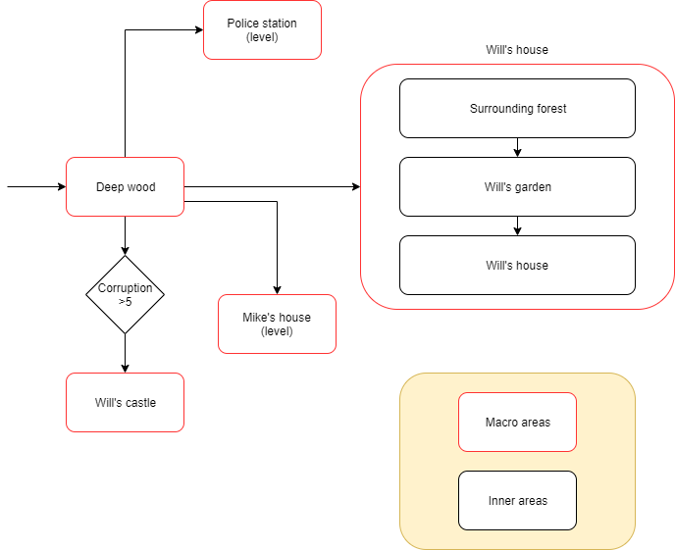

From Deep Woods the player can reach different levels, including Will’s House.

Settings and introduction

The level can be reached after Bad Eleven has visited Deep Woods for the first time. At this state Bad Eleven has not yet retrieved her memories and she must complete the mission that the Woman gave her in the vision.

Will’s house is one of the three places to visit in order to complete the quest for the memories.

In the vision she had in Deep Woods in fact, the Woman told her to visit these three places to retrieve part of her memory and to accomplish her final mission. This final mission is unknown yet and will be revealed only in the ending of the story.

To begin this Level the player must reach the connection area 3-6, Street and continue to the road in front of the Byers mailbox.



**Before accessing the level, in front of Byers mailbox:**

***Dialogue 6.0 A***

Eleven *[3]: Uhm, Byers’ house...this reminds me of something, this must be one of those places that woman was talking about.*

***Dialogue 6.0 B (Mikey is present)***

Eleven: *Uhm, Byer’s house...this reminds me of something, this must be one of those places that woman was talking about. Mikey, what do you think?*

Mikey*: Grroar.*

*Eleven: Well, I guess you’re right.*

**Accessing the Level**

**6.1 Surrounding Forest**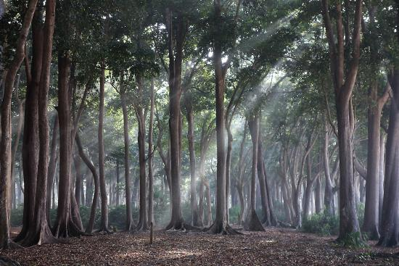

Bad Eleven ( and Mikey if present) accesses to the Forest that surrounds Will’s House. Here a lot of minor enemies are waiting for her. The player can follow two paths:

* Explore the Surrounding Forest and find the shortcut to Will’s Castle. [Optional]
* Go straight to Will’s Garden. [Intended path]

**Explore the Surrounding Forest [Optional]**

If Bad Eleven starts exploring the area she will soon find some armor pieces, items and a path leading to the Will’s Castle shortcut.

The shortcut is not accessible from here because it is on a raised ground so it is a one-way shortcut: the player must reach Will’s castle from the other side of the forest. (Deep Woods and then Forest)

In front of the shortcut the Father is waiting for Bad Eleven. He will warn her that the path is one-way only and it’s not accessible from this position.

The Father will also mention the Corruption [4] of Eleven. Will’s Castle in fact is only accessible if the Corruption Level is major than 5.

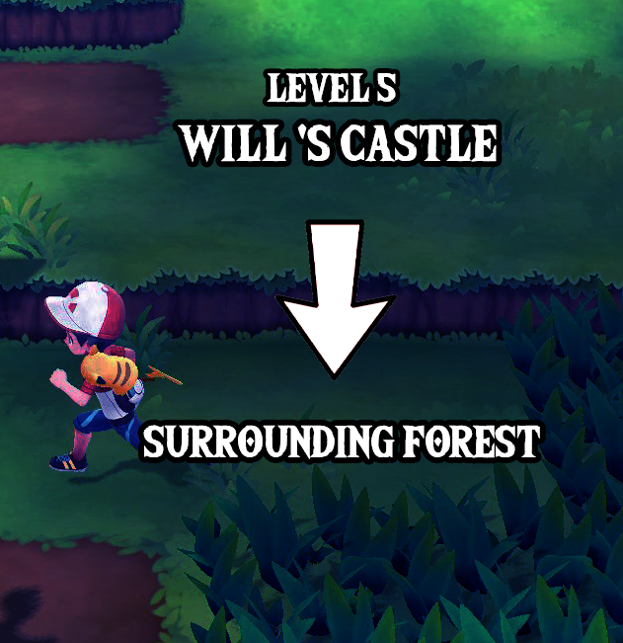

One-way shortcut example (Game: ”Pokemon Let’s go, Pikachu !”)

The father will also warn Eleven to not try to proceed in direction of Will’s House because it will awaken something in herself and change her behavior completely.

The dialogue with the Father can change depending on different reasons:

* Mikey is present.
* Bad Eleven has enough *Corruption* to access Will’s Castle.
* Bad Eleven has not enough Corruption to access Will’s Castle.

**Interaction with the Father, in front of Will’s Castle shortcut:**

***Dialogue 6.1 A - Enough Corruption to access Will’s Castle***

Father: *You are ready to earn more power but you can’t go this way, this passage is unreachable. Maybe you should look around and find another way through. By the way, some places may get you even more confused, don’t follow that road or stupid voices in your head...remember to focus on what you really are, and not be deceived by stupid memories… The path to the Lab is not here, go back now.*

Eleven*: Maybe I should pay attention to your words...or maybe not. Urgh I’m so confused.*

Father: *When you will reach the lab all your confusion will be vanished, trust me and go back now.*

***Dialogue 6.1 B - Not Enough Corruption to access Will’s Castle***

Father: *You are not ready to go there, you’ve not reached your full potential. You should follow my advices more and try to absorb more creatures. By the way, some places may get you even more confused...remember to focus on what you really are, and not be deceived by stupid memories...The path to the Lab is not here, go back now.*

Eleven*: Well, I’ll know what to do when needed...I hope. Your words just confuse me…*

***Dialogue 6.1 Addiction - The Father comments on Mikey***

Father: *(Sees Mikey) Oh..that must be the one that escaped from us. One of a kind.*

Eleven: *What do you mean by that? Escaped from where?*

Father: *It doesn’t matter, once we reach the Lab everything will turn out right. Focus on yourself.*

***Dialogue 6.1 C - Default interaction with the Father***

Father: *When you’ll reach the lab all your confusion will be vanished, trust me and go back now.*

**Go straight to Will’s Garden [Intended Path]**

If Bad Eleven goes straight to Will’s Garden she will face another type of enemies protecting the area near the access and the interaction with the Father in front of the Will’s Castle shortcut will no longer be available.

**6.2 Will’s Garden**

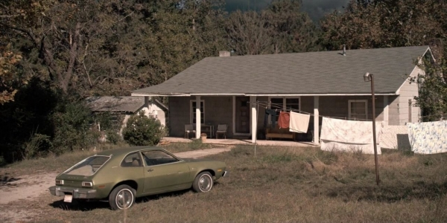

Will’s Garden from Stranger Things, the Netflix Series.

In the Garden Area, Eleven will find the Father waiting for her another time: he has warned her to not proceed and now she must leave or face the consequences.

**When accessing Will’s Garden: Cutscene 6.2.1**

***Dialogue 6.2.1 - The Father’s warning***

Father: *I told you not to reach this place. You better get out of here while you can, this is not good for you trust me. You could become something that you are not and you don’t want that, want you? Memories get you weak, you are not weak...humans are, and you are different.*

Eleven: *But something got me there, I feel this place could really help me, I feel like a sort of connection is calling me in there.*

Father: *Do what you want but i warn you: he will try to stop you.*

Eleven: *Who is he? What are you talking about??*

Father: *Doesn’t matter, you’ll find out it soon, i’ll wait for you at the Lab.*

The Father will leave the place and, if the player decides to go on, behind him will spawn a major enemy: the *Demodorgon* (a Demodog half transformed into a Demogorgon).

The *Demodorgon* will try to stop Bad Eleven, following the will of the Father (Mind Flayer).

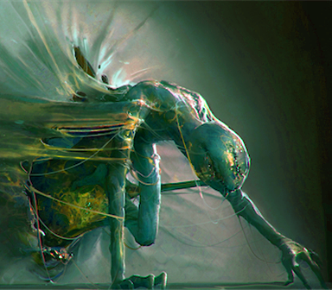

The entrance of the Demodorgon.

Once the battle is over Bad Eleven will listen a voice in her head: it’s the Woman of the vision.

**Once that the *Demodorgon* is defeated:**

***Dialogue 6.2.2 - The Woman***

Mother: *You did very good, I’m proud. You are on the right path, trust me and go ahead.*

Eleven: *Where’s this voice from? It’s very close...is it inside my head? Everyone always says “trust me”... who should I trust then? Maybe I should just trust my inner instinct…*

From this point Bad Eleven can decide to enter the Will’s House , to explore or leave the area.

**Explore or leave the area [Optional]**

The player can find some items in the area to use in combat and has several interactions with some objects. He can retrieve also some letters of the puzzle that is inside the House.

By exploring the area the player can access the Shed where some minor enemies are waiting for Bad Eleven.

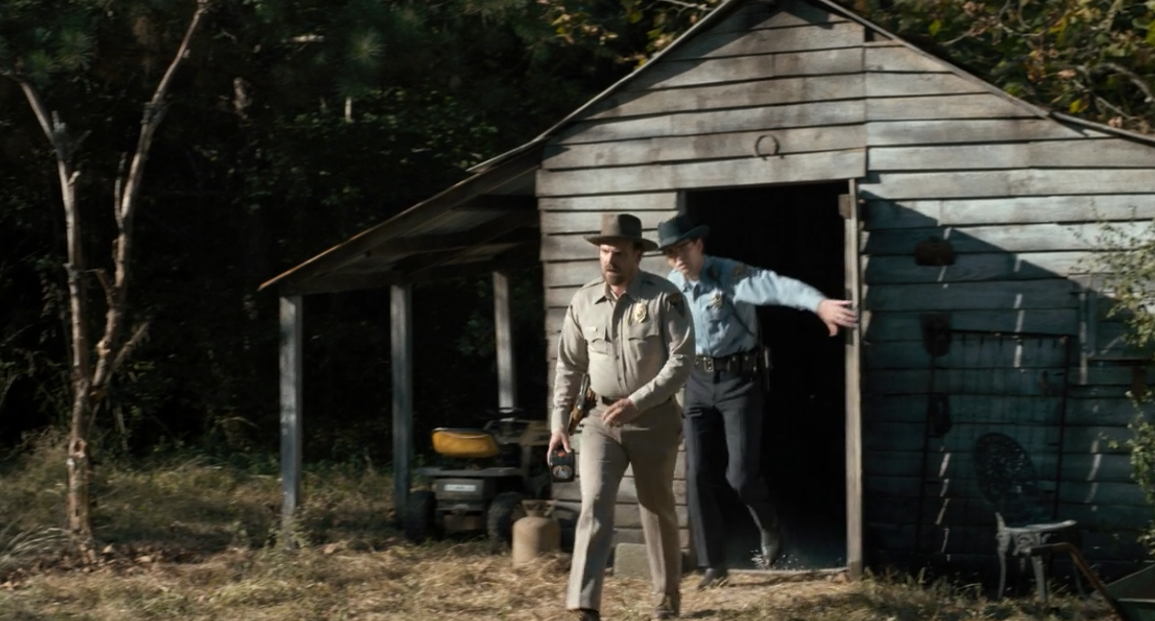

Byers’ Shed (Stranger Things S1, the Netflix TV series).

The Shed is only accessible if the player has obtained the Shed keys, available in one of the Rooms inside the house.

**In front of Will’s House door:**

***Dialogue 6.2.3 - Comment***

Eleven*: Ok this is the place, i don’t know what’s inside.. let’s get in and find it out…*

**Interaction with the car:**

***Dialogue 6.2.4 A - Comment***

Eleven: *Uhm, i guess i’ve seen something like this before. But i have no idea how to use it!*

***Dialogue 6.2.4 B (Mikey) - Comment***

Eleven: *Uhm, i guess i’ve seen something like this before. But i have no idea how to use it!*

*Mikey: Grroar…*

Eleven: *Oh shut up, you have no idea either...*

**Interaction with the hammock:**

***Dialogue 6.2.5 - Comment***

Eleven: *There’s no time to rest. Also this looks quite gross...*

**Interaction with the Shed (without keys):**

***Dialogue 6.2.6 - Comment***

Eleven: *It’s locked, I could break the door using my power...but maybe it’s better to preserve my powers for later. I’m sure I can find the keys around here...*

**Inside the Shed, interaction with the Rifle:**

***Dialogue 6.2.7 A - Comment***

Eleven: *This could be useful later, it’s heavy but i could lighten it a little bit with my power..*

***Dialogue 6.2.7 B (Mikey) - Comment***

Eleven: *This could be useful later…*

Mikey: *Grroar!*

Eleven: *I don’t care if it’s bad, but I can use it to protect us.*

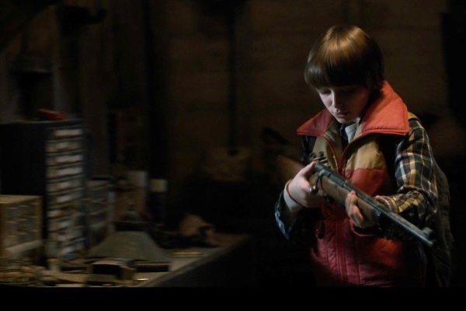

Will finds the rifle in the Shed (Stranger Things S1, the Netflix TV series).

**Default interaction with a letter (Same in Will’s House):**

***Dialogue 6.3.3 A- Comment (Without interaction with the Letter Wall)***

Eleven: *A letter...quite strange. Maybe it could be useful later...but i don’t know how.*

***Dialogue 6.3.3 B- Comment (First letter retrieved)***

Eleven: *It must be one of those letters that paper was talking about, i should take it.*

***Dialogue 6.3.3 C- Comment (Not the first letter retrieved)***

Eleven: *Another letter, i need to find the others.*

***Dialogue 6.3.3 D- Comment (Last of the letters retrieved)***

Eleven: *Yes! Another one...this should be the last one.*

**Enter Will’s House [Intended path]**

By entering directly Will’s House the player will not lose the optional interactions with the objects in Will’s Garden and can do them later.

**6.3 Will’s House**

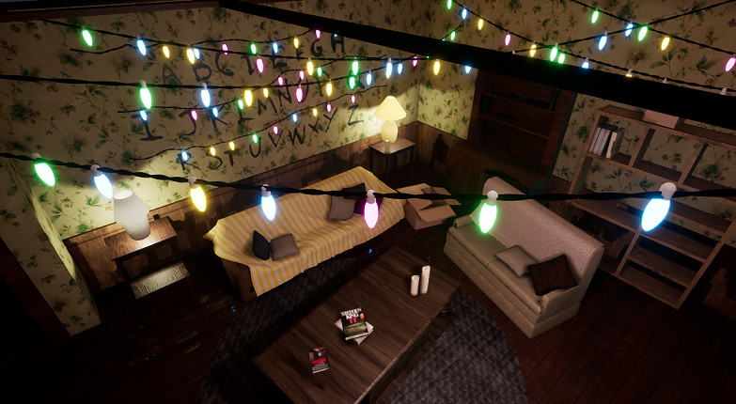

Will’s House Living room in the real world (Stranger Things S1).

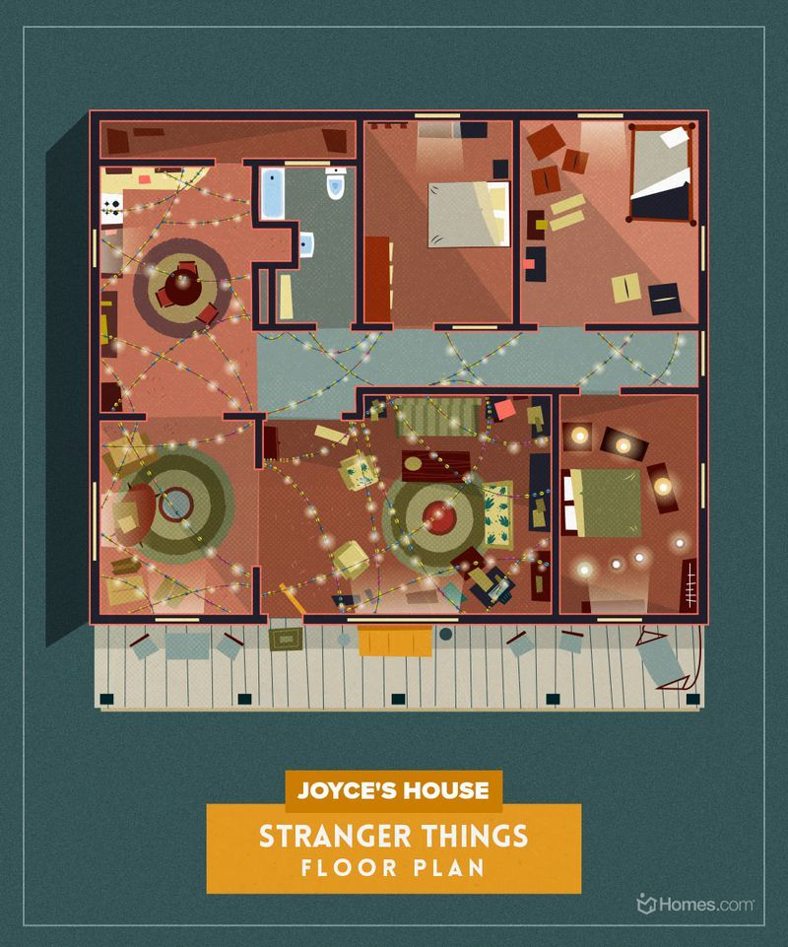

Will’s House internals Sample Map.

This is **not** the actual level map, but an example of the rooms placement.

see Level 6 Details for the detailed plant.

**Entering Will’s House:**

***Dialogue 6.3.1 A - Comment***

*Eleven: Everything’s messy and distressed, but I’m sure i can find something useful…*

***Dialogue 6.3.1 B (Mikey)- Comment***

*Eleven: Everything’s messy and distressed, but I’m sure i can find something useful…*

*Mikey: Grroar, grroar…*

*Eleven: You always act like you know everything...be useful and try to help me instead.*

When entering Will’s House the first thing the player will see is the Letter Wall. This wall has been important for the events of Stranger Things S1 and in the Upside Down is half damaged but working. The Wall is composed by letters lighted by Christmas lights. The player can light them individually in order to form a word.

Initially Bad Eleven is confused by this wall: she does not understand what she must do but she finds a document near the wall, it says: “6 letters”.

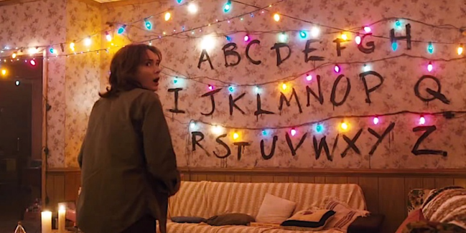

The Letters Wall, Stranger Things Season 1.

**Interacting the first time with the Wall:**

***Dialogue 6.3.2 - Comment***

Eleven: *That looks very strange...there’s a paper on the ground, It says “6 Letters”...what? Is this a message for me? Why would someone leave a message? I should search for something else around here..*

**Default interacting with the Wall:**

By interacting another time with the wall the player can select in order the letters to light on and solve the puzzle.

Bad Eleven will find the letters for the puzzle inside the House and outside, in the Garden and in the Shed.

The letters can be found in:

Kitchen, Room 1, Room 2, two in the Garden, one in the Garden Shed.

**Default interaction with a letter (Same in Will’s Garden):**

***Dialogue 6.3.3 A- Comment (Without interaction with the Letter Wall)***

Eleven: *A letter...quite strange. Maybe it could be useful later...but i don’t know how.*

***Dialogue 6.3.3 B- Comment (First letter retrieved)***

Eleven: *It must be one of those letters that paper was talking about, i should take it.*

***Dialogue 6.3.3 C- Comment (Not the first letter retrieved)***

Eleven*: Another letter, i need to find the others.*

***Dialogue 6.3.3 D- Comment (Last of the letters retrieved)***

Eleven: *Yes! Another one...this should be the last one.*

In order to complete the puzzle the player must explore the other rooms.

**Kitchen:**

Here Bad Eleven can find a letter and there are some interactions with the objects.

**Interaction with the kitchen:**

***Dialogue 6.3.4 - Comment***

Eleven: *These tools look familiar and....a Knife! It’s gross but very sharp, i should take it.*

**Bathroom:**

Bad Eleven has some interactions with the objects .

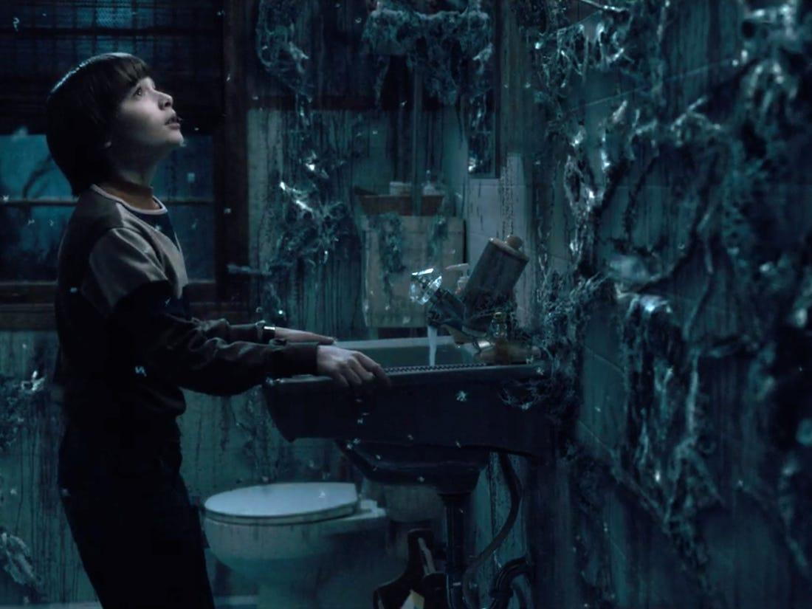

The bathroom in the Upside Down, Stranger Things S1

**Interaction with the bathroom:**

***Dialogue 6.3.5 - Comment***

Eleven: *I wonder what’s this for...*

**Room 1:**

Here Bad Eleven can find a letter.

**Room 2:**

Here Bad Eleven can find a letter and some minor enemies (another type).

Bad Eleven finds also a key on a desk

**Room 3 [Optional] :**

Here there is a Source of Power. Bad Eleven can acquire a new power to use in combat.

Sources of Power are strange fountains of dark power that can be found in different places of the world, this place is one of them.

Bad Eleven has been told about these fountains by the Father.

The fountains unlock new powers for Bad Eleven that can be used both in combat and exploration (to unlock secrets or optional paths).

**Interaction with the Source of Power:**

***Dialogue 6.3.6 - Comment***

Eleven: *This must be one of the sources he was talking about. I need to absorb it to acquire more power...*

Once the player has acquired all the letters in the House, he can exit and return to the Garden to acquire the others.

If the player has acquired ALL the 6 Letters:

**Interaction with the Letter Wall once ALL the letters are acquired:**

***Dialogue 6.3.7 - Comment***

Eleven:  *Ok, now i need to create a word with those letters...what could it be?*

**After the word is completed:**

***Dialogue 6.3.8 - Comment***

Eleven: *This makes sense i guess...but why “Mother”? I’m getting a strange feeling from that...*

Bad Eleven thinks about the word someone left in this place, “Mother”. Suddenly a vision of someone, someone in a different reality but in the same place, shakes Bad Eleven’s mind.

Bad Eleven falls on the ground and find herself in the real world, with other kids playing a sort of game. They cannot see her, but she can.

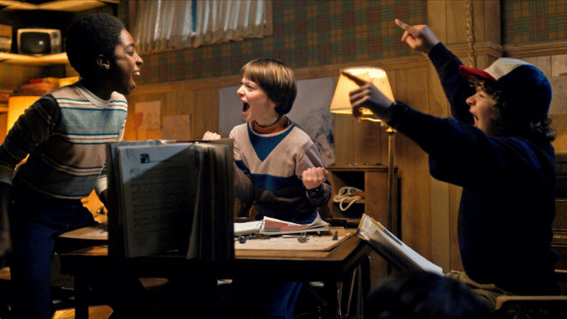

Will, Dustin and Lucas playing D&D, Stranger Things S1

**Cutscene 6.2.2 - Will’s House Vision**

***Dialogue 6.3.9 - Dustin, Lucas and Will playing.***

Will: *A shadow grows on the wall behind you, swallowing you in darkness. It is almost here.*

*Dustin: What is it? Is it a simple troglodyte? Or a Demogorgon?.*

Lucas*: Man i’m getting scared honestly…*

Will: *Behold...An army of Zombies charge into the chamber!*

Lucas: *We’re screwed!*

Dustin: *We could use a Fireball to defeat those!*

Lucas: *We’re out of mana, we can’t!*

Dustin: *Oh think fast, think fast!!*

Joyce: *Boys you need to stop! It’s snack time...*

Will: *“Mother, don’t you dare to stop the adventure of Will the wise!”*

Joyce: *Oh Will...don’t call me “mother” please. You have 5 minutes to come here, come on.*

Will: *Ok mum, sorry, but we should finish the game first...*

Lucas: *Well...honestly i’m kinda hungry, let’s go.*

Will: *Ok...we’ll continue the game later...*

Joyce: *The “mother” is waiting for you!*

*...*

Eleven: *Where am I? Who are those people? Do I know them?*

Eleven: *HEY! You three stop right where you are...tell me who are you.*

*\*Will, Lucas, Dustin leave the place\**

Eleven: *WHO ARE YOU?*

Eleven: *They cannot hear me….*

*\*Eleven falls on the ground\**

Bad Eleven find herself another time in the Upside Down.

**The Boss Battle:**

The vision gives the shivers to Bad Eleven but she has no time to think about that, something has caught her with a sort of tentacles.

It is an enemy, the *Broodmother, Bad Eleven starts to fight in order to free herself from that thing.*

The *Broodmother* has the aspect of a Demogorgon but is smaller and has some tentacles around her body. The *Broodmother* can call minor enemies in her help. Once Bad Eleven is free from the hold of the monster, the battle starts.

***-- Boss Battle --***

The battle is over and Bad Eleven makes some considerations about the vision. She can’t easily remember the guys but she starts to feel something different from the anger that has felt from the beginning. This is a proof of the fact that if she completes what the Woman said to her she would certainly be on the right path to remember everything.

If this was the last memory to retrieve, Bad Eleven is still confused.

The reason of this confusion is the darkness inside herself. She does not recognize herself in these memories and she feels a lot distant from that reality. She must return to Deep Woods and speak another time with the Woman. The player can now exit from the level or stay and explore the area in search of items.

***Dialogue 6.3.10 - Comments about the vision.***

Eleven: *Urgh...was that just in my head? I think it was like a “vision” or something like that. Those guys...i can’t recognize them but they look familiar. Who are they? Oh i’m trying so hard to remember them...i feel like they lay somewhere in my memories…Mother...mum...maybe it means something for me. Maybe that Woman is right… should i follow her advice?*

***Dialogue 6.3.11 A - Quest for memories not finished***

*Eleven: Maybe i should, this place was very important and i think the others will be the same...the anger inside myself is not the same as before.. it’s not growing anymore! I feel better in a sort of way..*

***Dialogue 6.3.11 B- Quest for memories finished***

*Eleven: This was the last place to visit but… i’m still so confused! These memories are laying somewhere in my head but i’m not able to put them together and remember something useful!*

*Eleven: I should return to that Woman and contact her someway as fast as possible….and that man…. he might be very angry this time.*

**Explore the remaining Area [Optional]**

The player can remain in the area to explore in search of items and secrets.

**Exit to the Will’s Garden → Surrounding Forest and leave the Level [Intended Path]**

The player can leave the area and exit the level to return to Deep Woods (intended) or to follow another path.

## Level 6 - Will’s House

Level Details

# Scope of the level

The scope of the level strongly depends on how the player decides to play and to engage the battles.

The following scopes are intended if the player engages all the battles and retrieves an average number of object without an in-depth exploration.

|  |  |
| --- | --- |
| Area | Scope |
| 6.1 - Surrounding Forest | ~ 15 min |
| 6.2 - Will’s Garden + Byers’ Shed | ~ 20 min |
| 6.3 - Will’s House + Puzzle | ~ 40 min |
| TOTAL | ~ 75 min |

# **Event Diagram (Impact - Timeline)**

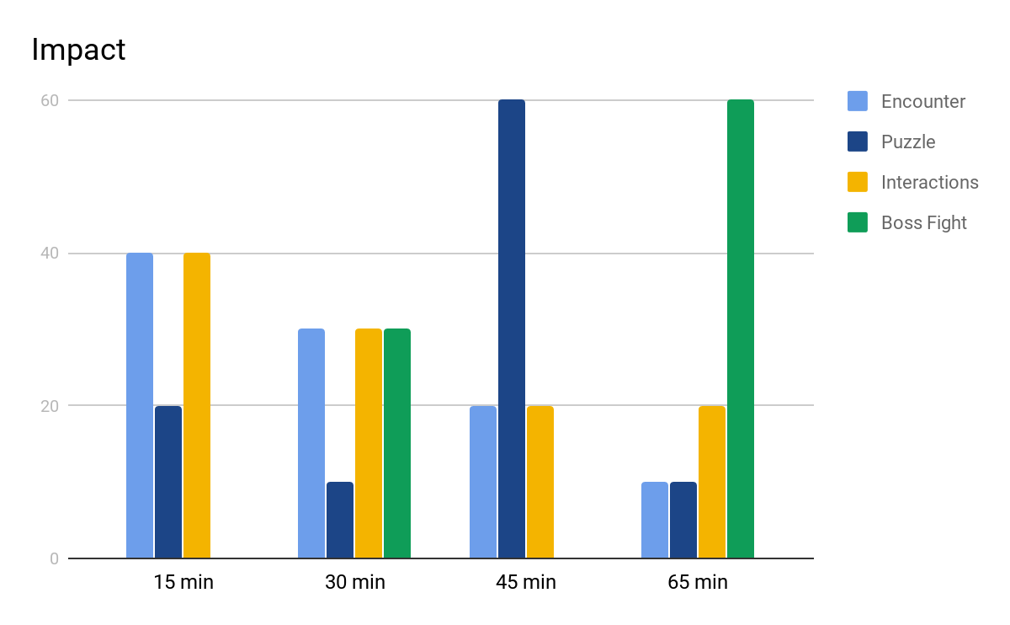Interactions : NPC interactions and key objects interactions.

Boss Fight: Minor bosses and main bosses.

Encounter: Minor enemies.

Puzzle: Puzzles and ambience interactions.

# **Level Diagram**

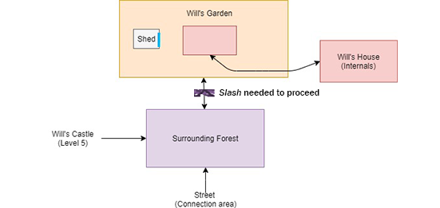

# The Ability “***Slash***” is needed to proceed to Will’s Garden and free the access from the ***Mind Flayer’s Roots***.

# The Shed is part of the Will’s Garden Area. It can be accessed using the ***Shed Keys****.*

# Despite is inside of Will’s Garden, Will’s House Internals can be considered as a different area due to its complexity.

# 

# **Skills or Quests required to access the level**

The level (from Will’s Garden) is accessible only after the player has visited Deep Woods for the first time, obtained the Quest “Retrieve your memories” and acquired the ability “*Slash*”.

If the player tries to access Will’s House from Will’s Castle, without reaching Deep Woods ad acquiring the quest, the path to Will’s Garden will be blocked by the Mind Flayer’s vines.

The ability “***Slash***” is required to destroy these vines.

The ability “*Dash*” ( the player can acquire it in the Police Station) is required to access some secrets in Surrounding Forest and in Will’s Garden.

# **Level Goal Outline**

1. Retrieve your memories [Facultative] [Required for the level]
   1. Visit Byers’ House
      1. Find a way to the House **6.1 Surrounding Forest**
      2. Defeat or Absorb the Demodorgon **6.2 Will’s Garden**
      3. Enter the House
      4. Find some clues **6.3 Will’s House (internals) - 6.2 Will’s Garden**
      5. Solve the Letter Wall
      6. Defeat or Absorb the Brood Mother **6.3 Will’s House (internals)**

## Area 6.1 - Surrounding Forest

# Event Diagram (6.1) ( Impact - Time)

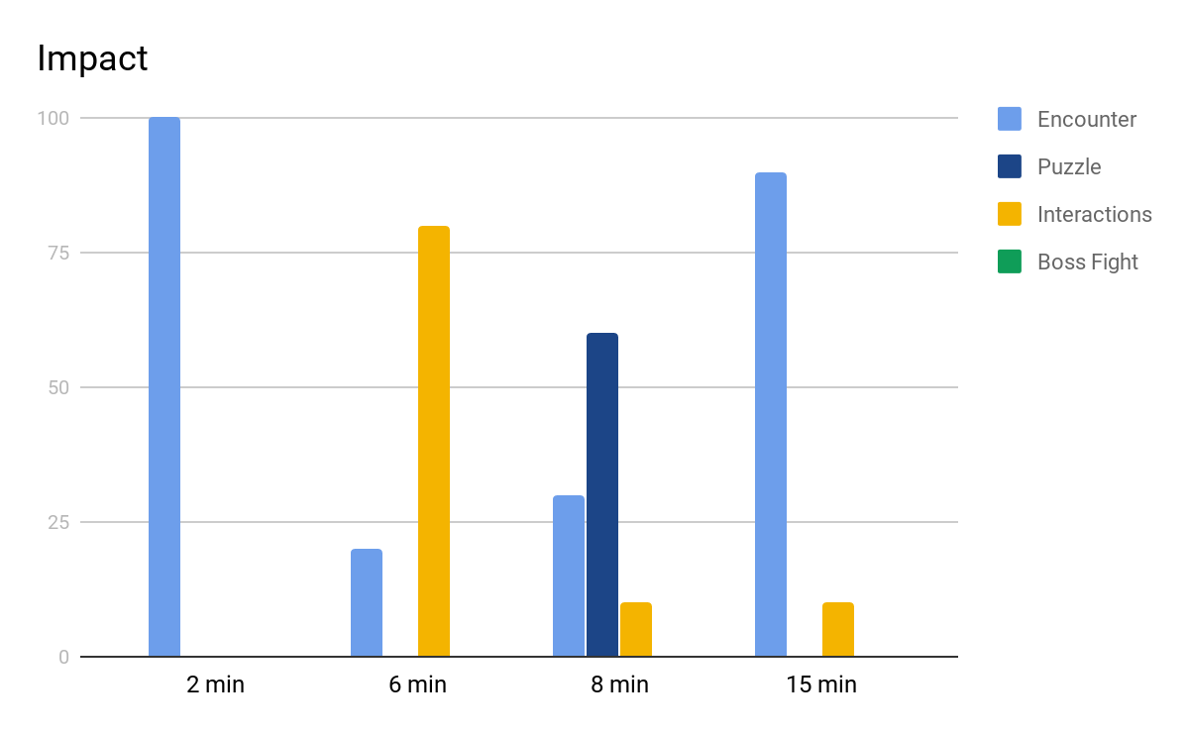

# 

# **Plant of the area**

Notice:

The plants of the outside areas (Surrounding Forest and Garden) are rectangular-shaped.

In the final game they should be shaped in a more natural way. (See Prototype).

These plants have **nothing** in common with the battlefields in combat mode: their dimension and positioning is completely different.

Every square is purely indicative and is about **6 ft**. long; it can contain different elements including obstacles, objects, NPCs and enemies that might not necessarily occupy the whole “square”.

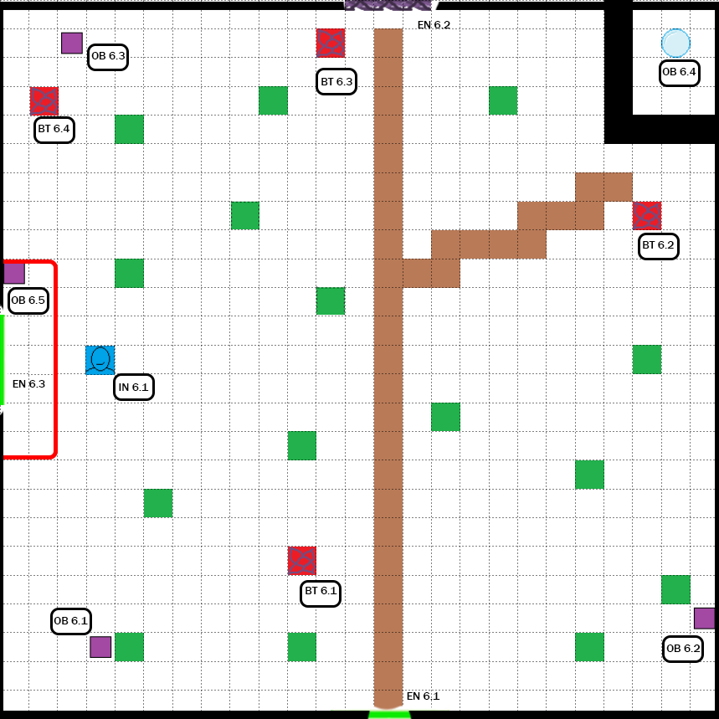

# **Legend**

**OB** : Object / Item / Chest

**BT** : Battle

**IN** : Interaction / NPC Interaction

**EN** : Entrance / New Area

**CUT** : Cutscene

**SoP** : Source of Power

|  |  |  |  |
| --- | --- | --- | --- |
|  | Wall |  | Gorge |
|  | Area  delimitation |  | Mind Flayer’s Roots |
|  | Entrance  (To another area) |  | Tree / Bush |
|  | Not reachable Area (Raised Ground) |  | Minor Enemy |
|  | Main Road |  | NPC (Father) |
|  | Object / Item |  | Skill Point |

# **Objects and Items**

In the area can be found different items:

* **OB 6.1** Healing Root
* **OB 6.2** Rage Root
* **OB 6.3** Meditation Root
* **OB 6.4** Skill Point (***2 Points***)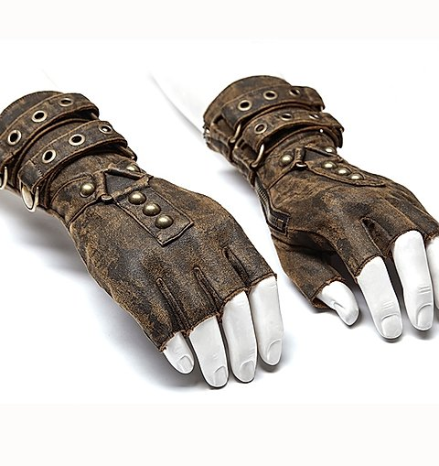
* **OB 6.5 *Armor***: Corruption Gloves

[Effect: Ignore the first 5 damage in each round]

[***Corruption***Full Set: the first Skill Eleven uses in a turn has it’s cooldown reduced by 1].

# Battles / Enemies List

* **BT 6.1:**
  + 1x Demodog
  + 1x Frogorgon
* **BT 6.2:** 
  + 1x Demodog
  + 1x Demodog Alpha
  + 1x Catogorgon
* **BT 6.3:** 
  + 2x Catogorgon
* **BT 6.4:** 
  + 2x Catogorgon
  + 1x Frogorgon

# 

# **Paths and Actions**

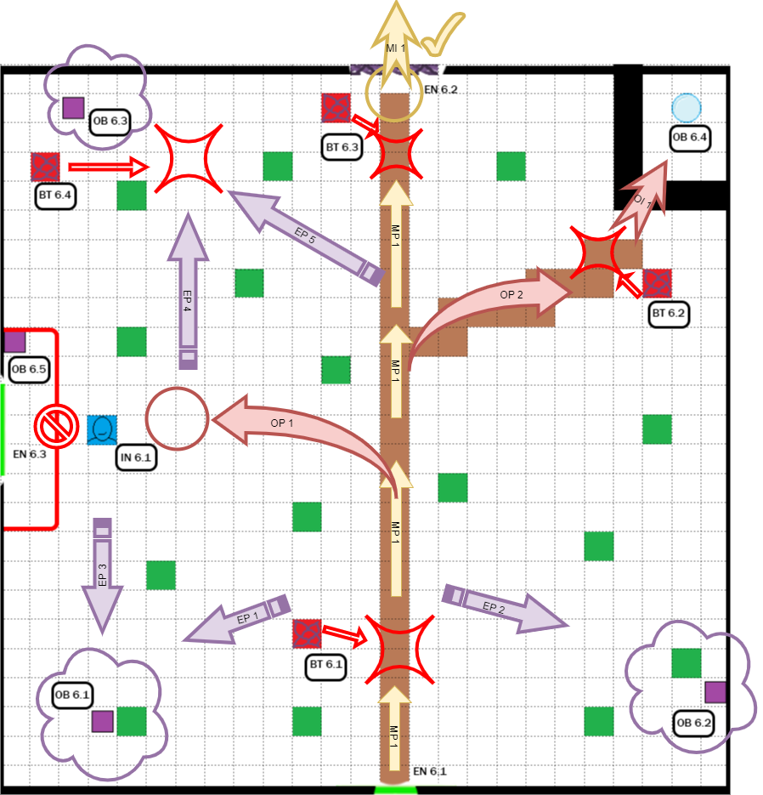

Notice:

Battles are **unique** and enemies do not respawn, if the player has already done a battle he doesn’t have to repeat it when he comes back in the same place.

**Legend:**

**MP** : Main Path

**OP** : Optional Path

**EP** : Exploration Path

**OI**: Optional Interaction

**MI** : Main Interaction

|  |  |  |  |
| --- | --- | --- | --- |
|  | Main Path | | |
|  | Optional path |  | Exploration Path  (Example of exploration  to retrieve some objects) |
|  | Access Denied |  | Passage unlocked |
|  | Main Interaction with Ability |  | Optional interaction with Ability |
|  | Main  Interaction |  | Optional  Interaction |
|  | Exploration Object  (Object that can be retrieved only by exploring) |  | Engage Battle |

# 



Main Path - **MP 1**

The player arrives from the connection area “Street” and accesses the area through the Entrance 6.1 (***EN 6.1***). The first thing he will notice will be the enemies on the left side.

Few steps ahead and they will begin to chase the player. If the player does not run from them, the battle will begin (***BT 6.1***). The Frogorgon should be not a problem but the Demodog can be a quite aggressive enemy, at this point of the game the player should be prepared to face these enemies (in the previous area ”*Street*” there are many loots in order to keep the player ready).

At the end of the battle the player can choose to explore (***EP 1, EP 2,*** then ***OP 1, OP 2,*** then ***EP 4***) or to continue on the main road.

If the player continues to the top of the main road he will soon be engaged by other enemies that were eating from strange bulbs. The player must necessarily defeat them in order to interact with the Entrance (***EN 6.2***).

The battle (***BT 6.3***) should not be a problem: there are only few Catogorgons and at this point of the game the player should be ready to face them.



*Main Interaction 1 -* ***MI 1***

After the battle the player should be able to interact with the Entrance and to use the Ability “***Slash***” (Acquired in Deep Woods) to free the access from the Mind Flayer’s roots.

 The player can now access the other area of the level, ***Will’s Garden.***

Estimated time of Main Path without Exploration and Optional Paths : ~ **6 min.**



Optional Path - **OP 1**

The first Optional Path is the one that leads to the Father interaction (***IN 6.1***). After the ***BT 6.1*** the player can choose to follow the feeble light on this optional path. The ***IN 6.1*** triggers the ***Dialogue*** ***6.1*** (A /B /C, depends on several factors - See Level 6, Story of the level) with the Father.

The access to the shortcut on the left (***EN 6.3***) is denied from this side because is on a raised ground. It is a one-way shortcut, accessible only from the other level, ***Will’s Castle***.

After the dialogue the player can choose to return on the main road (***MP 1***) or to explore the area (***EP 3, EP 4***).

Estimated time : ~ **2 min.**



Optional Path - **OP 2**

The second optional path is the one that leads to an optional area. This area is watched by some enemies (***BT 6.2***). This battle is quite complex: there is one Demodog and a Demodog Alpha, a more aggressive Demodog.



Optional Interaction - ***OI 1***

The enemies are watching over a gorge, protecting a Skill Point (***OB 6.4***). The player can surpass the gorge through the ability “***Dash***” (Optional Interaction, ***OI 1***)that can be acquired in Level 7, Mike’s House.

Estimated time (with battle): ~ **7 min.**



Exploration Paths

***EP 1 , EP 3***:

After the ***BT 6.1*** or the ***IN 6.1*** the player can choose to explore to the south-west side of the map. Here he can find an Healing Root (***OB 6.1***)

***EP 2 :***

After the ***BT 6.1***  the player can explore the south-east side of the map and find

a Rage Root.

***EP 4, EP 5 :***

Before starting ***BT 6.2*** or after taking the ***OP 1***  the player can reach the north-west side of the map. Here he can find an object (***OB 6.3***) and some enemies hiding behind a Bush. If the player tries to get close to the object, the enemies will engage the battle (***BT 6.4***). The player can retrieve the object only after he has defeated them.

Total estimated time of exploration (with battle): ~ **5 min.**

# **Area flow diagram**

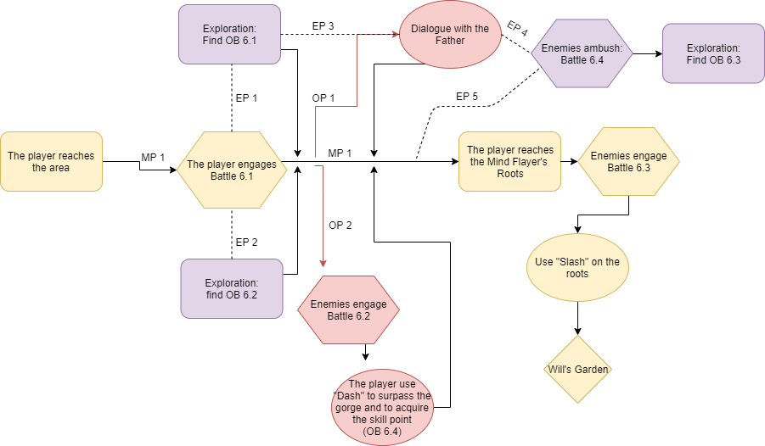

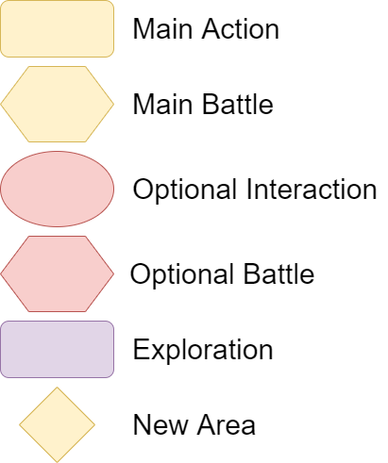

Notice:

Battles are **unique** and enemies do not respawn, if the player has already done a battle he doesn’t have to repeat it when he comes back in the same place.

# 

# **Sounds**

* Ambient sounds:
  + Soft wind blowing in the air;
  + Screeches and wooden noises all around;
* Eleven makes a loud crunchy sound when walkingking on leaves.

Music :

forest_Music.mp3

fightTheme1_Music.mp3

fightTheme2_Music.mp3

# **Color palette and lightning**

## 

A thick blue haze covers the forest, the light is faint and shows small parts of the path. The fog doesn’t allow to see too much far away.

## Area 6.2 - Will’s Garden

# Event Diagram ( Impact - Timeline)

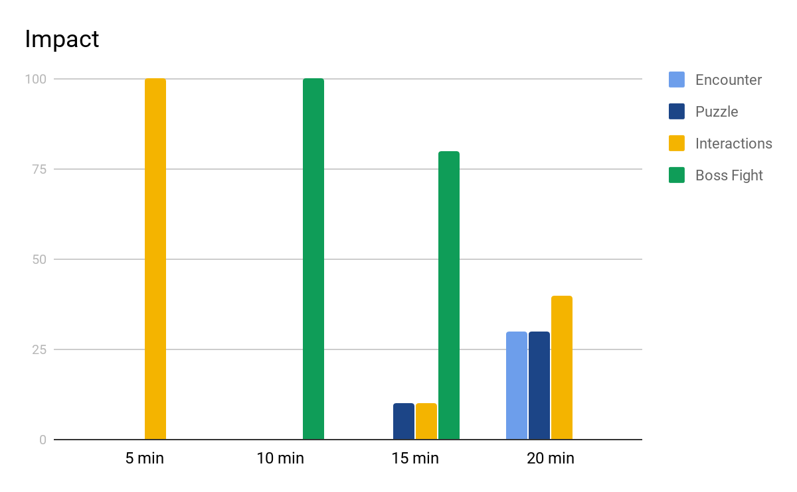

# 

# **Plant of the area**

Notice:

The plants of the outside areas (Surrounding Forest and Garden) are rectangular-shaped.

In the final game they should be shaped in a more natural way. (See Prototype).

These plants have **nothing** in common with the battlefields in combat mode: their dimension and positioning is completely different.

Every square is purely indicative and is about **6 ft**. long; it can contain different elements including obstacles, objects, NPCs and enemies that might not necessarily occupy the whole “square”. In the Shed every square is about **3ft.** long

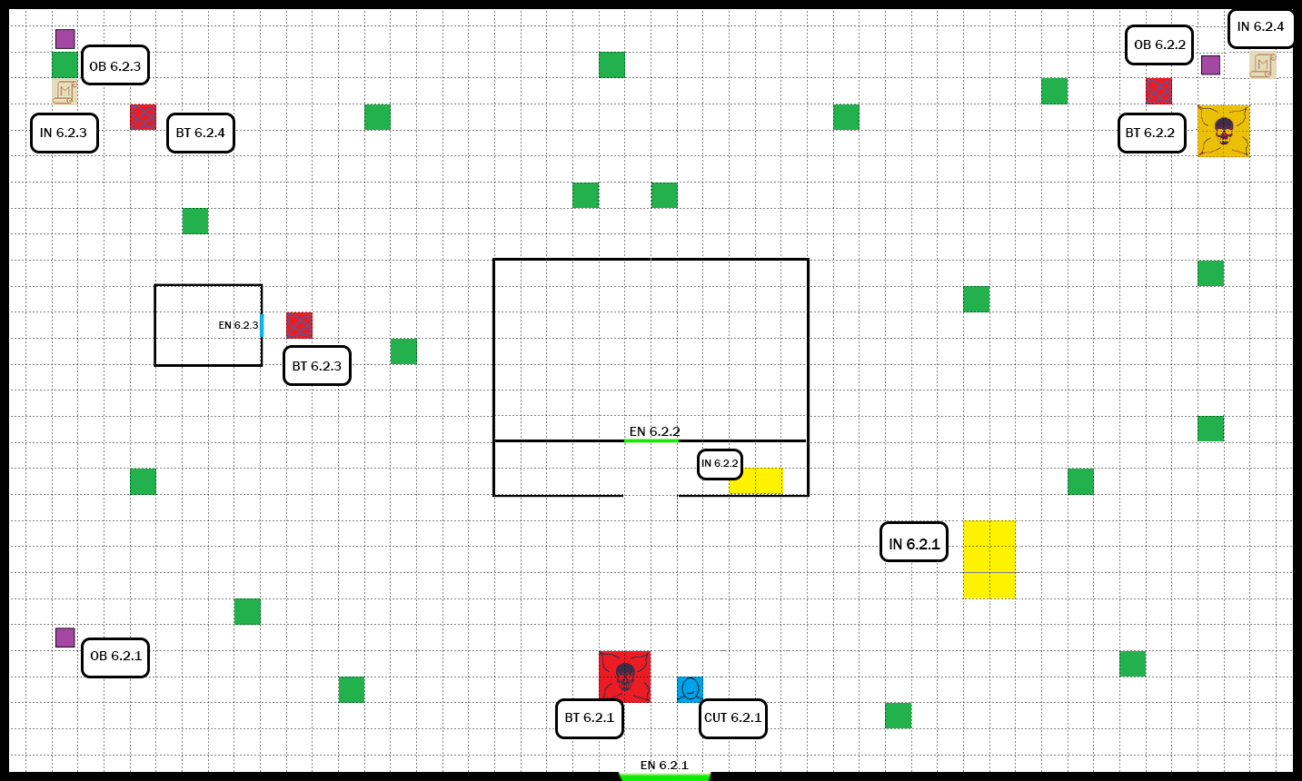

The Shed:

# 

# **Legend**

**OB** : Object / Item / Chest **BT** : Battle

**IN** : Item Interaction / NPC Interaction **EN** : Entrance / New Area

**CUT** : Cutscene **SoP** : Source of Power

|  |  |  |  |
| --- | --- | --- | --- |
|  | Wall | | |
|  | Entrance  (To another area) |  | Area delimitation |
|  | NPC (Father) |  | Tree / Bush |
|  | Object / Item |  | Minor Enemy |
|  | Interagibile Object |  | Bench / Table / Desk / Crate |
|  | Weapon (With Interaction) |  | Major Enemy |
|  | Puzzle Piece |  | Mini Boss |
|  | Locked Chest |  | Locked Entrance |

# **Objects and items**

* **OB 6.2.1** Nimble Root
* **OB 6.2.2** Catnip Demon blood vial
* **OB 6.2.3 Ammo:** Slingshot Ammo
* **IN 6.2.4 Weapon:** Huntsman Rifle

2 Actions: *Ranged Weapon Attack:* DEX to hit, range 60 ft., one target. Hit: 3d8 + DEX piercing damage.

Avg: 13.5+DEX

[Comes with 8 bolts when obtained]

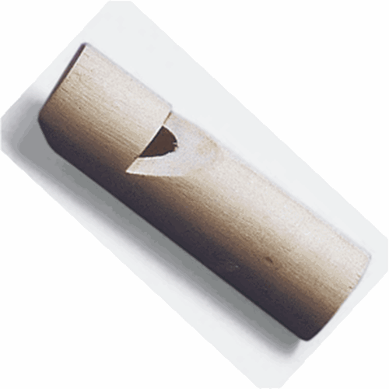

In the Shed

* **OB 6.2.4 Combat Item:**

Demodog Root Whistle

(*Locked Chest* requires at least a

STR mod of +2 to be opened)

Effects in combat of the *Demodog Root Whistle*:

When used the Demodog Root Whistle can stun a nearby **Demodog** and ***Demodog Alpha*** (*WIS ST* 12). Cooldown: 5 turns.

# Battles /Enemies List

* **BT 6.2.1:** 
  + 1x Demodorgon
* **BT 6.2.2:** 
  + 2x Catogorgon
  + 1x Catnip Bulb
  + ?x Catogorgon (summoned by Catnip Bulb)
* **BT 6.2.3:** 
  + 2x Bulb
* **BT 6.2.4:** 
  + 1x Demodog Alpha

In the Shed

* **BT 6.2.5:** 
  + 3x Demomole

# **Paths and Actions**

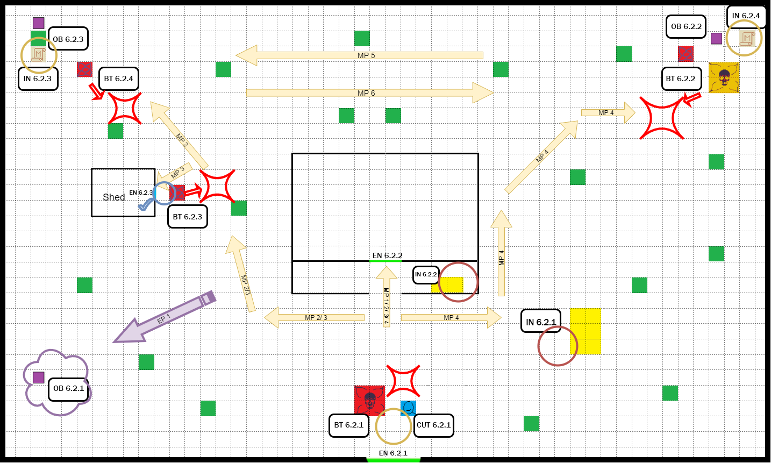

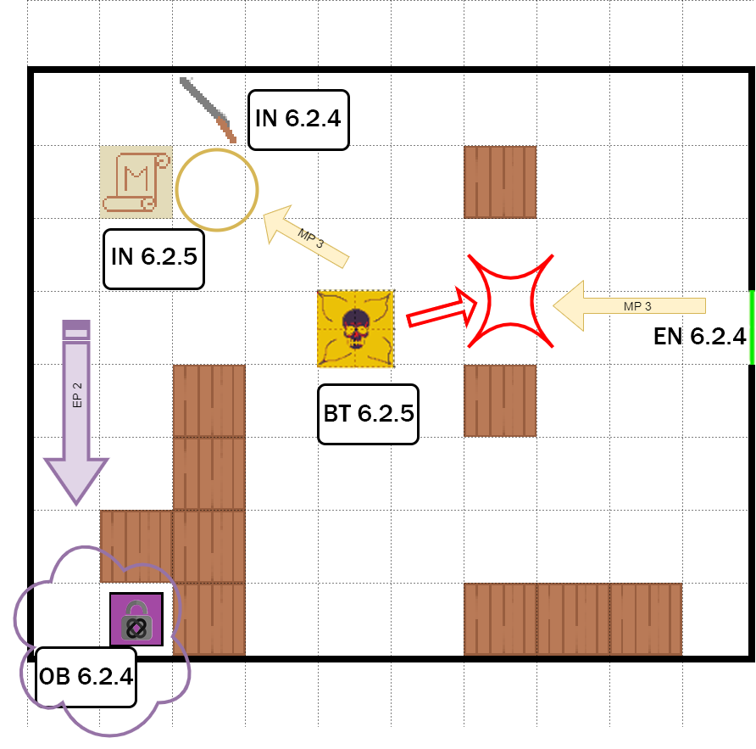

**Legend:**

**MP** : Main Path

**OP** : Optional Path

**EP** : Exploration Path

**OI**: Optional Interaction

**MI** : Main Interaction

|  |  |  |  |
| --- | --- | --- | --- |
|  | Main Path | | |
|  | Optional path |  | Exploration Path  (Example of exploration to retrieve some objects) |
|  | Main  Interaction |  | Optional  Interaction |
|  | Exploration Object  (Object that can be retrieved only by exploring) |  | Engage Battle |
|  | Unlocked Path |  | Object action needed |

# 



Main Paths

The player arrives from the previous area “Surrounding Forest” and immediately the Father appears in front of him (***CUT 6.2.1***).

After the Father’s warnings the player chooses to continue and a Mini Boss appears: the *Demodorgon* (***BT 6.2.1***).

After the battle the player can choose to follow different paths.

**MP 1**

The player can choose to enter directly the House and change area. (***EN 6.2.2***) (See *Will’s House (internals) - Paths*).

There is an Optional Interaction with the *Hammock* near the entrance door (***IN 6.2.2***).

Estimated Time (With interaction) : ~ **1 min**

*The following paths can be done both before or after visiting the House.*

**MP 2 / 3 - EP 1 - EP 2**

The player can choose to explore the east side of the map.



**EP 1**- Exploration

Exploring the South-East side of the map will bring the player to find an object (***OB 6.2.1***).

The player will pass near the Shed and engage a battle against some Bulbs (***BT 6.2.3***), a plant-form type of enemy.

Estimated Time (With Battle and exploration) : ~  **3 min**

***MP 2***

The player can choose to continue and visit the north-east side of the map. Here he can find a Demodog Alpha (***BT 6.2.4***) that is protecting a *letter of the puzzle (****IN 6.2.3****)* and an object (***OB 6.2.3***).

The letter of the puzzle can be picked up also without having entered the house first. The dialogue of the interaction will change according to what the player chose to visit first and how many letters he has retrieved. (**Dialogue 6.3.3 A / B/ C/ D**)

After the player has retrieved the letter and the object (optional), he can return back and continue exploring or enter the House.

Estimated Time (With Battle) : ~ **4 min**

***MP 3***

The player can choose to visit the Shed, it can only opened with the *Shed Keys,* an object that can be found inside the House.

If the player hasn’t got the keys the interaction with the door will change (***Dialogue 6.2.6 -*** *Without keys - If the player has got the keys there will be not any dialogue*).

Inside the Shed is waiting a major enemy, 3 Demomoles (***BT 6.2.5***), that will surprise Eleven with an underground attack.

After the battle the player can interact with a letter of the puzzle (***IN 6.2.5***) and a rifle (***IN 6.2.4***).



***EP 2*** - Exploration

The player can choose to find out what’s behind the tables and benches, he will find a Locked Chest that can be unlocked only if the player has certain abilities or points. (See ***OB 6.2.4*** for details).

The player can now exit from the Shed and return in the Garden.

Estimated Time (With Battle and Exploration) : ~ **7 min**

**MP 4**

On the Main Path 4 the player will explore the West side of the Area.

After an Optional Interaction (***IN 6.2.1***) with the *Byers’ Car*, he will visit the North side of the map and he will engage battle with some enemies. There are some *Catogorgons* eating from a strange big plant that will turn out to be a major enemy, a *Catnip Bulb*. (***BT 6.2.2***).

After the battle, the player can interact with the letter of the puzzle (***IN 6.2.4***) and can retrieve an object (***6.2.2***).

Estimated Time (With Battle and Interaction) : ~ **8 min**

**MP 5 / 6**

These are connection paths, the player can go directly from the North-East area to the North-West one and vice versa passing behind the House.

Estimated Time (With Battle and Interaction) : ~ < **1 min**

# **Area flow diagram**

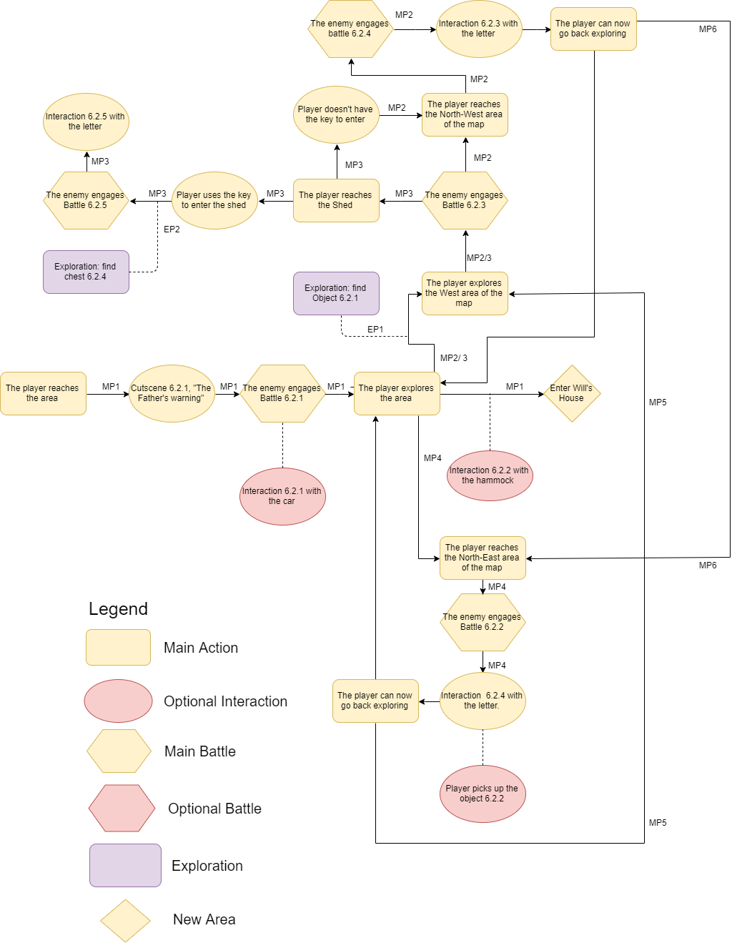

Notice:

Battles are **unique** and enemies do not respawn, if the player has already done a battle he doesn’t have to repeat it when he comes back in the same place.The player can choose what path to follow first and has always the capability to turn back on his steps, every interaction with the objects ends with the player returning to explore.

The paths are purely indicative and could not reflect what the player really will do.

# **Sounds**

* Ambient sounds:
  + Soft wind blowing in the air;
  + Creepy sounds coming from the forest;
* Eleven makes a soft crunchy sound when walking on the grass.
* Short creaky sound when opening the door.
* Eleven makes a creaky sound when walking on the wooden floor of the Shed.
* Sound of the locked chest.
* Sound of the chest opening.
* Object pickup sound.

Music :

willsGarden_Music.mp3

fightTheme1_Music.mp3

fightTheme2_Music.mp3

TheDemodorgon_Music.mp3

# 

# **Color palette and lighting**

The Garden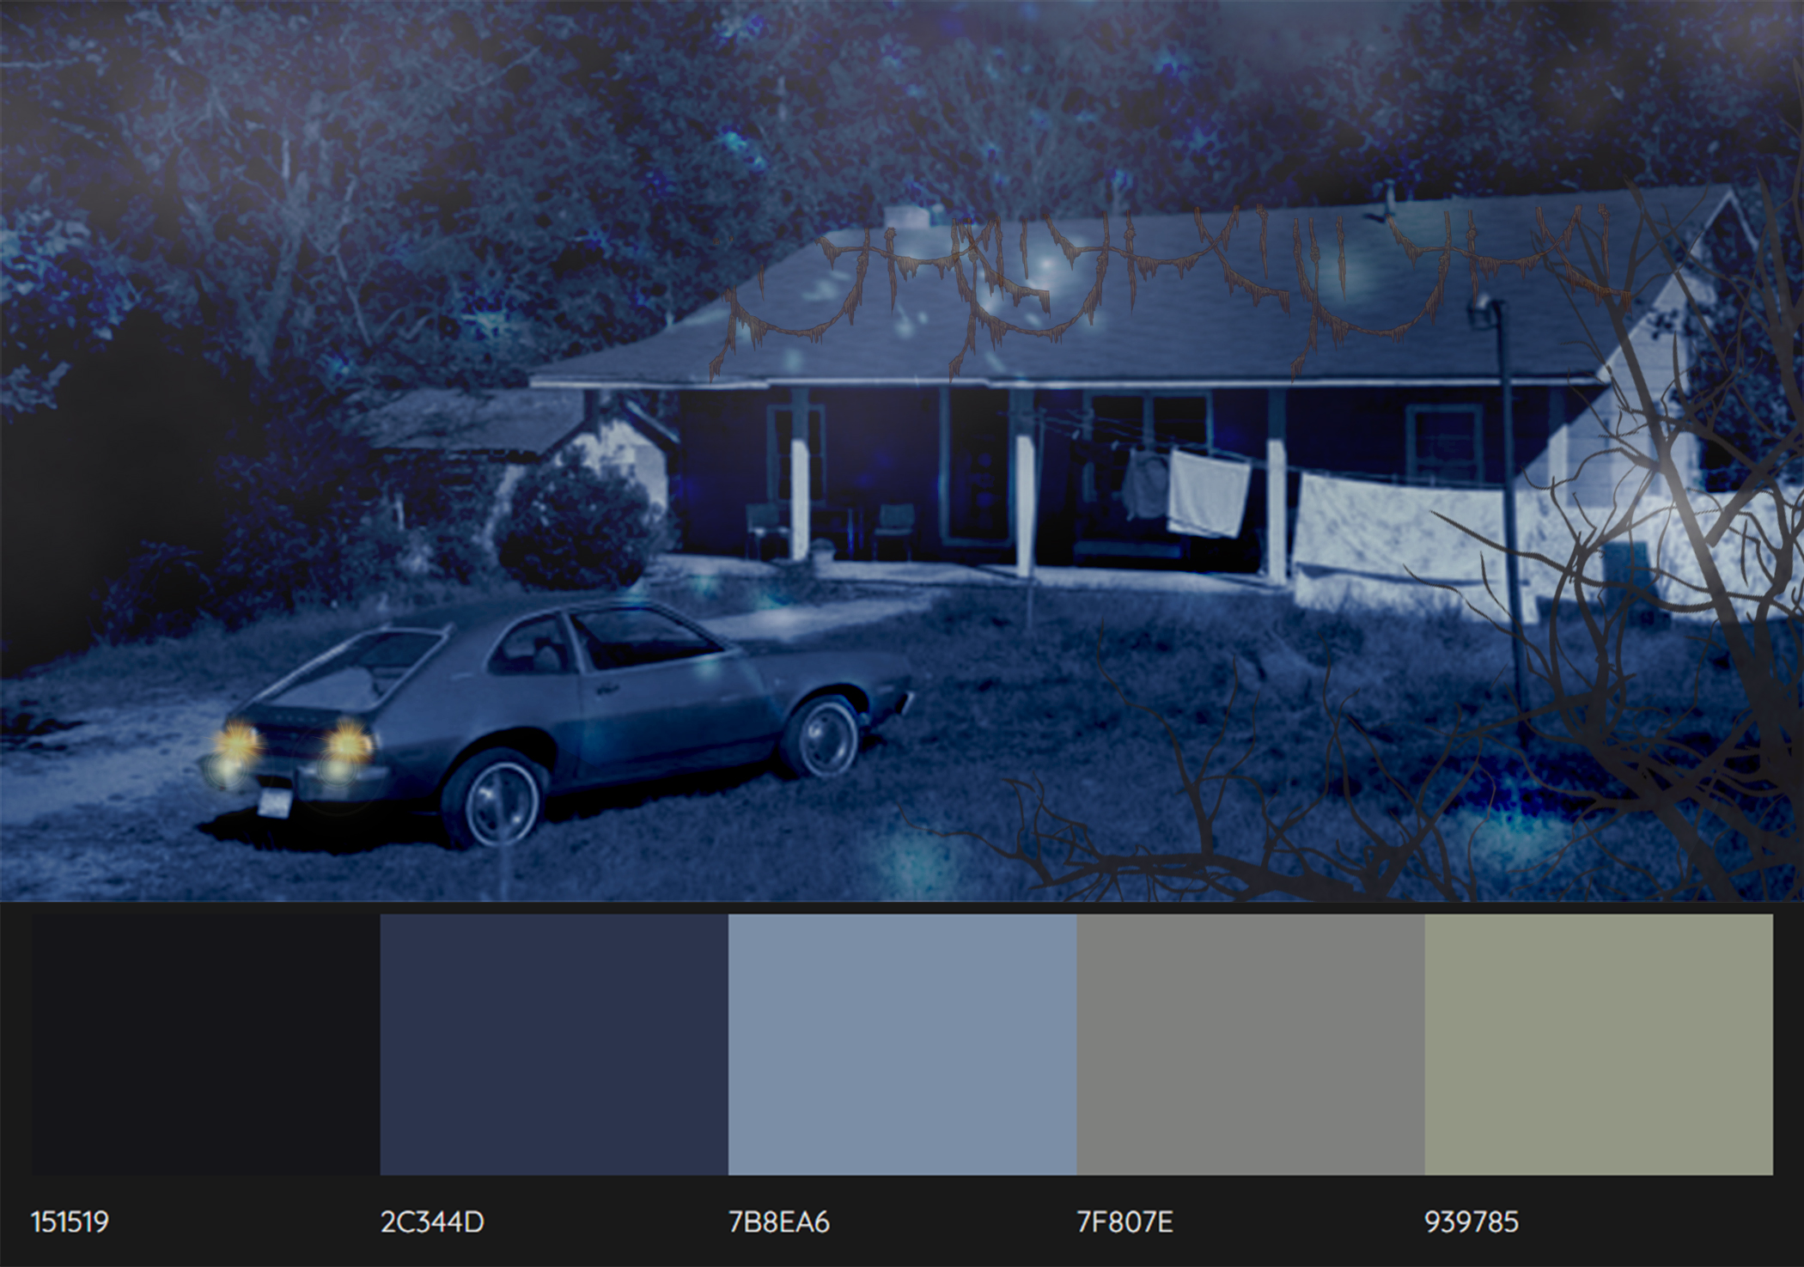

The Shed

## 

## A misty soft blue light illuminates the environment.

## Area 6.3 - Will’s House - Internals

# Event Diagram ( Impact - Time)

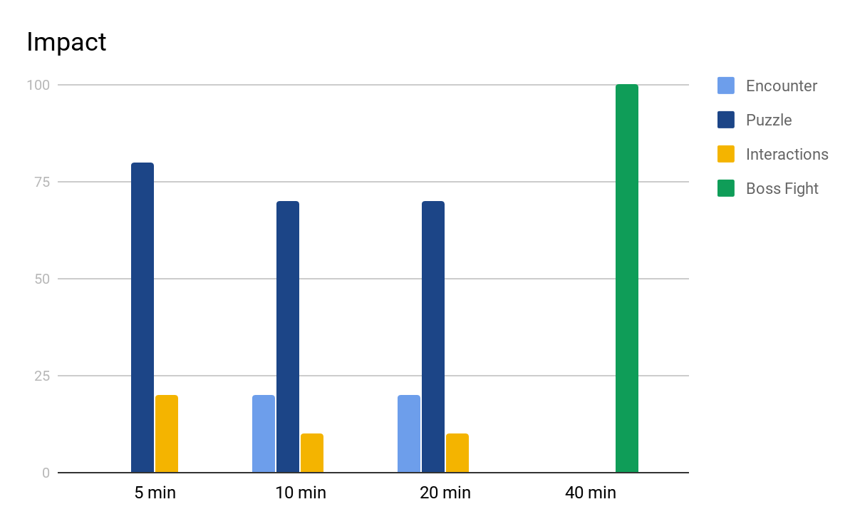

# 

# **Plant of the area**

Notice:

These plants have **nothing** in common with the battlefields in combat mode: their dimension and positioning is completely different.

Every square is purely indicative and is about **3 ft.** long; it can contain different elements including obstacles, objects, NPCs and enemies that might not necessarily occupy the whole “square”.

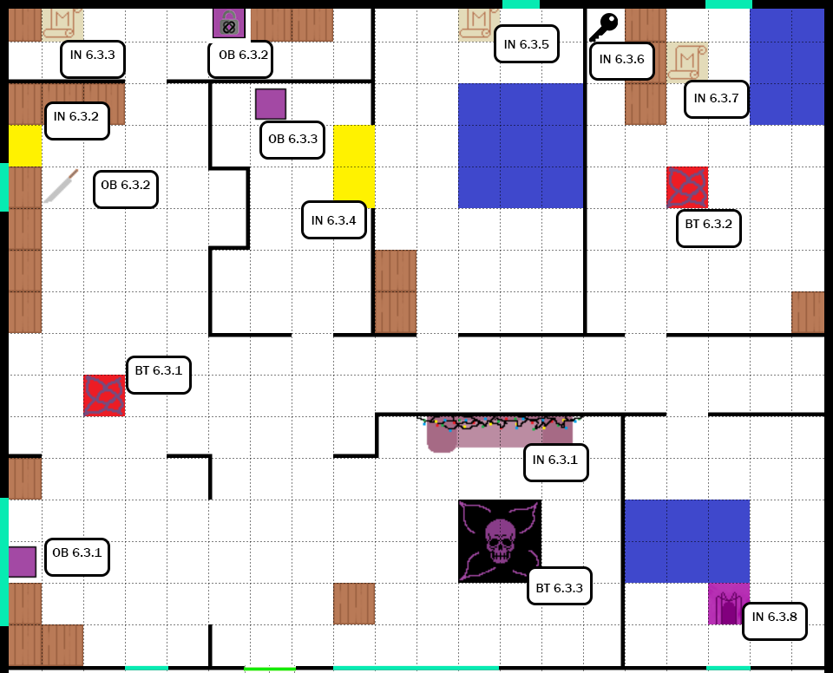

**In order to allow a better exploration, internal areas dimensions are not real and do not respect the real dimensions seen in the external areas**.

# 

# **Legend**

**OB** : Object / Item / Chest **BT** : Battle

**IN** : Item Interaction / NPC Interaction **EN** : Entrance / New Area

**CUT** : Cutscene **SoP** : Source of Power

|  |  |  |  |
| --- | --- | --- | --- |
|  | Wall | | |
|  | Area delimitation | | |
|  | Entrance  (To another area) | | |
|  | Couch and Letter Wall (Puzzle Interaction) |  | Minor Enemy |
|  | Bench / Table / Box |  | Main Boss |
|  | Object / Item |  | Interagibile Object |
|  | **Hidden** Locked Chest |  | Weapon (Interaction) |
|  | Puzzle Piece |  | Window |
|  | Source of Power |  | Bed (Non interagibile object) |

# **A Full plant of the level**

# 

# **Objects and Items**

* **OB 6.3.1** ***Weapon***: Plunger

[Melee Attack: STR to hit, one target. Hit: 1 bludgeoning damage]

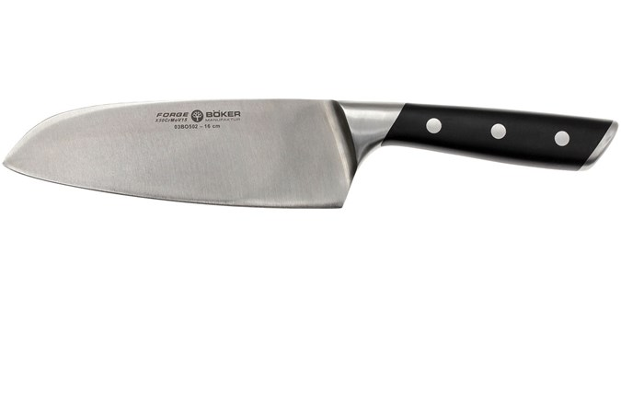

* **OB 6.3.2 *Weapon***: Knife

[Melee Attack: STR/DEX to hit, one target. Hit: 1d4 + STR/DEX piercing damage]

* **OB 6.3.3 Hidden** Locked Chest: First Aid Kit, requires at least a STR mod of +2 (to be opened) and a PER mod of +2 (to be spotted).
* **OB 6.3.4** Healing Root
* **IN 6.3.8** Source of Power : Unlocks the skill ”***Telekinesis***”.

# **Battles / Enemies List**

* **BT 6.3.1:** 
  + 2x Bulb
  + 2x Vine Tentacles
* **BT 6.3.2:** 
  + 3x Frogorgon
  + 7x Slug
* **BT 6.3.3:** 
  + 1x BROOD MOTHER
  + 2x Catogorgon
  + ?x Slug, Summoned by the Brood Mother (during the battle)

# 

# **Paths and Actions**

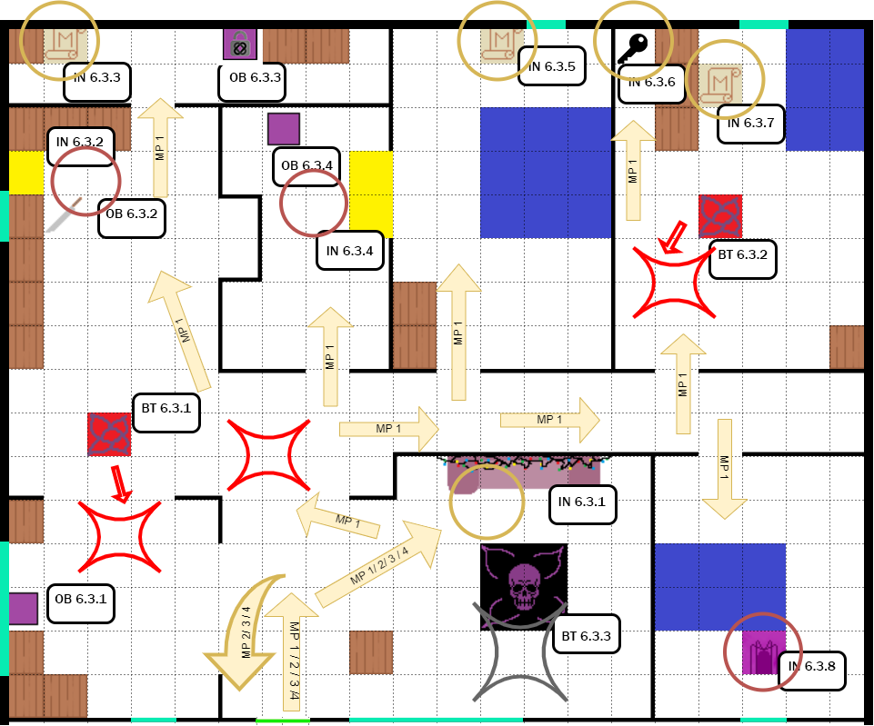

Notice:

Battles are **unique** and enemies do not respawn, if the player has already done a battle he doesn’t have to repeat it when he comes back in the same place.

The Boss (***BT 6.3.3***) will spawn only after the Puzzle is completed.

The player can choose what room to visit first and has always the capability to turn back on his steps, every interaction with the objects ends with the player returning to explore.

The paths are purely indicative and could not reflect what the player really will do.

# 

**Legend:**

**MP** : Main Path

**OP** : Optional Path

**EP** : Exploration Path

**OI**: Optional Interaction

**MI** : Main Interaction

|  |  |  |  |
| --- | --- | --- | --- |
|  | Main Path | | |
|  | Optional path |  | Exploration Path  (Example of exploration to retrieve some objects) |
|  | Main  Interaction |  | Optional  Interaction |
|  | Battle | | |
|  | Boss Battle:  The Boss will spawn only after the puzzle is complete. | | |

# 



Main Paths

The paths inside the House strongly depend on what the player did in the previous area, Will’s Garden.

**MP 1**

The first thing the player would do is to interact with the lighted Letter Wall (***IN 6.3.1***). The interaction will change according to what the player has done in the Garden. (Has the player recovered one or more letters?)

With the second interaction with the Wall, the player can start lighting on the letters to form the word. (See more on Puzzle Description).

After the player has interacted with the wall he will start to search for the missing letters and to explore the House.

By Going into the Kitchen or the room on the left (where object ***OB 6.3.1*** can be found), the player will be engaged by some minor enemies. (***BT 6.3.1***).

After the battle the player can explore the kitchen and optionally interact with some tools on a table (***IN 6.3.2***) where can be found also a knife (***OB 6.3.2***).Behind the kitchen there’s another room: here can be found a letter (***IN 6.3.3***) and a hidden Locked Chest containing a useful FIrst Aid Kit (See ***OB 6.3.3*** for details).

By returning back the player can visit the other rooms:

In the bathroom (Optional) he can interact with the mirror (***IN 6.3.4***) and pick up an object (***OB 6.3.4***) (a Plunger, Eleven can use it as a weapon). In Room 1 (Joyce’s room) the player can retrieve a letter (***IN 6.3.5***). In Room 2 (Jonathan’s room) the player can retrieve a letter (***IN 6.3.7***) and the Shed Keys (***IN 6.3.6***), needed to access the Shed in the Will’s Garden area.

Lastly the player can visit the Room 3 (Will’s room)(Optional): here he can find a Source of Power (***IN 6.3.8***) that unlocks a skill, “***Telekinesis***”. The ability is not required for this level, but can be useful in the others and is strongly recommended.

Estimated Time (With Battles and Optional interactions) : ~ **15 min**

The player has now completed the exploration of the House: having acquired the Shed Keys, he can now access it from the Garden, where also other letters can be found, so he must turn back and exit from the House temporarily. (See Will’s Garden - Main Paths).

After the player has acquired ALL the letters he must return in the living room of the House and complete the puzzle. (See Puzzle description).

Once the puzzle is complete, a cutscene (***CUT 6.2.2***) will start and after that the Main Boss, the *BROOD MOTHER* will spawn.

The Brood Mother is a smaller complete Demogorgon with tentacles, it can summon some minor enemies during the battle. (***BT 6.3.3***)

Bad Eleven should be well prepared thanks to the objects that can be found in the House and outside.

The battle will take more time than the other battles: the Brood Mother will continue summoning minor enemies (*Slugs* and *Pollywogs*) and has the ability to evolve them. (Ex: Pollywog → Frogorgon, See Level Enemies for details)

After the battle and after the dialogue (***Dialogue 6.3.10*** and ***Dialogue 6.3.11 A/ B***),

the player has finished the level and can exit returning to the Will’s Garden first and then to the Surrounding Forest.

Estimated Time (With Battle and Puzzle) : ~ **20 min**

# **Puzzle description**

The first time Eleven interacts with either one of the “Puzzle Pieces” or the “Letter Wall” (***IN 6.3.1***) a new objective starts that requires Eleven to find all the letters, to compose a word and to light the letters on the wall one after the other.

There are six letters to find in total and their position is:

* At the top two corners of Will’s Garden area
  + North-West side <O> (***IN 6.2.3***)
  + North-East side <H> (***IN 6.2.4***)

* In the Byers Shed <R> (***IN 6.2.5***)
* In the room behind the kitchen <M> (***IN 6.3.3***)
* In Room 1 <E> (***IN 6.3.5***)
* In Room 2 <T> (***IN 6.3.7***)

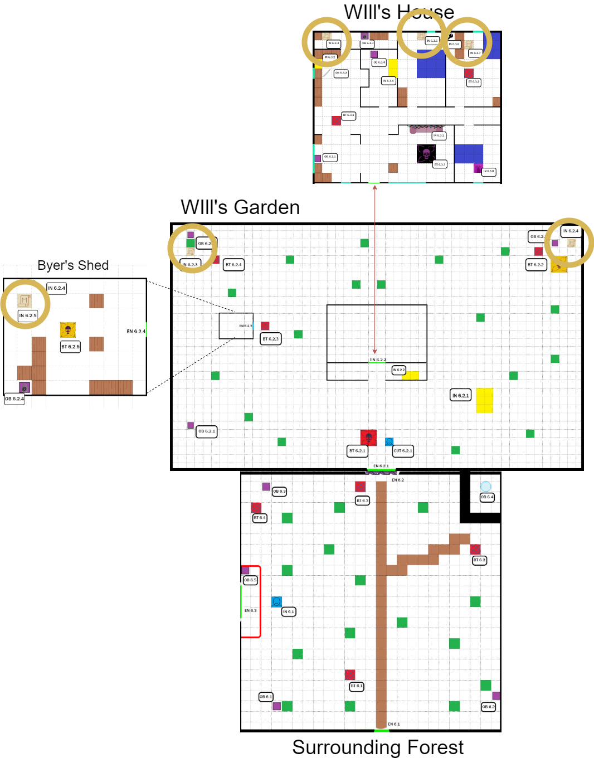

After interacting with the wall at least a second time, the player can select one by one the six letters to compose the word “MOTHER”.

The letters must be selected in order one after the other.

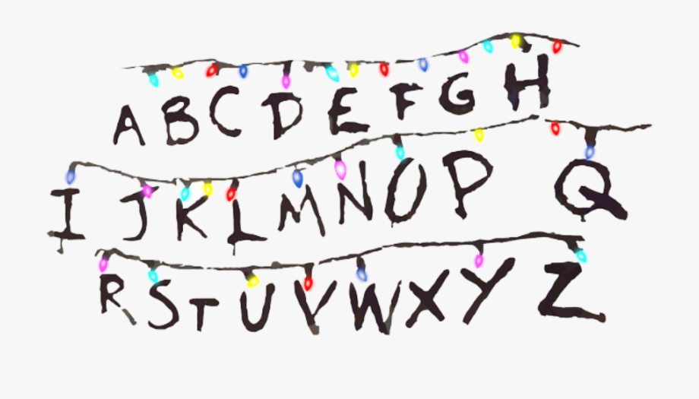

The Letter Wall

If she/he didn’t find all the “Puzzle Piece”s before resolving the puzzle a dialog will pop up:

*“I should find all the clues first, i don’t know what’s going to happen if the word is wrong..”*

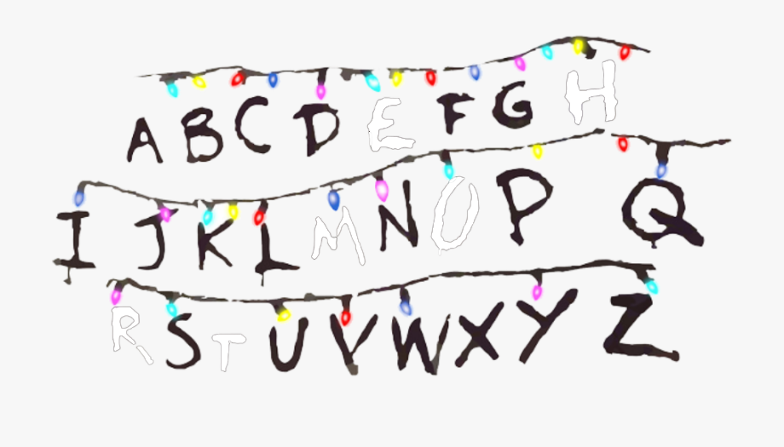

The Letter Wall after lighting up the word “Mother”.

If the player has lighted up the wrong word:

“*This reminds nothing to me, something must be wrong, i should retry..*”

Otherwise if the player has lighted the right word in order on the wall, a dialog (***dialogue 6.3.7*** and ***dialogue 6.3.8***) will pop up:

*“This makes sense i guess...but why “Mother”? I’m getting a strange*

*feeling from that...”*

The puzzle solving will unlock the cutscene (***CUT 6.2.2***) in front of the Letter Wall and the Boss Fight with the *Brood Mother* after it (***BT 6.3.3***).

# 

# **Area flow diagram**

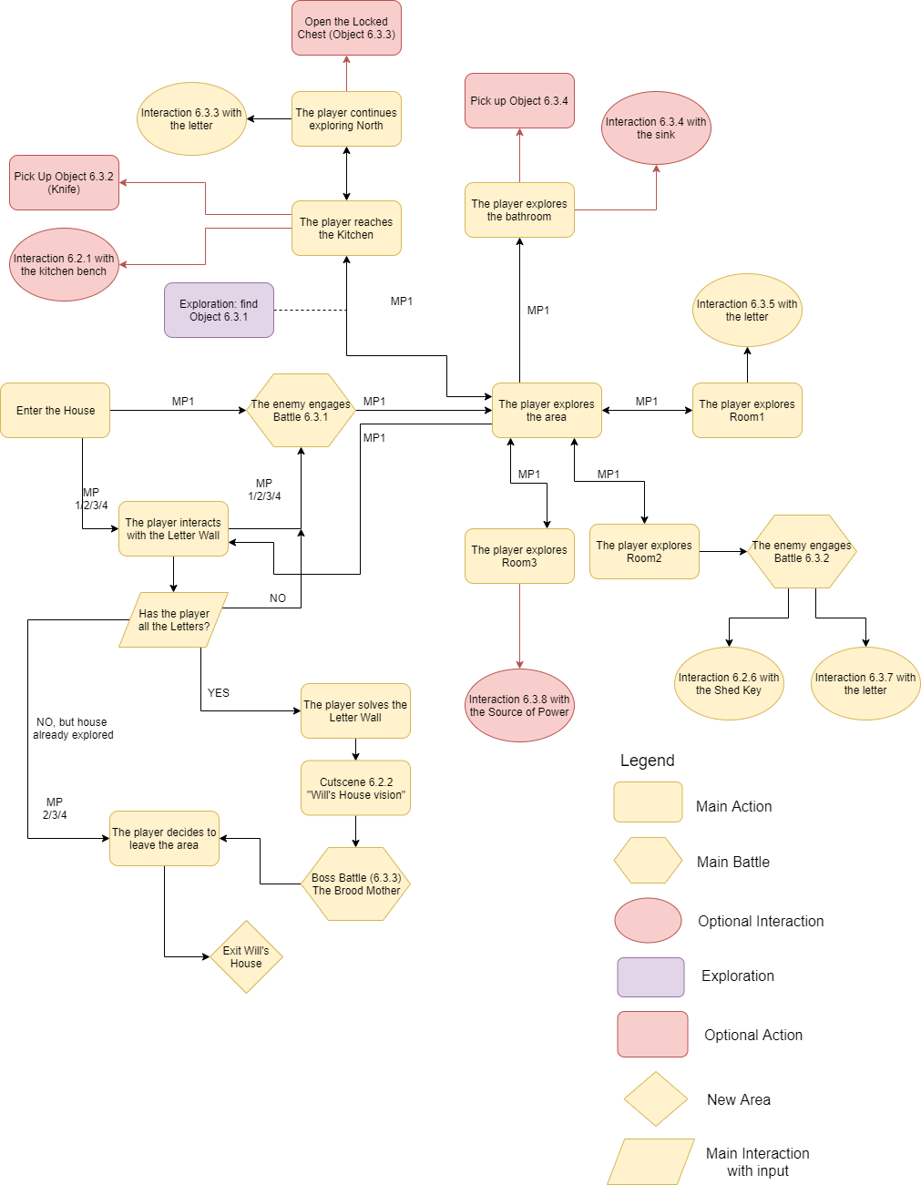

Notice:

Battles are **unique** and enemies do not respawn, if the player has already done a battle he doesn’t have to repeat it when he comes back in the same place.

The Boss (***BT 6.3.3***) will spawn only after the Puzzle is completed.

The player can choose what room to visit first and has always the capability to turn back on his steps, every interaction with the objects ends with the player returning to explore.

The paths are purely indicative and could not reflect what the player really will do.

# **Sounds**

* Ambient sounds:
  + Sometimes, lights will make a buzzing sound due to interferences;
  + Screeches and wooden noises all around;
* Eleven makes a creaky sound when walking on wooden floor.
* A light bell sound when the hidden chest is spotted
* Sound of the locked chest.
* Sound of the chest opening.
* Object pickup sound.
* Source of Power sounds like a dripping fountain, is loud and can be heard from the other rooms also.
* The letters of the puzzle make a buzzing sound when lighted on.

Music :

No background music during exploration, just ambient sounds. In order to give a feeling of concentration and suspense, that something important will be found in the house.

fightTheme1_Music.mp3

fightTheme2_Music.mp3

TheBroodmother_Music.mp3

# **Color palette and lightning**

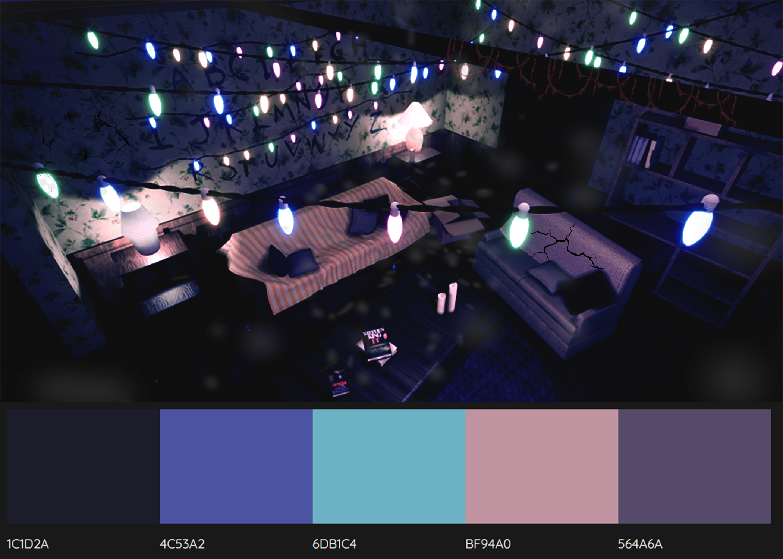

The house has a soft orange lighting, made by the few buzzing lamps. Colored lights over the couch make that room the brightest. Very weak blue light enters through the windows.

## Level 6 - Enemies details

## Level enemies chart

|  |  |  |  |
| --- | --- | --- | --- |
| **Enemy** | **Area 6.1**  **Surrounding Forest** | **Area 6.2**  **Will’s Garden,**  **Byers Shed** | **Area 6.3**  **Will’s House**  **(Internals)** |
| Slug |  |  | **X** |
| Pollywog |  |  | **X** |
| Frogorgon | **X** |  | **X** |
| Catogorgon | **X** | **X** | **X** |
| Demodog | **X** |  | **X** |
| Demodog  Alpha | **X** | **X** |  |
| Demodorgon |  | **X** |  |
| Bulb |  | **X** | **X** |
| Catnip Bulb |  | **X** |  |
| Vine Tentacles |  |  | **X** |
| Demomole |  | **X** |  |
| BROOD  MOTHER |  |  | **X** |
| Strange Cocoon |  |  | **X** |

About enemies stats and state diagrams that you can find below:

**Charisma (CHA)** (classic D&D) **== Darkness (DAR)** (our game).

As the game hasn’t any Experience Points, **XP** equals to the **Organic Materials (OA)** the enemy will drop.

**Corruption Points** of the enemiesare listed for every major battle (See Level Battles). **Battle Mode** will start when the enemy hits Eleven with an attack, ranged or melee, or reaches her.

The **Challenge** mentioned in the stats is not implemented in the game.

Slug

A Slug is a Demogorgon in its larval state. They are roughly the same shape as a normal garden slug but they’re bigger and different in coloring. Slugs are generally dark green with bright yellow spots. This little monster is a parasite that inhabits the bodies of its victims, when it reaches the target it tries to stick mainly to the face in order to get inside. It doesn’t deal much damage, but it’s quite obnoxious. The ones who live in the Upside Down are much bigger than the real world ones. (they can reach 30 cm).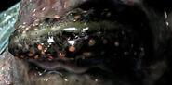

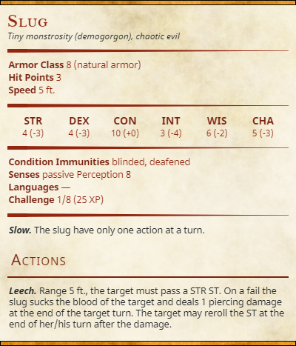

## State Diagram: Slug

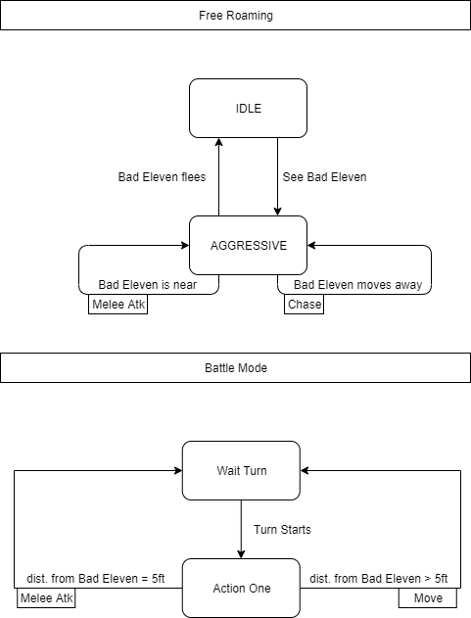

**Turns Predictions: Slug**

**How many turns does the enemy takes to kill Eleven with an AVG damage?**

Eleven’sBaseHp/ ((EnemyAvgDamage * numOfActions) x P[Hit Eleven]) =

30/((1)*(10/20)) = 60Turns

## Pollywog

A Pollywog it’s a Demogorgon in the second stage of its life cycle. It’s like a small amphibian with a translucent skin colored in yellow-green. They possess a pair of forelimbs with small claw-like hands, a mouth, and a lizard-like tail. At this stage they’re not very intelligent creatures, but quite aggressive. Like Slugs, the ones who live in the Upside Down are much bigger than the real world ones (they can grow up to 50 cm long ).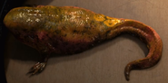

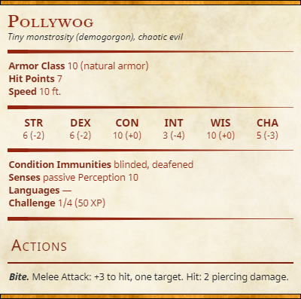

## State Diagram: Pollywog

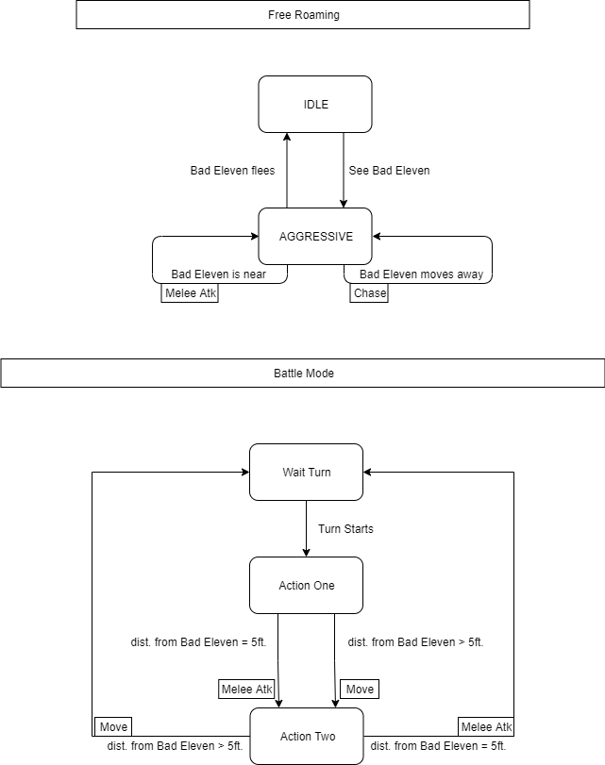

**Turns Predictions: Pollywog**

**How many turns does the enemy takes to kill Eleven with an AVG damage?**

Eleven’sBaseHp/ ((EnemyAvgDamage * numOfActions) x P[Hit Eleven]) =

30/((2.5*2)*(12/20)) = 10 Turns

## Frogorgon

This third stage is signaled by the Pollywog's skin taking on a dark green color, as well as an increase in body mass. The pollywog will then sprout a pair of hind legs, becoming quadrupedal. Small, sharp teeth begin growing in the creature's mouth. The Pollywog has now acquired the ability to jump and it’s generally more agile than its previous stages. It’s size is similar to a real world’s cat.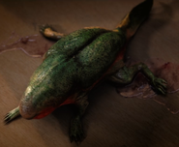

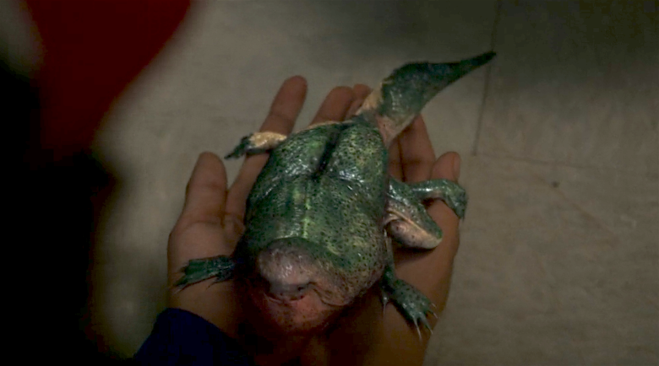

A Frogorgon in the real world,

Upside Down’s ones are much bigger.

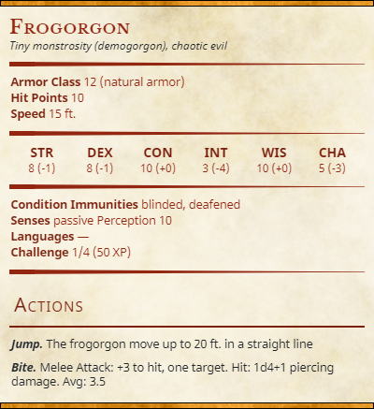

## 

## State Diagram: Frogorgon

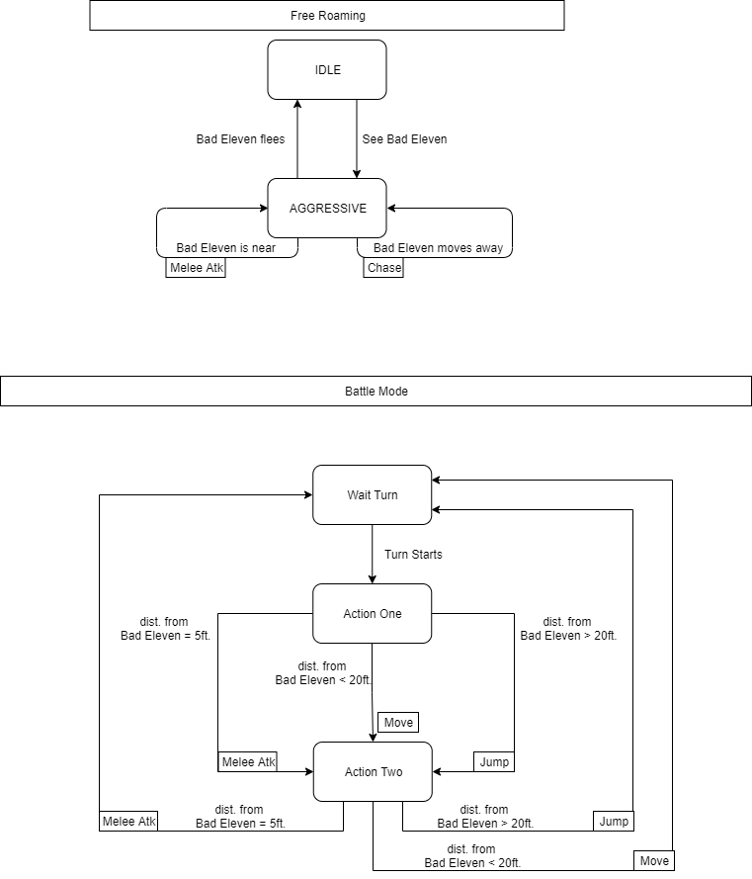

**Turns Predictions: Frogorgon**

**How many turns does the enemy takes to kill Eleven with an AVG damage?**

Eleven’sBaseHp/ ((EnemyAvgDamage * numOfActions) x P[Hit Eleven]) =

30/((3.5*2)*(12/20)) = 7.14 Turns

Catogorgon

At this point the monster has grown quite larger than a standard cat, more likely as much as a dog. It is in this stage that the Demogorgon develops the signature “petal mouth” that the species is best known for. In addition, the Catogorgon becomes carnivorous. Its skin takes on a darker color.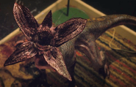

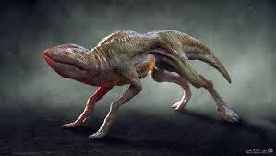

A Catogorgon with his mouth closed[5]

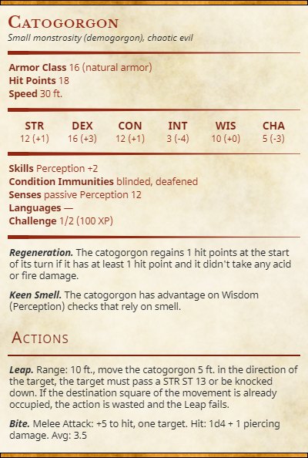

## 

## State Diagram: Catogorgon

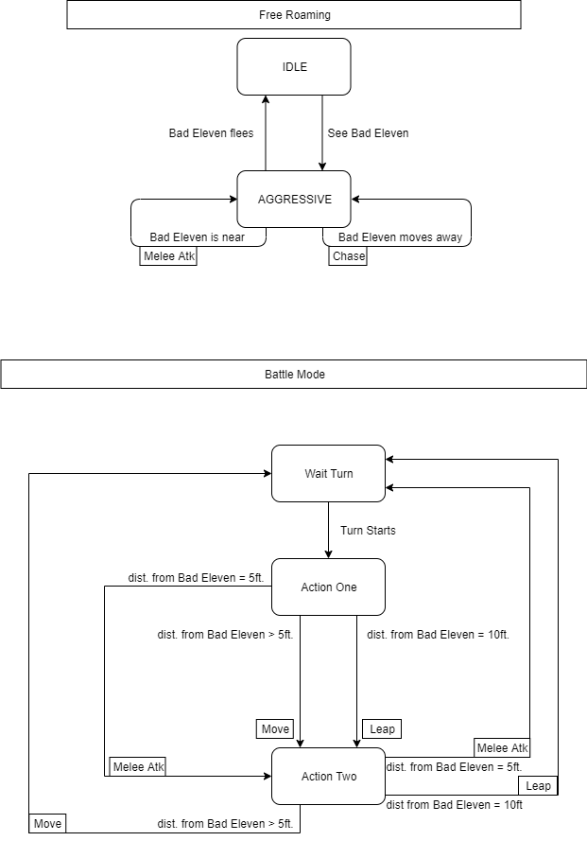

**Turns Predictions: Catogorgon**

**How many turns does the enemy takes to kill Eleven with an AVG damage?**

Eleven’sBaseHp/ ((EnemyAvgDamage * numOfActions) x P[Hit Eleven]) =

30/((3.5*2)*(14/20)) = 6.12 Turns

## Demodog (Alpha)

It’s the penultimate stage of the Demogorgon’s life cycle, the Demodog is a much larger version of their previous form. Now roughly the size of a very large dog, the Demodog is strong enough to tackle a grown human. They are proficient in digging tunnels and are able to climb steep precipices. While a Demodog is not invulnerable to gunfire, its skin is thick enough to resist several gunshots. He can be found also in an ***Alpha*** form. An Alpha form is a special form of the monster with higher stats, much more resistance and with unique abilities. The Alpha dog is usually whiter and paler than the standard one, making it easier to recognize.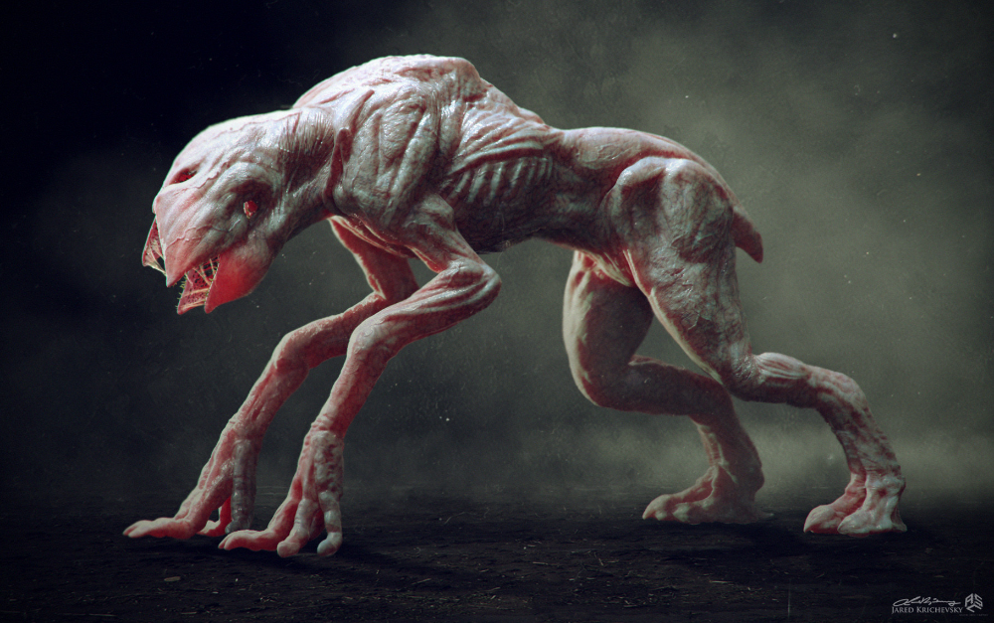

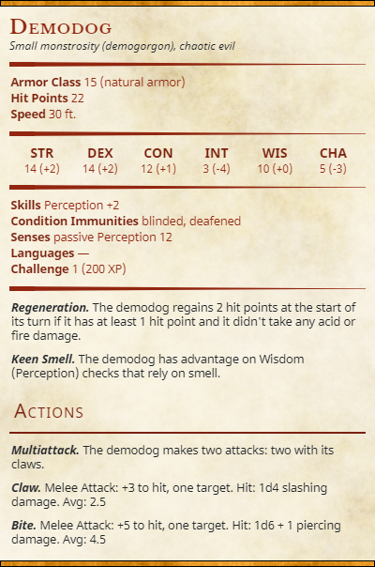

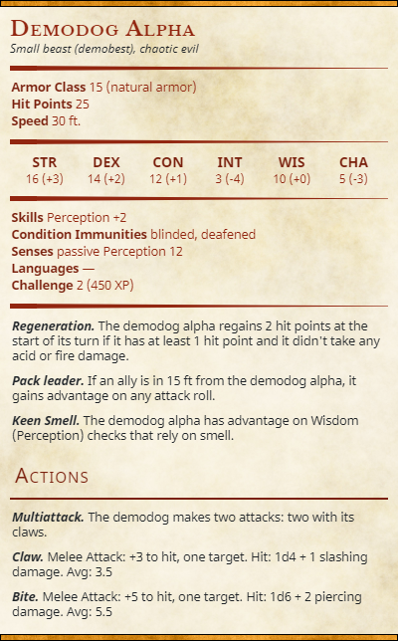

## State Diagram: Demodog (Alpha)

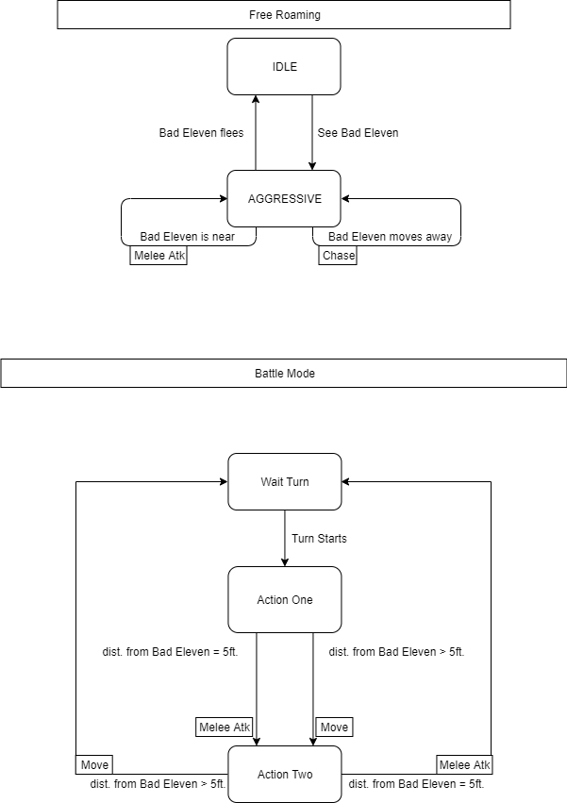

**Turns Predictions: Demodog, Demodog Alpha**

**How many turns does the enemy takes to kill Eleven with an AVG damage?**

Eleven’sBaseHp/ ((EnemyAvgDamage * numOfActions) x P[Hit Eleven]) =

Demodog: 30/((4.5*2)*(14/20)) = 4.76 Turns

Demodog Alpha: 30/((5.5*2)*(14/20)) = 3.89 Turns

**Demodorgon [Mini Boss]**

It’s an evolution halfway between a Demodog and a Demogorgon. It is way stronger and bigger than its previous form. Its big limbs allow it to inflict a huge amount of damage, and make it a frightening threat not easy to defeat.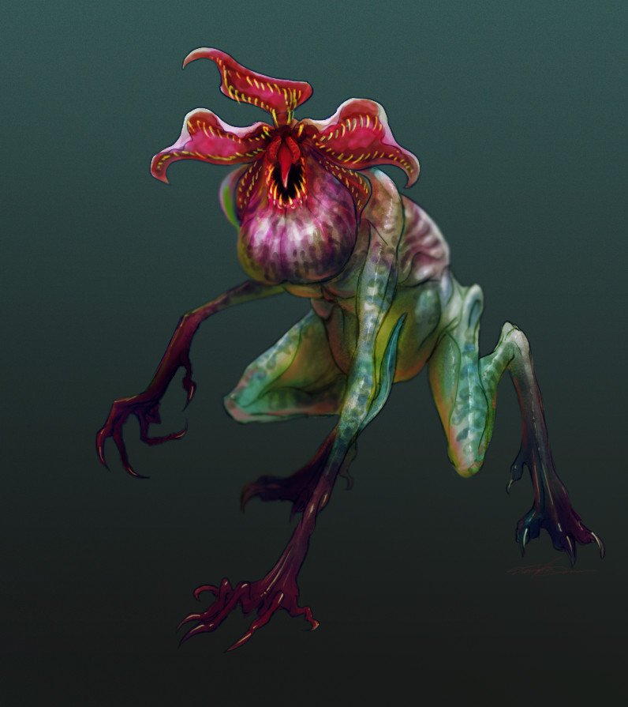

His aspect resembles the Demogorgon (for the size) but it’s still a quadrupede and has some green colouring on its skin and swellings on all the body, signs of the mutation that’s happening.



A mouth-opened Demodorgon with swellings all over its body.[6]

A mouth-closed Demodorgon

exiting from a Rift in a wall.[7]

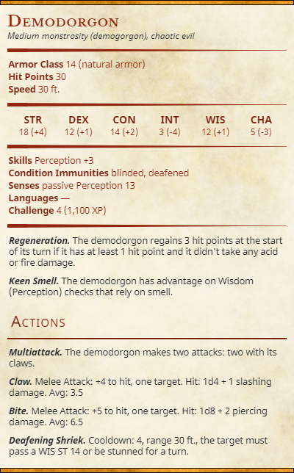

## State Diagram: Demodorgon

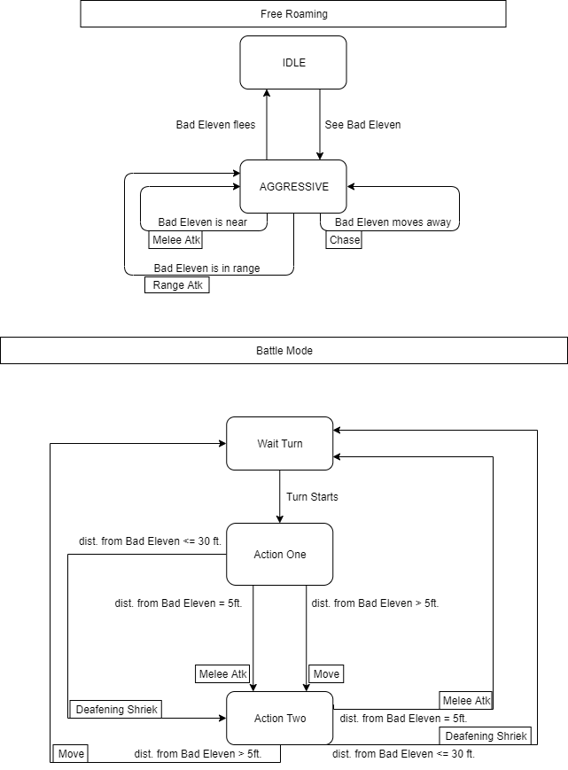

**Turns Predictions: Demodorgon**

**How many turns does the enemy takes to kill Eleven with an AVG damage?**

Eleven’sBaseHp/ ((EnemyAvgDamage * numOfActions) x P[Hit Eleven]) =

30/((6.5*2)*(14/20)) = 3.29 Turns

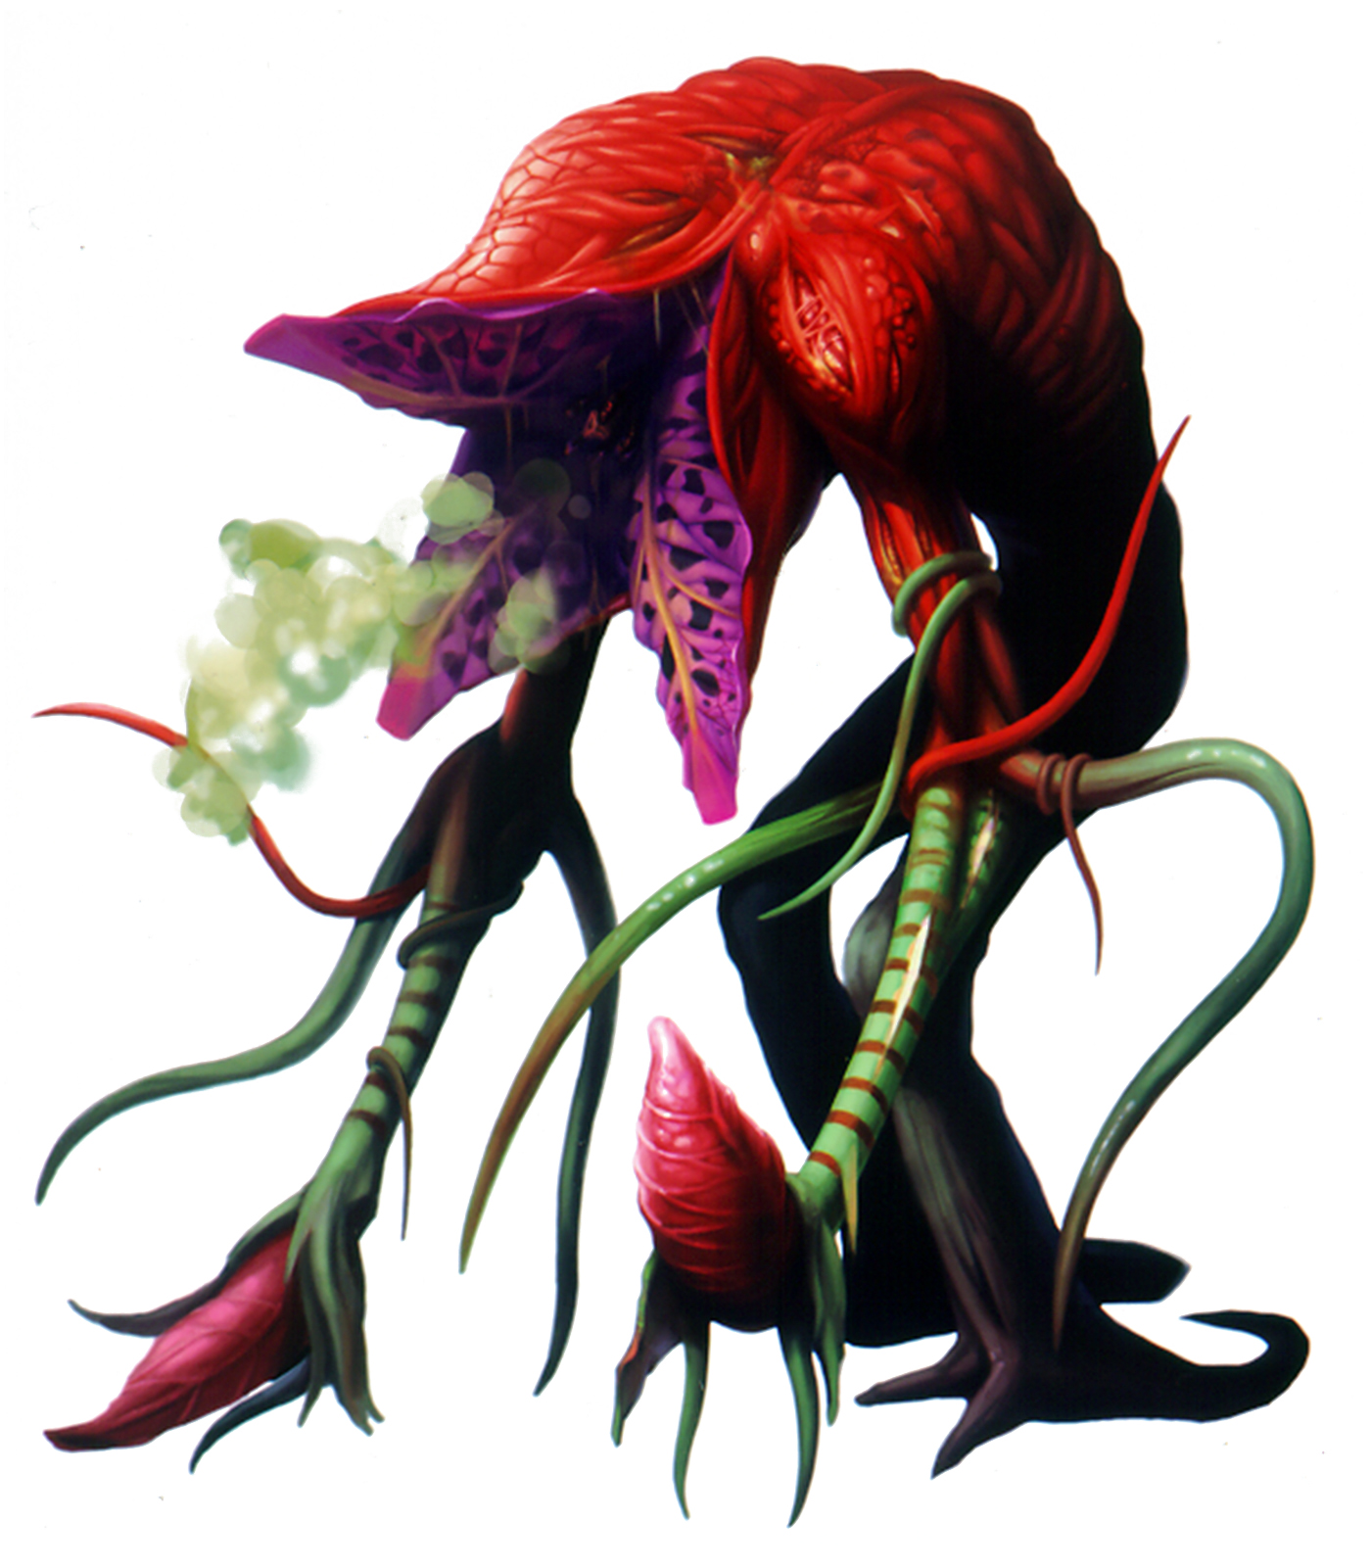

Bulb[8]

It is a bulb attached to some roots of the Mind Flayer. It can’t move, so it can only attack from distance with its poison cloud. It is often protected by vine tentacles or other types of rooted enemies.

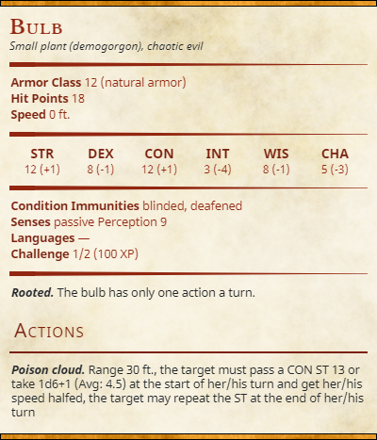

## State Diagram: Bulb

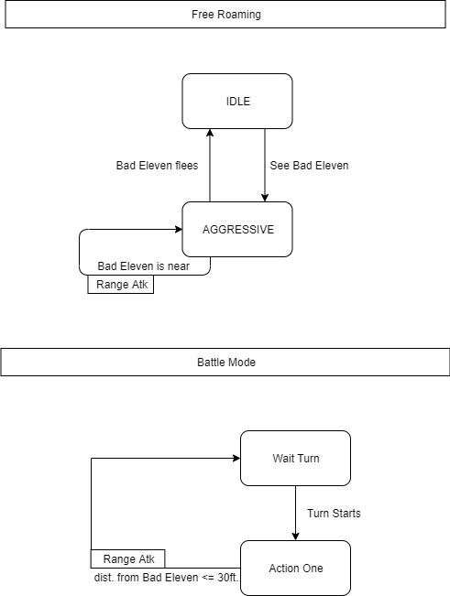

**Turns Predictions: Bulb**

**How many turns does the enemy takes to kill Eleven with an AVG damage?**

Eleven’sBaseHp/ ((EnemyAvgDamage * numOfActions) x P[Hit Eleven]) =

30/((4.5)*(12/20)^2[9]) = 18.51 Turns

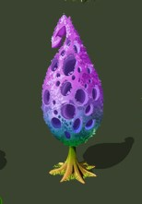

Strange Cocoon[10]

It is a cocoon containing a Brood Mother in a vegetative state. It has a high regeneration capacity but it can’t move nor attack, that makes it an easy target.

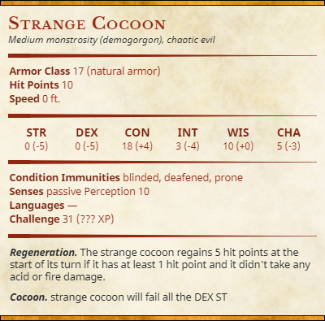

## State Diagram: Strange Cocoon

The Strange Cocoon doesn’t make any actions, at the beginning of its turn he will **regenerate himself** only. His only scope is to provide a new spawn point for the Brood Mother when she dies.

**Catnip Bulb [Major Enemy][11]**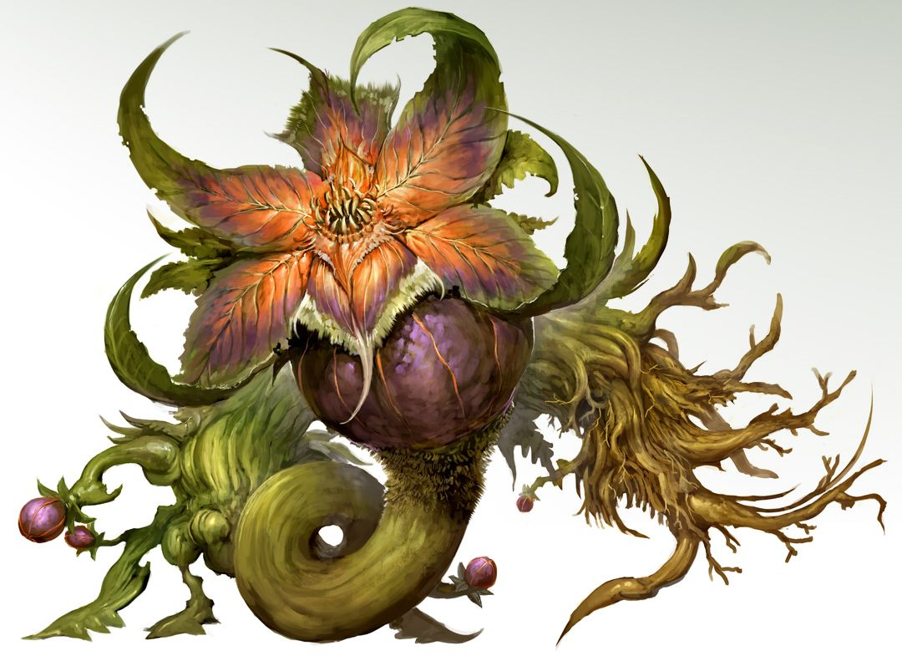

It is a rooted enemy, he can’t move. It is in fact a larger Bulb that shares an affinity with other enemies, especially Catogorgons. It has the ability to attract them thanks to its spores, in order to protect it.

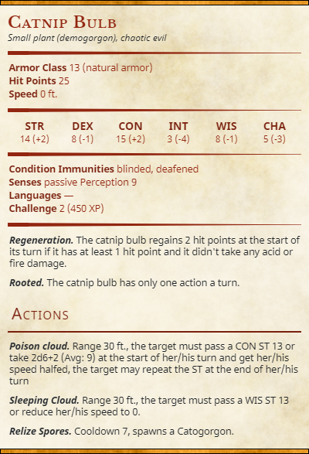

## State Diagram: Catnip Bulb

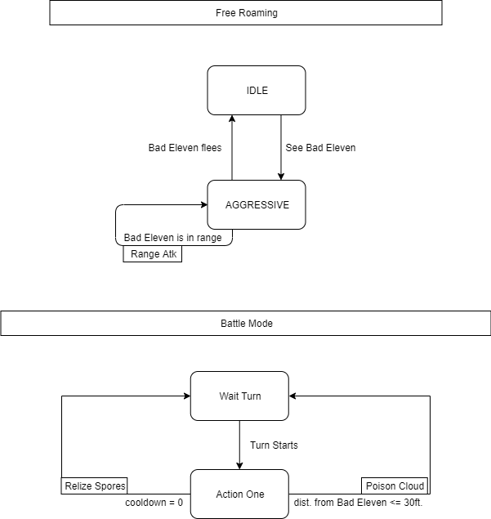

**Turns Predictions: Catnip Bulb**

**How many turns does the enemy takes to kill Eleven with an AVG damage?**

Eleven’sBaseHp/ ((EnemyAvgDamage * numOfActions) x P[Hit Eleven]) =

30/((9)*(12/20)^2[12]) = 9.25 Turns

Vine Tentacles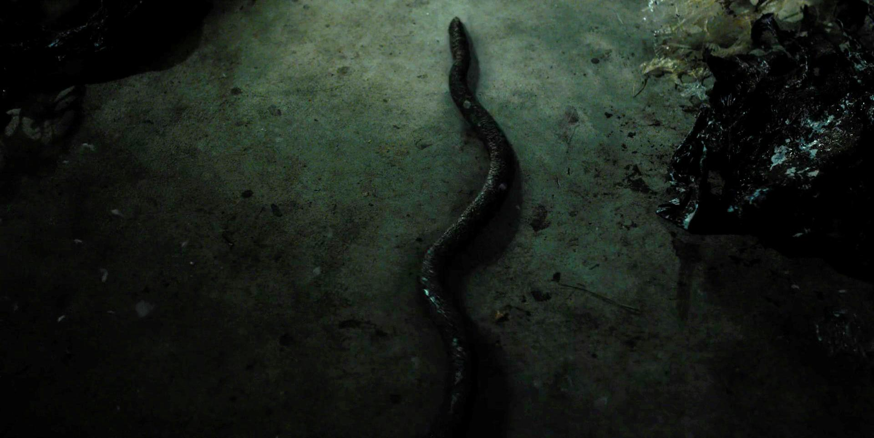

They are tentacles attached to the Mind Flayer’s roots, they often protect Bulbs or other types of enemies. They can’t move and they are stuck to the ground. They block enemies with fast attacks and can stretch at will.

[13]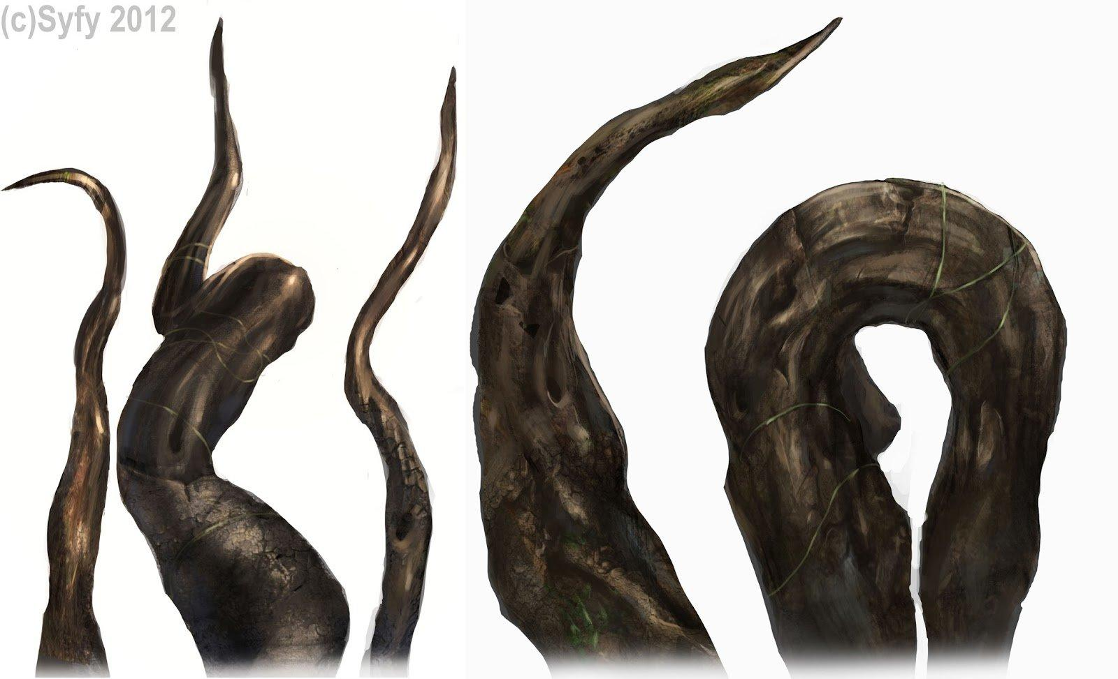

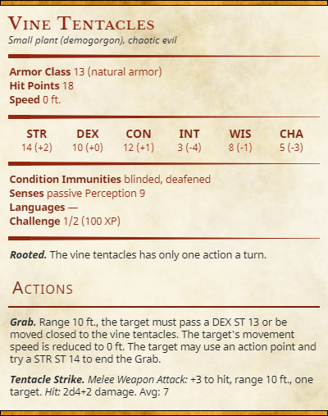

## State Diagram: Vine Tentacles

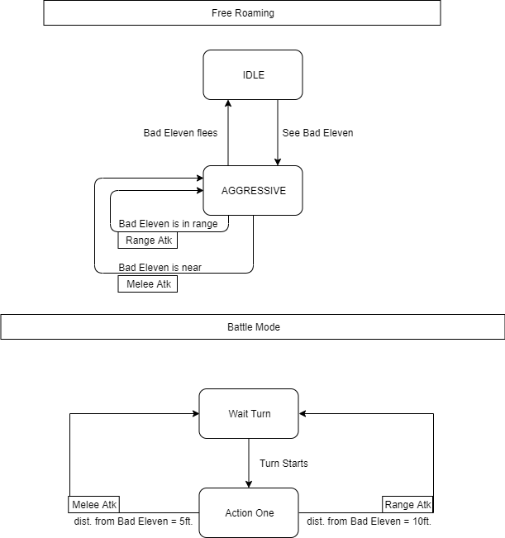

**Turns Predictions: Vine Tentacles**

**How many turns does the enemy takes to kill Eleven with an AVG damage?**

Eleven’sBaseHp/ ((EnemyAvgDamage * numOfActions) x P[Hit Eleven]) =

30/((7)*(12/20)) = 7.14 Turns

**Demomole [Major enemy][14]**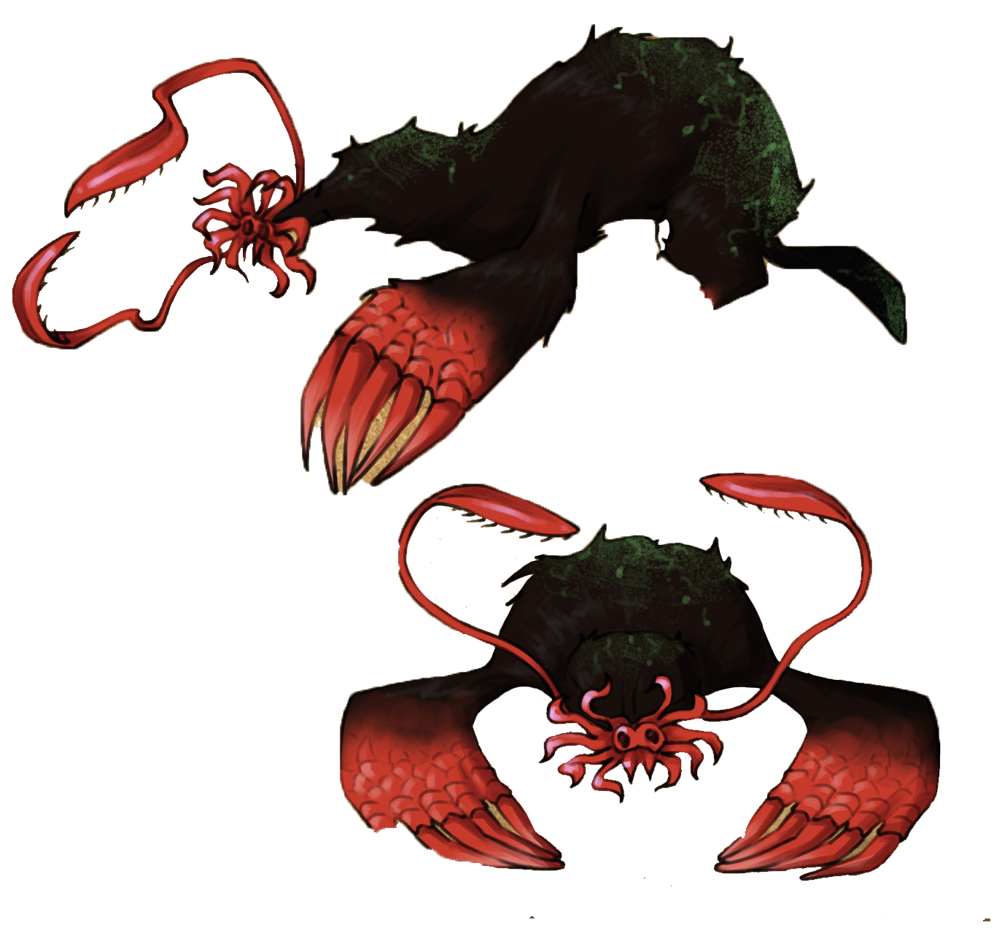

Those strange Demodogs have claws and paws that allow them to dig underground and move freely. They emerge and surprise their enemies damaging them, this makes them unpredictable. They often move in groups forcing their enemies to back off.

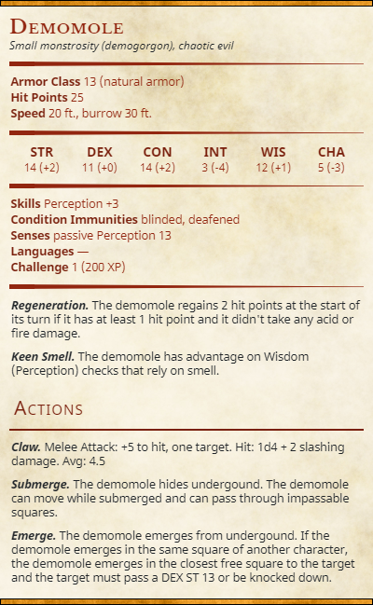

**State Diagram: Demomole**

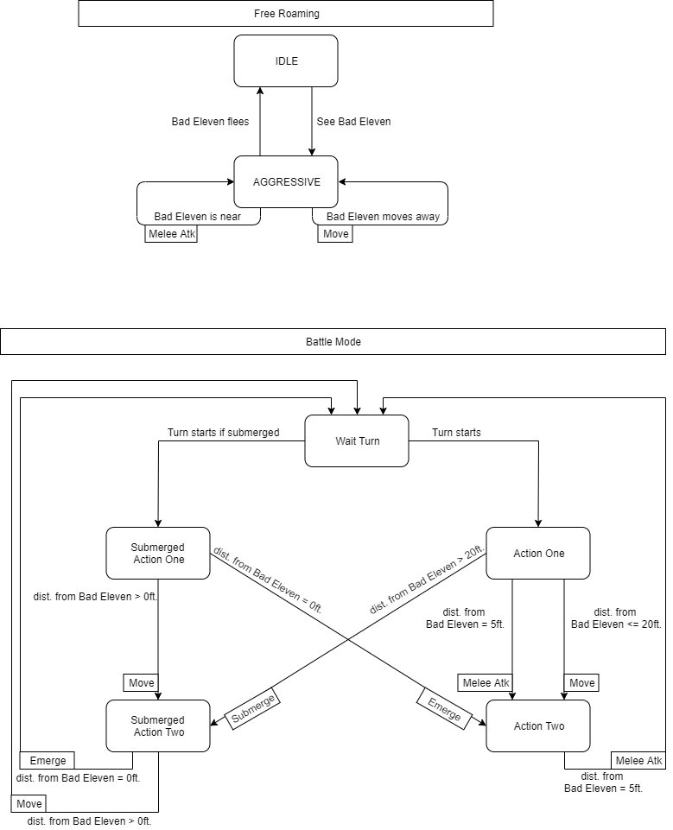

**Turns Predictions: Demomole**

**How many turns does the enemy takes to kill Eleven with an AVG damage?**

Eleven’sBaseHp/ ((EnemyAvgDamage * numOfActions) x P[Hit Eleven]) =

30/((4.5*2)*14/20) = 4.76 turns

**BROOD MOTHER [Level Boss][15]**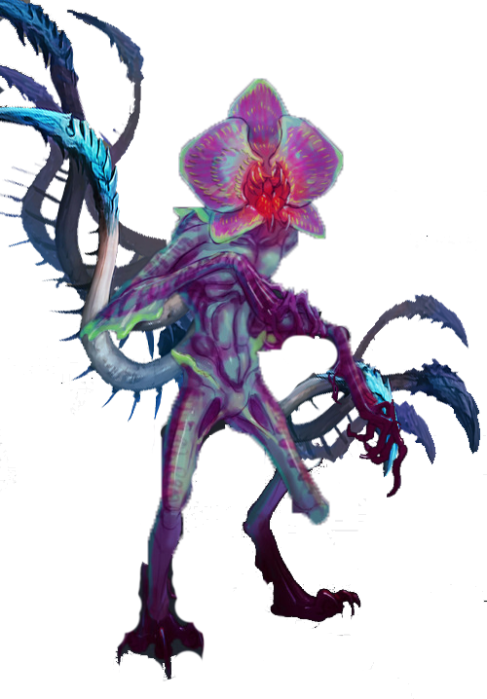

A Demogorgon smaller in size but capable to call back every Slug in the area. It has the capacity to increase the evolutionary process of the other creatures allowing them to reach their next stage faster. Actually, it’s scope is to evolve the other creatures into Strange Cocoons in order to have a new container for her rebirth. We don’t know exactly how long the Brood Mother existed, probably since the creation of the Mind Flayer because its abilities make it almost immortal. In fact, by killing it you are not sure that it is completely destroyed. A Strange Cocoon in another place may be ready for its rebirth, although the Brood Mother tends to respawn to the nearest one.

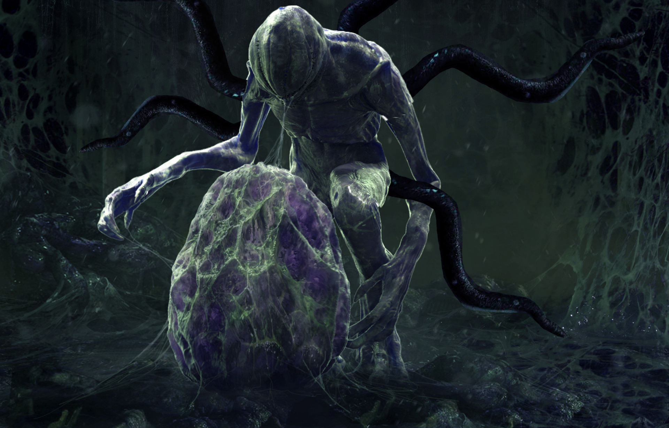[16]

A mouth-closed Brood Mother protecting a *Strange Cocoon*

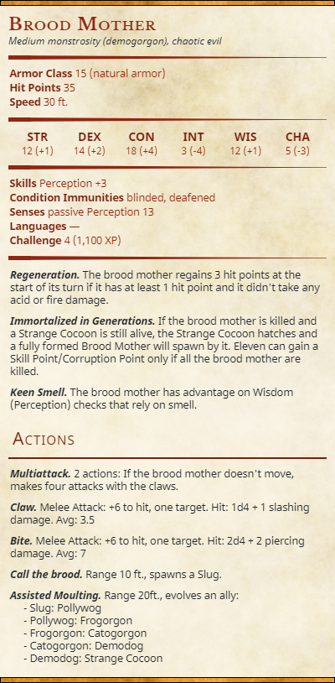

## State Diagram: Brood Mother

## 

**Turns Predictions: Brood Mother**

**How many turns does the enemy takes to kill Eleven with an AVG damage?**

Eleven’sBaseHp/ ((EnemyAvgDamage * numOfActions) x P[Hit Eleven]) =

30/((7*2)*15/20) = 2.85 turns

## Level 6 - Battles

Level 6 is a battle-focused level: there are several enemies of different types that the player must face. Battle examples are given for the most complex battles only.

AVG Damage Taken and AVG Turns have been calculated by simulating real battles at least 3 times[17] per battle.

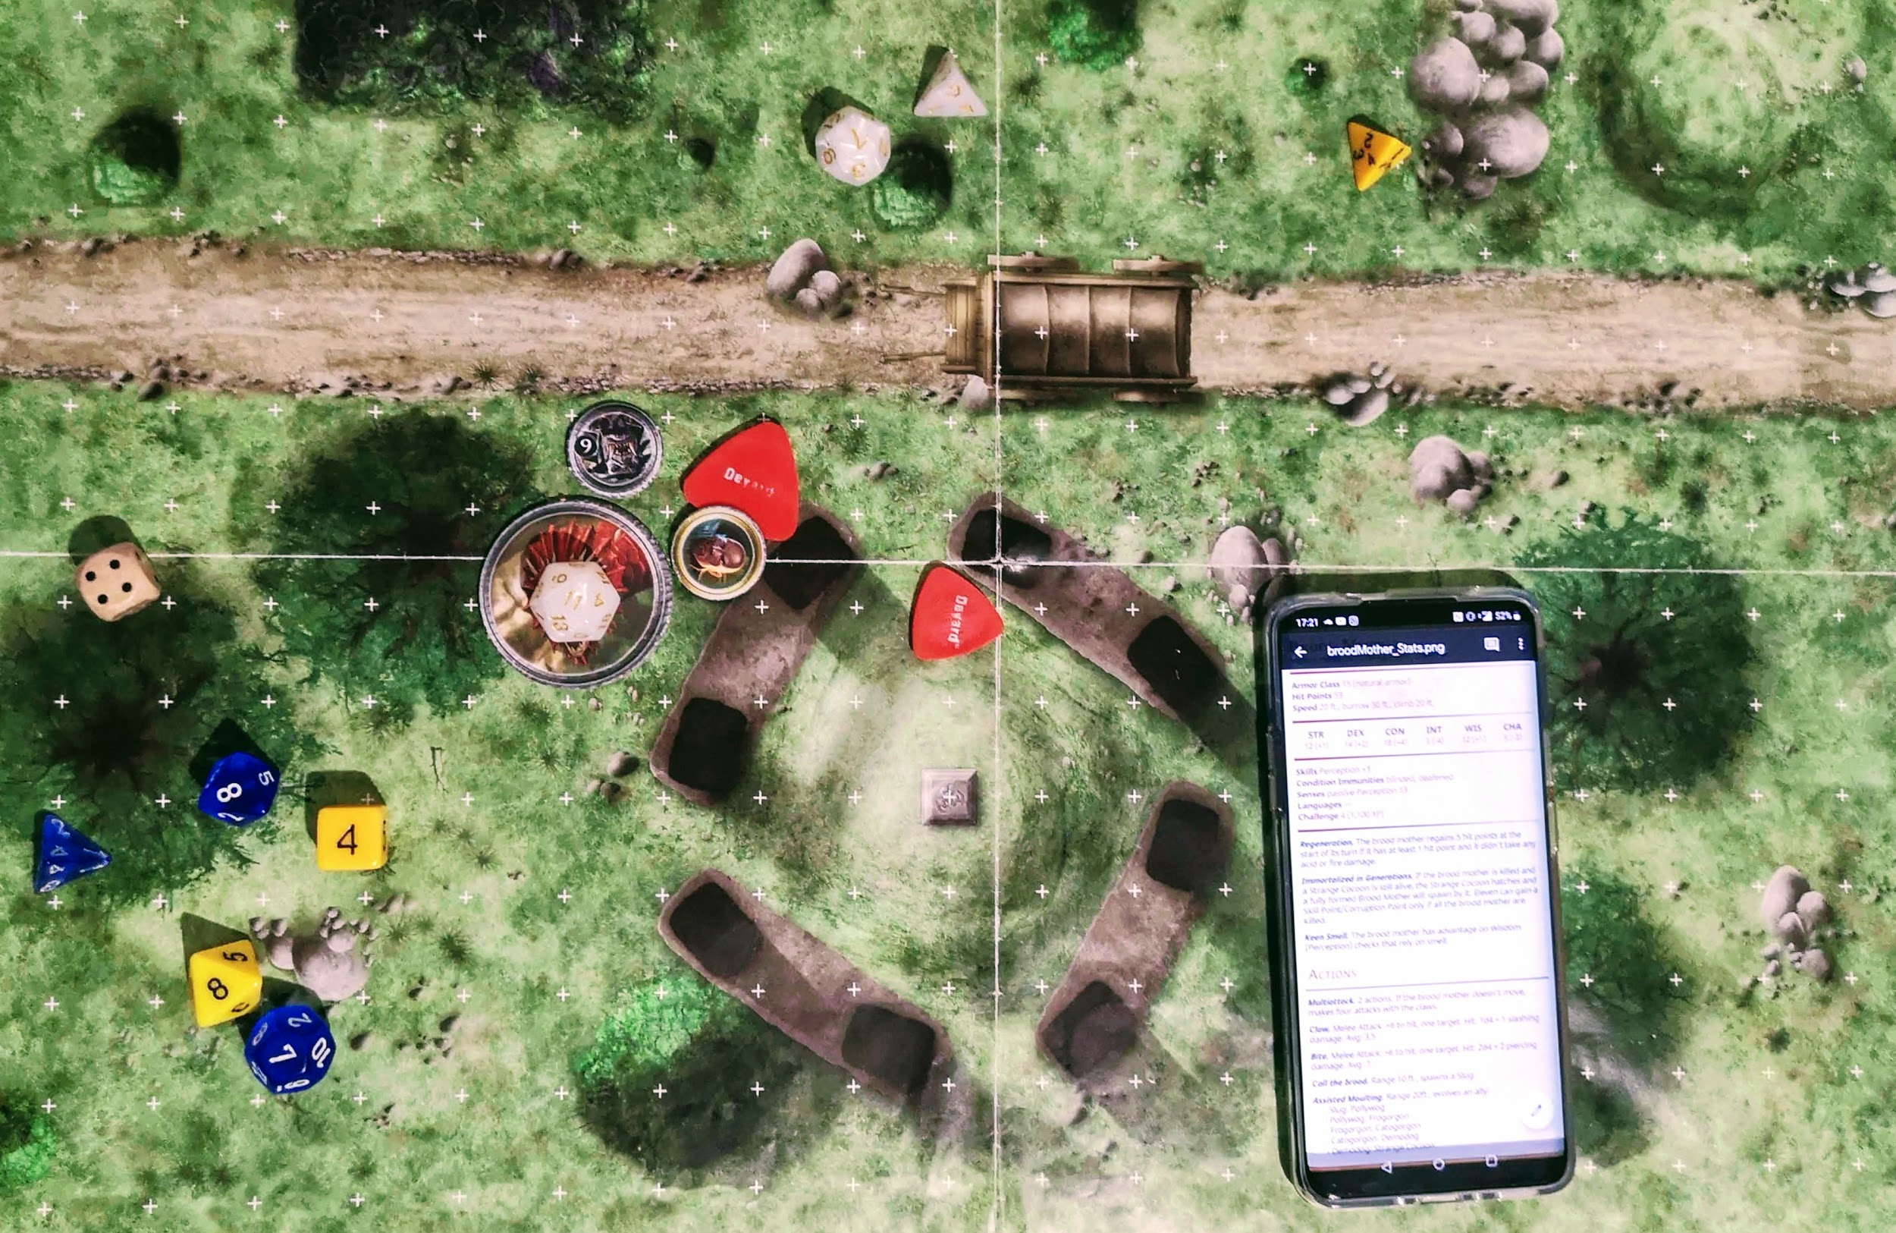

A simulation with our D&D set

To simulate every battle we considered the base stats that Eleven has at this point of the game:

* 30 Hit Points.
* All the base skills plus *Slash*
* The base equipment (*Crowbar* and *Fire Striker*)
* 12 in INT, 10 to the other abilities (chosen at the beginning of the game)

And a good amount of Items, Skills and equipment, needed to proceed in the level without dying too many times and that Eleven should had acquired earlier (we considered this level as the first that the player visits after acquiring the “Find your Memories” in L3 - Deep Woods):

* Skills unlocked: *Spark, Living Bomb, Ignite, Phoenix Burst, Mind Scream*, *Rejuvenation.*
* Items possessed: *3 Healing Roots, 2 Meditation Roots, 1 Rage Root, 1 Cat. Demon blood vial*.
* 14 Armor Class.

We did not consider any *Corruption Level* but we assumed that the player didn’t absorbed any enemy (except the one in the tutorial) and spent every skill point available up to that zone (7 points).

In our simulation every battle starts with all Eleven skills charged and all the items declared available; as Eleven recharges her health during exploration, she starts all these battles fully healed.

**Surrounding forest**

**BT 6.1**

* + 1x Demodog
  + 1x Frogorgon

The first battle of the level is a quite simple one. Despite this, the ***Demodog*** could be a fairly insidious enemy if the player hasn’t visited the other levels before *(Level 4 or 7),* hasn’t acquired *Mikey* or is not enough prepared for the battle.

The battle takes place at the entrance of the *Surrounding forest:* there aren’t any objects that can be picked or used as coverage on the battlefield, but due to the difficulty of the battle the player shouldn’t need them.

Simulation

|  |  |
| --- | --- |
| **Total Damage Taken (AVG)** | **Turns (AVG)** |
| 25 | 7 |

**Loot**

|  |  |
| --- | --- |
| **Enemy type** | **Loot (Organic Materials)** |
| Demodog | 200 OM |
| Frogorgon | 50 OM |

BT 6.1 - Battlefield

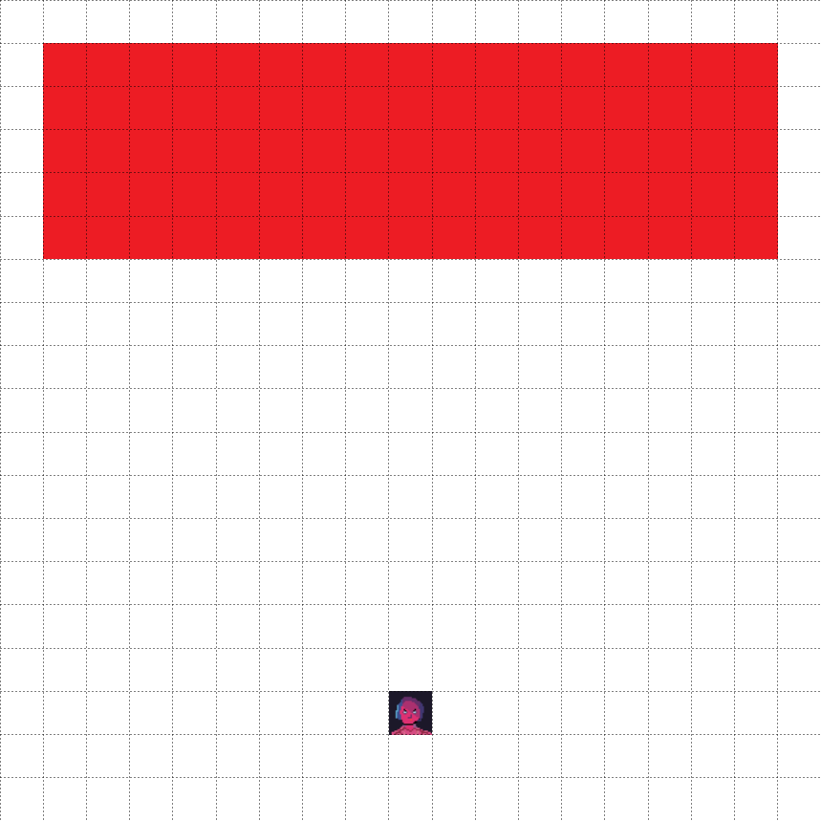

**Red area → Enemies random position (5x17)**

(Listed enemies can randomly be positioned in these cells)

|  |  |  |
| --- | --- | --- |
| **Icon** | **Name** | **Effect** |
|  | Eleven | Player’s position |

**BT 6.2**

* + 1x Demodog
  + 1x Demodog Alpha
  + 1x Catogorgon

Unlike the previous one this **optional** battle is a quite difficult one. There is a ***Catogorgon*** instead of a Frogorgon and a nearly major enemy: a ***Demodog Alpha.*** This enemy is particularly resistant and can boost other enemies near him with his ability ***Pack Leader***.

The player should therefore defeat him first and then concentrate on the other two enemies in order to not be surrounded.

The battlefield is nearly empty: there are only few trees that can be used as coverage despite the enemy hasn’t any ranged attack. The role of the enemy here is to protect a **Skill Point** object that can be accessed through the ***Dash*** skill only (the player must have acquired it in ***Level 7*** and then return here).

Simulation[18]

|  |  |
| --- | --- |
| **Total Damage Taken (AVG)** | **Turns (AVG)** |
| 31 | 7 |

The battle will force Eleven to heal at least one time, our suggestion is to use either the skill Rejunevation or an Healing Root.

**Loot**

|  |  |
| --- | --- |
| **Enemy type** | **Loot (Organic Materials)** |
| Demodog | 200 OM |
| Catogorgon | 100 OM |
| Demodog Alpha | 450 OM |

BT 6.2 - Battlefield

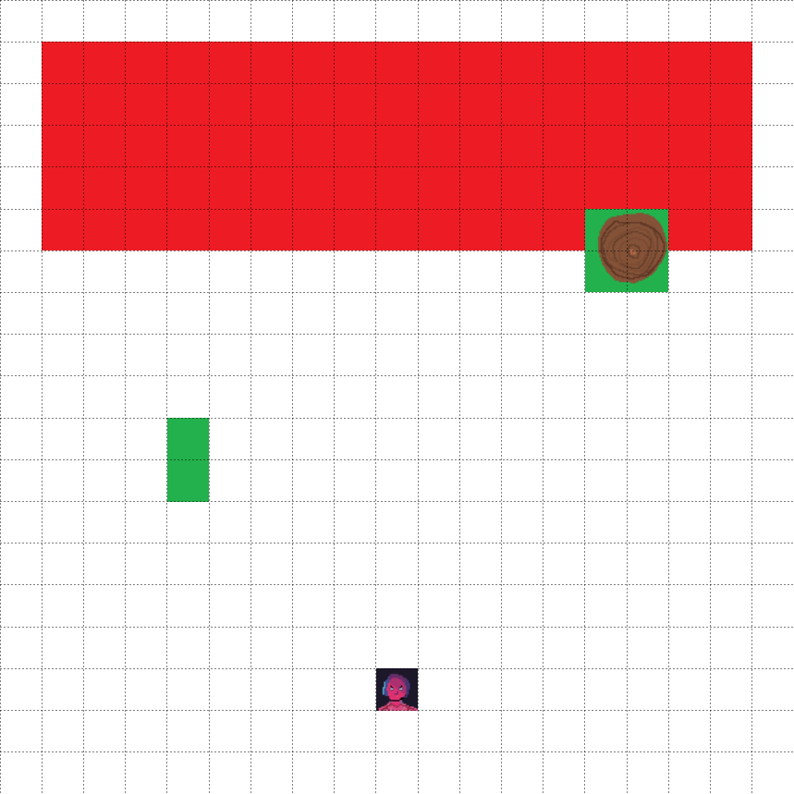

**Red area → Enemies random position (5x17)**

(Listed enemies can randomly be positioned in these cells)

|  |  |  |
| --- | --- | --- |
| **Icon** | **Name** | **Effects** |
|  | Eleven | Player’s position |
|  | Tree Trunk | Impassable terrain. Grants partial cover to anyone that stands behind it. |
|  | Bushes & Small Trees | Counts as difficult terrain. Grants partial cover to anyone that stands behind it. |

**Battle example**

The fight before the gorge of the Skill Point is harder than the other common battles, where the player must defend her/himself from a frontal attack. In this example the player chose to use his skill point into the Mikey Skills Tree (Mikey is present). The Initiative in this case is:

1. Catogorgon (**C**)
2. Eleven and Mikey
3. Demodog (**D**)
4. Demodog Alpha (**DA**)

|  |  |
| --- | --- |
| **TURN** | **CATOGORGON’S TURN** |
| **ELEVEN’S TURN** |
| **DEMODOGS’ TURN** |
| **1** | C moves 60 ft. in Eleven’s direction |
| Eleven uses *Evolve: legs* and *Evolve: claws*. |
| D and DA moves 60 ft. |
| **2** | C moves close to Eleven and uses *Leap*, but fails. |
| Mikey moves close to C and deals 7 slashing damage. |
| D close the gap with Eleven and DA with Mikey. |
| **3** | C deals 6 piercing damage to Eleven. |
| Eleven uses Apex Predator.  Mikey uses Cannibalism on C and succeeds. It heals 3 HP. |
| D deals 7 piercing damage to Eleven.  DA deals 13 slashing damage to Mikey. |
| **4** | C is dead. |
| Mikey uses Cannibalism two time on D: the first time D passes the saving throw, but fails the second. Mikey heals 8 HP. |
| DA moves to Eleven and misses the attack. |
| **5** | C is dead. |
| Mikey uses Bite one time on DA and deals 7 piercing damage.  Eleven uses Dash to escape DA. |
| DA hits 3 time Mikey with its claws and deals 11 slashing damage. |
| **6** | C is dead. |
| Mikey uses Bite two time and deals 12 piercing damage to DA. |
| DA hits 2 time Mikey with its claws and deals 7 slashing damage. |
| **7** | C is dead. |
| Mikey uses Bite two time and deals 14 piercing damage to DA. |
| DA is dead. |

**BT 6.3**

* + 2x Catogorgon

Quite simple battle: ***Catogorgon****s* at this point of the game are not a real threat and can be easily defeated.

They’re trying to protect the access to Will’s Garden standing in front of the ***Mind Flayer’s Roots***. Like the other battles that take place in this area, the battlefield is populated only by some trees.

Simulation

|  |  |
| --- | --- |
| **Total Damage Taken (AVG)** | **Turns (AVG)** |
| 20 | 6 |

**Loot**

|  |  |
| --- | --- |
| **Enemy type** | **Loot (Organic Materials)** |
| Catogorgon | 100 OM |
| Catogorgon | 100 OM |

BT 6.3 - Example of battlefield

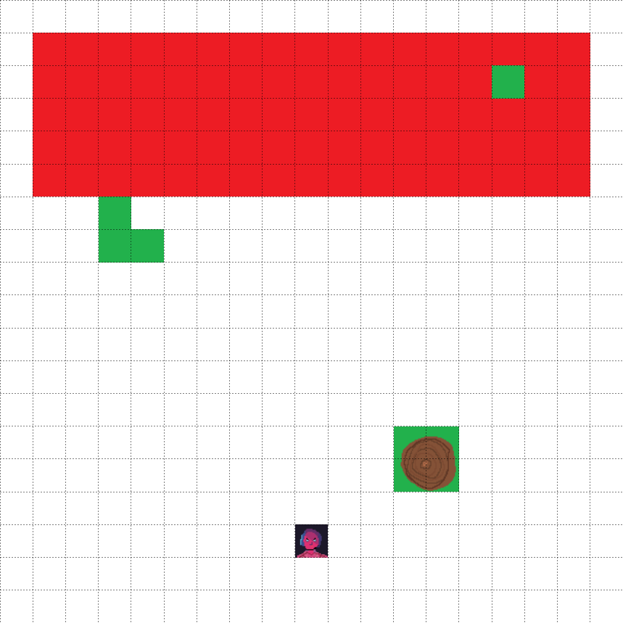

**Red area → Enemies random position (5x17)**

(Listed enemies can randomly be positioned in these cells)

|  |  |  |
| --- | --- | --- |
| **Icon** | **Name** | **Effects** |
|  | Eleven | Player’s position |
|  | Tree Trunk | Impassable terrain. Grants partial cover to anyone that stands behind it. |
|  | Bushes & Small Trees | Counts as difficult terrain. Grants partial cover to anyone that stands behind it. |

**BT 6.4**

* + 2x Catogorgon
  + 1x Frogorgon

Like the previous one, also this battle is quite simple. The enemies are protecting an object (OB 6.2) and they will try to ambush the player by hiding behind a tree. The **Frogorgon** can easily reach and attack the player using his ***jump*** skill.

The area is populated by some trees and enemies will often take coverage behind them.

|  |  |
| --- | --- |
| **Total Damage Taken (AVG)** | **Turns (AVG)** |
| 29 | 8 |

The battle will force Eleven to heal at least one time, our suggestion is to use either the skill Rejunevation or an Healing Root if available.

**Loot**

|  |  |
| --- | --- |
| **Enemy type** | **Loot (Organic Materials)** |
| Frogorgon | 50 OM |
| Catogorgon | 100 OM |

BT 6.4 - Example of battlefield

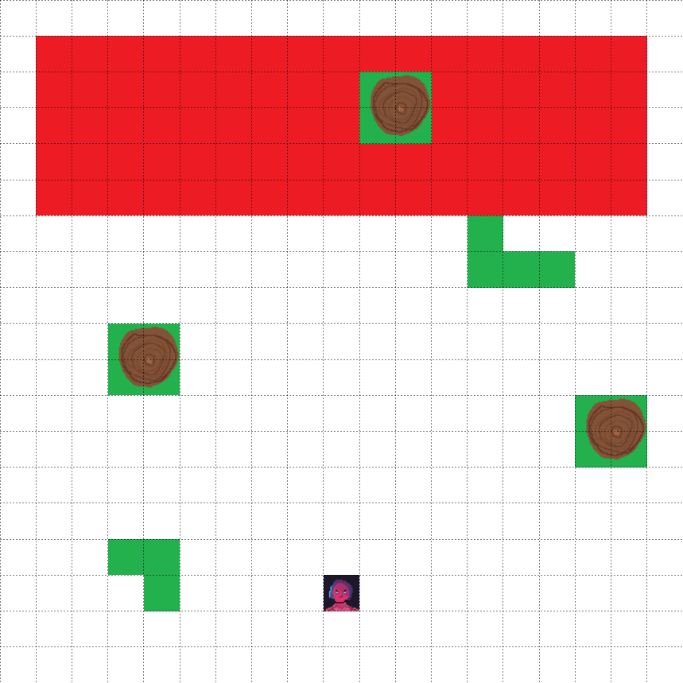

**Red area → Enemies random position (5x17)**

(Listed enemies can randomly be positioned in these cells)

|  |  |  |
| --- | --- | --- |
| **Icon** | **Name** | **Effects** |
|  | Eleven | Player’s position |
|  | Tree Trunk | Impassable terrain. Grants partial cover to anyone that stands behind it. |
|  | Bushes & Small Trees | Counts as difficult terrain. Grants partial cover to anyone that stands behind it. |

**Garden**

**BT 6.2.1 - Mini Boss**

* + 1x Demodorgon

Mini Boss battle: after the entrance in the new area and the Cutscene sequence, this enemy will try to prevent the player from entering the house. The battle is not complex but due to the resistance and the strength of the ***Demodorgon***  it can be quite difficult and could take a lot of time: the enemy will attack relentlessly and the player won’t have the time to completely heal himself or to retreat. The damage of the enemy can become quite serious and he’s the ability to stun the player too, so the player should focus on ranged attacks and retreat when the enemy gets too close.

On the battlefield there are some trees, obstacles and the Byers’ Car.

As a major enemy, he can be **absorbed** by the player **or** killed for ***Skill Points***.

Simulation

|  |  |
| --- | --- |
| **Total Damage Taken (AVG)** | **Turns (AVG)** |
| 52 | 11 |

The battle will force Eleven to heal at least one time, our suggestion is to use either the skill Rejunevation or an Healing Root if available.

**Loot**

|  |  |
| --- | --- |
| **Absorption** | **Skill Points** |
| 600 Corruption Points | 2 SP |

|  |  |
| --- | --- |
| **Enemy type** | **Loot (Organic Materials)** |
| Demodorgon | 1100 OM |

BT 6.2.1 - Example of battlefield

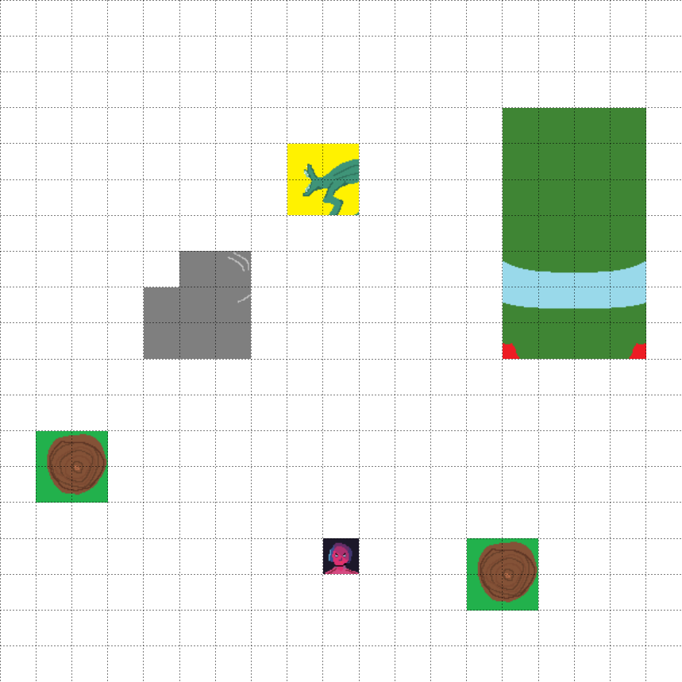

**Enemies position:** fixed

|  |  |  |
| --- | --- | --- |
| **Icon** | **Name** | **Effects** |
|  | Demodorgon | Mini Boss |
|  | Eleven | Eleven |
|  | Tree Trunk | Impassable terrain. Grants partial cover to anyone that stands behind it. |
|  | Rock | Impassable terrain. Grants total cover to anyone that stands behind it. |
|  | Car | Impassable terrain. Grants total cover to anyone that stands behind it. |

**BT 6.2.2**

* + 1x Catogorgon
  + 1x Catnip Bulb

In this battle is present a major enemy: a ***Catnip Bulb***. The battle is of medium difficulty as the Catnip Bulb cannot move (is rooted) and is not very resistant, but can be quite annoying due to its ranged attacks and the ability to summon ***Catogorgon***s to help him. This skill has a long cooldown (10 turns), so the player should focus defeating the bulb first and then killing the other enemies.

The battlefield has some trees and obstacles that can be used as coverage against the ranged attacks of the Catnip Bulb.

As a major enemy this Bulb can be absorbed too or killed for skill points. The ***Catogorgon***s summoned by the Bulb do not give any Organic Materials.

Simulation

|  |  |
| --- | --- |
| **Total Damage Taken (AVG)** | **Turns (AVG)** |
| 35 | 11 |

**Loot**

|  |  |
| --- | --- |
| **Absorption** | **Skill Points** |
| 300 Corruption Points | 1 SP |

|  |  |
| --- | --- |
| **Enemy type** | **Loot (Organic Materials)** |
| Catnip Bulb | 450 OM |
| Catogorgon | 100 OM |
| Catogorgon (Summoned) | 0 OM |

BT 6.2.2 - Battlefield

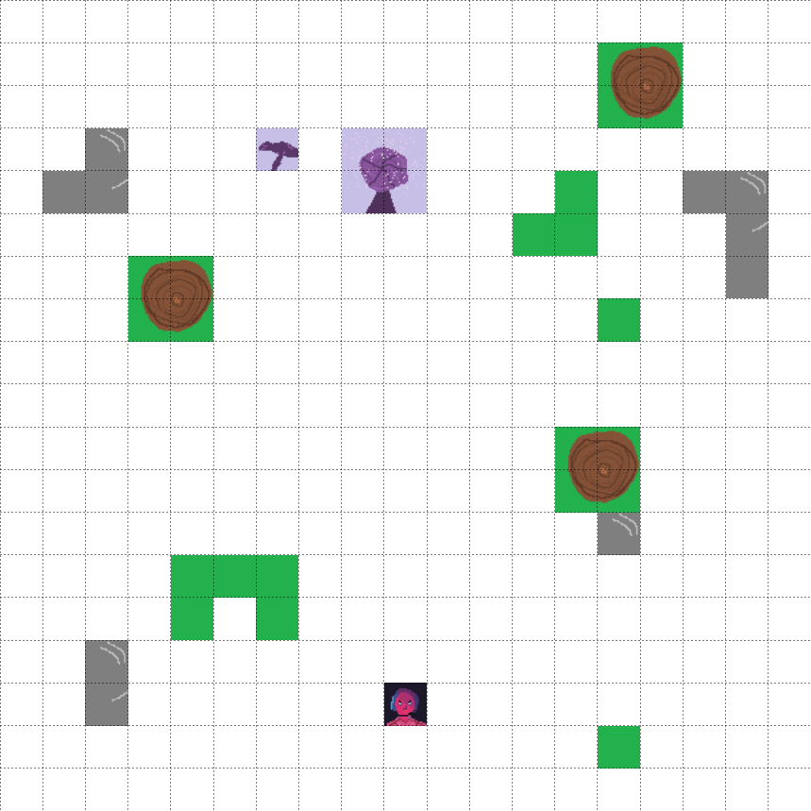

**Enemies position:** fixed

|  |  |  |
| --- | --- | --- |
| **Icon** | **Name** | **Effects** |
|  | Catnip Bulb | Major Enemy |
|  | Eleven | Eleven |
|  | Tree Trunk | Impassable terrain. Grants partial cover to anyone that stands behind it. |
|  | Bushes & Small Trees | Counts as difficult terrain. Grants partial cover to anyone that stands behind it. |
|  | Rock | Impassable terrain. Grants total cover to anyone that stands behind it. |
|  | Catogorgon | Enemy |

**Battle example**

In this fight the player must kill a major enemy in order to collect a puzzle piece, needed for the main quest. In the example the player chose to use his *Corruption Points* in DEX, with few skill points in the left Pyrokinetic branch. Eleven wins the *Initiative* and is the first to start.

|  |  |
| --- | --- |
| **TURN** | **ELEVEN’S TURN** |
| **MONSTER’S TURN** |
| **1** | Eleven moves behind the tree on the right. |
| The Catnip Bulb (**CP**) spawns a new Catogorgon (**C2**).  The Catogorgon (**C1**) approaches Eleven. **C1** is within 5 ft. of Eleven. |
| **2** | Eleven uses the *huntsman rifle* and deals 19 piercing damage to **C1. C1** dies. |
| **CP** skips the turn because it has nothing in range.  **C2** is within 5 ft. on Eleven. |
| **3** | Eleven uses the *Catnip Demon Blood vial* against **C2**. **C2** passes the save.  Eleven uses the crowbar on **C2** but misses |
| **CP** skips the turn.  **C2** uses *Bite* two times against Eleven dealing 8 piercing damage. |
| **4** | Eleven uses the *huntsman rifle* against **C2** but misses. |
| **CP** skips the turn.  **C2**  uses *Bite* two time against Eleven dealing 10 piercing damage. |
| **5** | Eleven uses the *huntsman rifle* against **C2** and deals 15 piercing damage.  Eleven uses *Adrenaline Rush.*  Eleven uses *Quick Punch* against **C2** and deals 4 bludgeoning damage. **C2** dies. |
| **CP** skips the turn. |
| **6** | Capitalizing on the rifle long range, Eleven uses the *huntsman rifle* against **CP** and deals 17 piercing damage. Eleven has no more rifle ammo. |
| **CP** skips the turn. |
| **7** | Eleven moves towards **CP** but stays 35 ft. away from **CP**.  Eleven uses a *Rage Root.* |
| **CP** skips the turn. |
| **8** | Eleven moves towards **CP**.  Eleven uses the *Slash* and deals 12 damage.  **CP** dies. |

**BT 6.2.3**

* + 2x Bulb

Quite simple battle: ***Bulb***s are simple enemies that will focus on ranged attacks. They can’t move and are protecting the entrance of the Shed, if the player gets too close to them they will trigger the battle with a ranged attack.

The battlefield has some trees and timbers that can be used as coverage.

Simulation

|  |  |
| --- | --- |
| **Total Damage Taken (AVG)** | **Turns (AVG)** |
| 15 | 6 |

**Loot**

|  |  |
| --- | --- |
| **Enemy type** | **Loot (Organic Materials)** |
| Bulb | 100 OM |

BT 6.2.3 - Battlefield

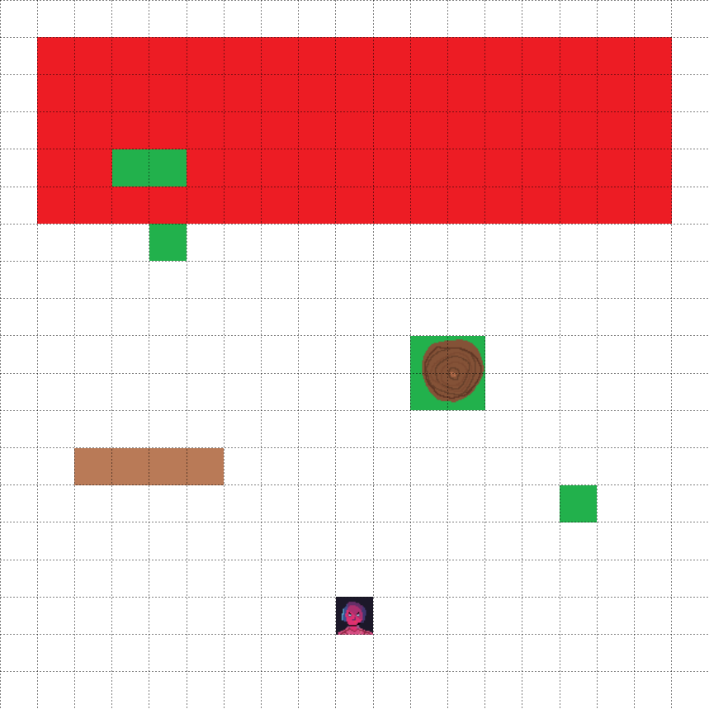

**Enemies position:** random on the **red area (5x17)**.

|  |  |  |
| --- | --- | --- |
|  | Eleven | Eleven |
|  | Tree Trunk | Impassable terrain. Grants partial cover to anyone that stands behind it. |
|  | Bushes & Small Trees | Counts as difficult terrain. Grants partial cover to anyone that stands behind it. |

**BT 6.2.4**

* + 1x Demodog Alpha

As seen before the ***Demodog Alpha*** can be quite annoying when in group, but alone it should be easily defeated.

He is protecting a piece of the puzzle, needed to complete the level. On the battlefield there are some trees and timber that can be used as coverage even if the player shouldn’t need them as the enemy will use melee attacks only.

Simulation

|  |  |
| --- | --- |
| **Total Damage Taken (AVG)** | **Turns (AVG)** |
| 31 | 5 |

**Loot**

|  |  |
| --- | --- |
| **Enemy type** | **Loot (Organic Materials)** |
| Demodog Alpha | 450 OM |

# 

# BT 6.2.4 - Battlefield

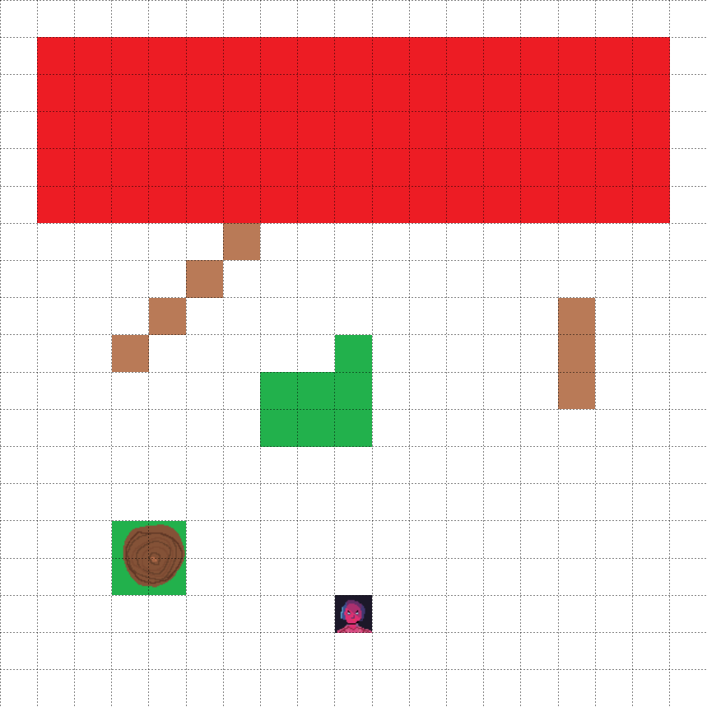

**Enemies position:** random on the **red area**.

|  |  |  |
| --- | --- | --- |
|  | Eleven | Eleven |
|  | Tree Trunk | Impassable terrain. Grants partial cover to anyone that stands behind it. |
|  | Bushes & Small Trees | Counts as difficult terrain. Grants partial cover to anyone that stands behind it. |

# 

# In the Shed

**BT 6.2.5**

* + 3x Demomole

This battle is a particular one, and could take a long time to complete. ***Demomole*s** are strange enemies: they will submerge and emerge from the ground continuously pushing the player to seek them trying to not take damage. They can move underground passing through the numerous objects in the Shed and they will retreat when the player would try to hit them. The battlefield is in fact full of work benches, tables and obstacles where the player can’t go but the enemies can.

As major enemies the player can choose to absorb them or take skill points when the battle is over. The absorption of the three of them will count as one.

Simulation

|  |  |
| --- | --- |
| **Total Damage Taken (AVG)** | **Turns (AVG)** |
| 37 | 7 |

**Loot**

|  |  |
| --- | --- |
| **Absorption** | **Skill Points** |
| 400 Corruption Points | 1 SP |

|  |  |
| --- | --- |
| **Enemy type** | **Loot (Organic Materials)** |
| Demomole | 200 OM |

# 

# 

# BT 6.2.5 - Battlefield

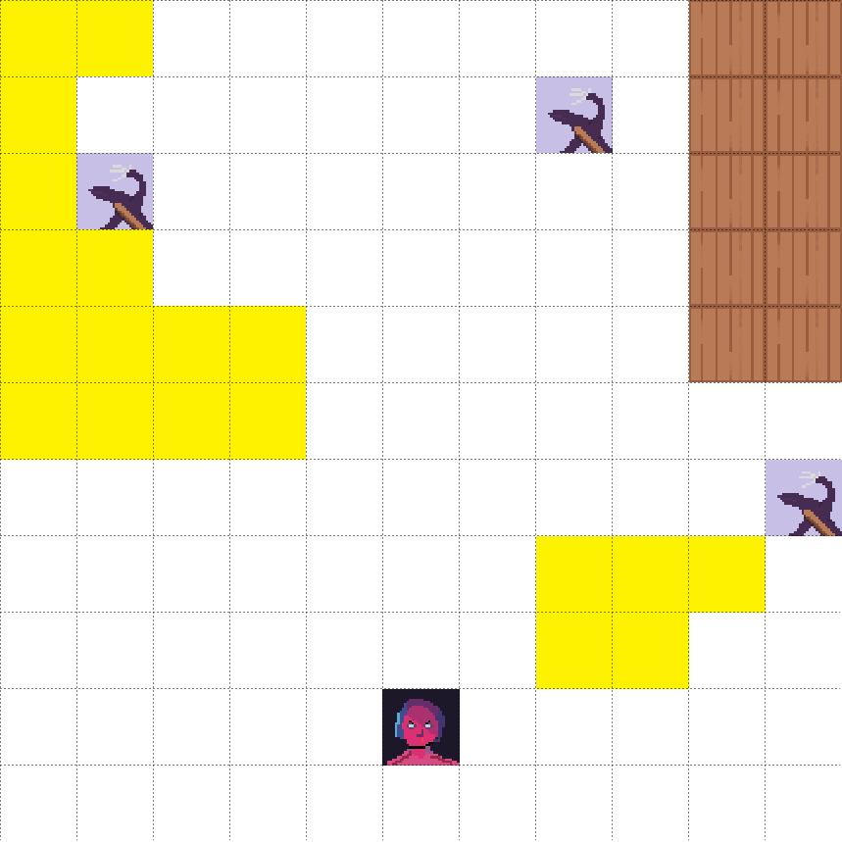

**Enemies position:** fixed.

|  |  |  |
| --- | --- | --- |
|  | Demomole | Major Enemy |
|  | Eleven | Eleven |
|  | Crates & Boxes | Anyone that tries to climb on, must spend 5 ft. of her/his movement. When anyone is attacked while on it, by an enemy that is not on top, the attacker gain disadvantage on her/his attack roll (except 2x2 monsters).  Grants partial cover to anyone that stands behind it. |
|  | Table | Anyone that tries to climb on, must spend 10 ft. (5 for 2x2 monsters) of her/his movement. When anyone is attacked while on it, by an enemy that is not on top, the attacker gain disadvantage on her/his attack roll (except 2x2 monsters). Slugs, Polliwog and Frogorgons can pass under it but can’t climb it. Enemies can’t attack each other between under and over the table. |

**Inside the house**

**BT 6.3.1**

* + 2x Bulb
  + 2x Vine Tentacles

Once entered the house the player will explore the kitchen, here he will be attacked by ***Bulb***s and some ***Vine Tentacles***.

These are rooted enemies and cannot move. The tentacles will try to protect the Bulbs from Eleven’s attacks with their ***Grab*** skill, forcing the player to not get close to them. The recommended tactic for this fight is to concentrate the tentacles first with ranged attacks. On the battlefield there are some tables, chairs and walls that can be used as coverage.

Simulation

|  |  |
| --- | --- |
| **Total Damage Taken (AVG)** | **Turns (AVG)** |
| 19 | 9 |

**Loot**

|  |  |
| --- | --- |
| **Enemy type** | **Loot (Organic Materials)** |
| Bulb | 100 OM |
| Vine Tentacles | 100 OM |

BT 6.3.1 - Battlefield

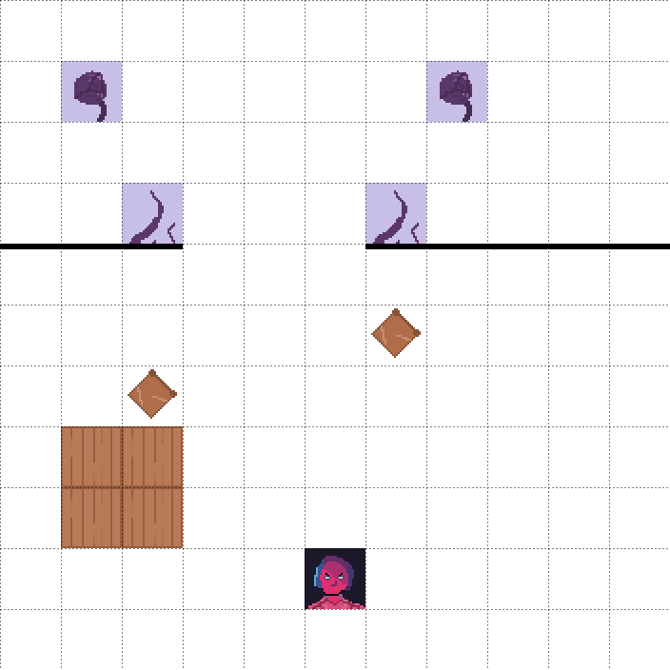

**Enemies position:** fixed.

|  |  |  |
| --- | --- | --- |
|  | Eleven | Eleven |
|  | Chair | Breaks when someone moves through it. |
|  | Table | Anyone that tries to climb on, must spend 10 ft. (5 for 2x2 monsters) of her/his movement. When anyone is attacked while on it, by an enemy that is not on top, the attacker gain disadvantage on her/his attack roll (except 2x2 monsters). Slugs, Polliwog and Frogorgons can pass under it but can’t climb it. Enemies can’t attack each other between under and over the table. |
|  | Vine Tentacles | Enemy |
|  | Bulb | Enemy |

**BT 6.3.2**

* + 3x Frogorgon
  + 7x Slug

The second battle in the house is a quite simple one, there are some minor enemies but their strength is in the number.

***Slug***s are at this point of the game not a threat, the player should focus them first and then defeat the remaining ***Frogorgon***s. If the player has unlocked them, skills with area damage are the best for this encounter as they can easily defeat the numerous slugs on the ground.

On the battlefield there are few objects including a bed, a desk and chairs.

Simulation

|  |  |
| --- | --- |
| **Total Damage Taken(AVG)** | **Turns (AVG)** |
| 10 | 6 |

**Loot**

|  |  |
| --- | --- |
| **Enemy type** | **Loot (Organic Materials)** |
| Slug | 25 OM |
| Frogorgon | 50 OM |

BT 6.3.2 - Battlefield

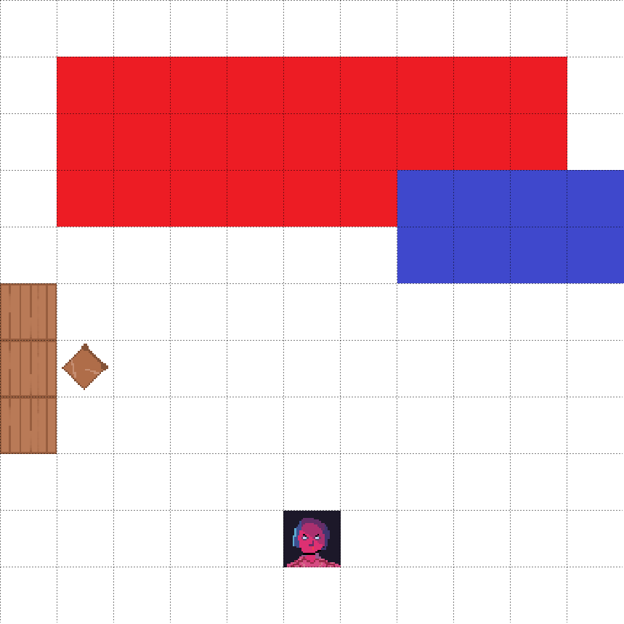

**Enemies position:** random in the **red area**. **(3x9)**

|  |  |  |
| --- | --- | --- |
| **Icon** | **Name** | **Effects** |
|  | Eleven | Eleven |
|  | Chair | Breaks when someone moves through it. |
|  | Table | Anyone that tries to climb on, must spend 10 ft. (5 for 2x2 monsters) of her/his movement. When anyone is attacked while on it, by an enemy that is not on top, the attacker gain disadvantage on her/his attack roll (except 2x2 monsters). Slugs, Polliwog and Frogorgons can pass under it but can’t climb it. Enemies can’t attack each other between under and over the table. |
|  | Bed | Anyone that tries to climb on, must spend 5 ft. of her/his movement. When anyone is attacked while on it, by an enemy that is not on top, the attacker gain disadvantage on her/his attack roll (except 2x2 monsters). |

**BT 6.3.3 BOSS BATTLE**

* + 1x BROOD MOTHER
  + 2x Catogorgon
  + ?x Slug, Summoned by the Brood Mother (during the battle)

This is the last battle of the level and the **Boss Fight** of level 6. The ***BROOD MOTHER*** is highly resistant to damage and as the ability to **evolve** the enemies into their next form. The existing ***Catogorgon***s that are on the battlefield should normally not be considered as a real threat, but in this case they can be evolved until they reach the stage of ***Strange Cocoon***.

In this particular stage if the *Brood Mother* dies, she can respawn on a random Cocoon destroying it in the process, plus she can summon Slugs in her help, keeping the player busy while she evolves other enemies. This battle could take a long time to be completed and is the most dangerous of the level but the player should be prepared thanks to the numerous items and weapons that can be found in the area.

The battlefield is full of coverages and environmental objects like a table and a couch. **This battle cannot be left until is finished.**

Enemies summoned by the *Brood Mother* do not give any Organic Material.

Simulation

|  |  |
| --- | --- |
| **Total Damage Taken (AVG)** | **Turns (AVG)** |
| 47 | 11 |

**Loot**

|  |  |
| --- | --- |
| **Absorption** | **Skill Points** |
| 900 Corruption Points | 3 SP |

|  |  |
| --- | --- |
| **Enemy type** | **Loot (Organic Materials)** |
| Brood Mother | 1500 OM |
| Catogorgon (already on stage) | 200 OM |
| Summoned enemy | 0 OM |

BT 6.3.3 - Battlefield

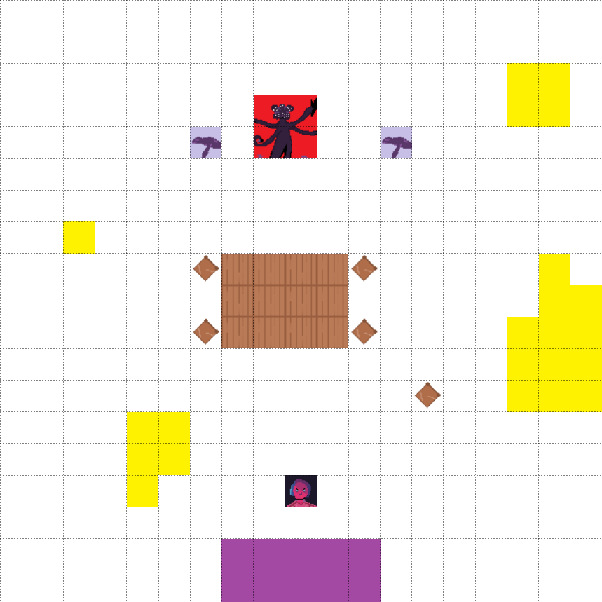

**Enemies initial position**: fixed

|  |  |  |
| --- | --- | --- |
| **Icon** | **Name** | **Effects** |
|  | Broodmother | Main Boss |
|  | Eleven | Eleven |
|  | Chair | Breaks when someone moves through it. |
|  | Crates & Boxes | Anyone that tries to climb on, must spend 5 ft. of her/his movement. When anyone is attacked while on it, by an enemy that is not on top, the attacker gain disadvantage on her/his attack roll (except 2x2 monsters).  Grants partial cover to anyone that stands behind it. |
|  | Sofa | Anyone that tries to climb on, must spend 5 ft. of her/his movement. When anyone is attacked while on it, by an enemy that is not on top, the attacker gain disadvantage on her/his attack roll (except 2x2 monsters). |
|  | Table | Anyone that tries to climb on, must spend 10 ft. (5 for 2x2 monsters) of her/his movement. When anyone is attacked while on it, by an enemy that is not on top, the attacker gain disadvantage on her/his attack roll (except 2x2 monsters). Slugs, Polliwog and Frogorgons can pass under it but can’t climb it. Enemies can’t attack each other between under and over the table. |
|  | Catogorgon | Enemy |

**Battle example**

The fight with the Broodmother can be approached in very different ways, and here’s some sample of what the player could do and how a battle can envelopes during a fight. In this example the player chose to use his skill point into the Pyrokinetic INT Skills, the most powerful for this fight. Since the Catogorgon and the Broodmother have a higher Initiative than Eleven they’ll start the fight.

In this example the Brood Mother won’t have a Strange Cocoon available and will die in 7 turns only due to the advantaged position of Eleven on the sofa, however the battle can take much longer.

|  |  |
| --- | --- |
| **TURN** | **MONSTER’S TURN** |
| **ELEVEN’S TURN** |
| **1** | The Catogorgons (**C1, C2**.) rush up on Eleven.  The Broodmother spawns two Slugs (**S1, S2**). |
| Eleven retreats on the sofa and hits **C1** with an *Ignite* skill and deals 6 damage. |
| **2** | **C1** & **C2** try to hit Eleven, but, due to the disadvantage, miss.  The Broodmother evolves **S1** and **S2** into Pollywogs. |
| Eleven uses the *Phenix Burst* dealing 10 fire damage to the two Cat.  Eleven uses *Spark* to deal 5 fire damage to **C1**. and kills it. |
| **3** | **C2** deals 5 piercing damage to Eleven.  The BroodM. spawns evolves **S1** and **S2** into Frogorgons.  **S1** and **S2** approach Eleven. |
| Eleven kills **C2** with *Spark*.  Eleven uses *Focused Laser* on the BroodM. but misses. |
| **4** | The BroodM. spawns two new Slugs (**S3, S4**).  **S1** and **S2**  deal a total of 7 damage to Eleven. |
| Eleven uses *Fireball* and deals 21 damage to **S3** and **S4**, **S1** and the BroodM. **S3** dies, **S4** dies  Eleven uses a Healing Root to heal 8 HP. |
| **5** | The BroodM. evolves **S2** two times into a Demodog.  **S2** jumps on the sofa and deals 4 piercing damage to Eleven.  **S1** skips the turn (he can do nothing). |
| Eleven uses a Great Meditation Root and shoots a *Focused Laser* on the BroodM. dealing 25 fire damage. |
| **6** | The BroodM. spawns a Slug (**S5**) and evolves **S1** (into Catogorgon).  **S2** deals 8 slashing damage to Eleven.  **S1** misses its attack. **S5** starts to move towards Eleven. |
| Eleven uses the Huntsman Rifle and deals 14 piercing damage to the BroodM. killing it.  Eleven uses the *Demodog Root Whistle* to stun **S1** and **S2**. |
| **7** | **S2** and **S1** lose their turn. **S5** moves two times towards Eleven. |
| Eleven uses *Ignite* and *Spark* to deal 15 fire damage to **S2**. |
| **8** | By sheer luck, **S2** misses all its attacks.  **S5** moves two times towards Eleven. |
| Eleven finishes **S2** with *Mind Blast*.  Eleven uses *Spark* and kills **S1** with a Critical Hit. |
| **9** | **S5** stays in place (cannot reach Eleven on the sofa). |
| Eleven finishes the fight by killing **S5** with *Spark*. |

Prototyping

Our prototypes focused on two main aspects of the game: Combat and Puzzles.

The **Physical Prototype** that we will show is focused on the Combat Mechanics: we prepared a game board with several ambient elements, the player and enemies pieces. The battle we would like to show is the main Boss Battle of the level (**BT 6.3.3**) due to its complexity and the presence of different types of enemies. We gave a set of skills, items and weapons to Eleven that the player can use during the combat, he can also choose to use Mikey or not. After the preparations the battle can be simulated through dices and the combat mechanics we already described.

The **Digital Prototype** focuses on the contrary on solving the main puzzle of the level. We made Will’s Garden (with Shed) and Will’s House (internals) areas based on the maps we had designed.

The items we placed on these areas are the same we declared in the level design part of the document but battles won’t be present: we did an example of them with our physical prototype.

Here are the actions that the player should follow in this prototype:

1. The player spawns in Will’s Garden and must reach the interior of the House to trigger the puzzle quest, otherwise he can explore the area:

he can pick up the two puzzle pieces in the two up corners of the Garden, but the Shed will remain closed.

1. When the player interacts with the lighted wall in the house a dialog will warn him that he must find six puzzle pieces to continue.
2. Once the quest is active the player should search in the house first for puzzle pieces: one is in the kitchen, one in Room 1, another one in Room 2 where he can find also the Shed’s key.
3. The player should now visit the Shed: here he can find another puzzle piece.
4. If the player hasn’t visited the two up corners of the Garden area, he should do it and pick up the other two puzzle pieces.
5. Now that the player has all the six pieces he can return inside the House and interact with the wall.
6. A dialog will ask him to enter a word, if the word is correct the Level is complete and the Prototype is over, otherwise he should retry and find a solution.

1. By going directly to the final level, Bad Eleven is much weaker and the enemies will be much harder to defeat. This conclusion is NOT recommended to less experienced players.

   **The costs of developing the “Bad Ending” will be almost none since the only difference with the canon ending (if the player chooses to defeat the Mind Flayer) is in the last fight that is against the powers of the Real Eleven and not against the Mind Flayer. (Need to develop a new final Boss Fight only).**
2. In the diagrams and in the detailed descriptions, Darkness will be referred as Charisma like the classical D&D.
3. **From now on we will refer to “Bad Eleven” as “Eleven” in the dialogues and in other references.**
4. Corruption: Gameplay feature, Corruption Levels will increase with the number of absorptions done.
5. Unknown Artist
6. Artist: CinemaMind (Tumblr)
7. Unknown Artist
8. Concept Artist: Resident Evil 2 Concept art
9. Poisoning damage, two rolls: one for being poisoned, one to remove the poisoning.
10. Concept Artist: justGames Armenia
11. Unknown Artist
12. Poisoning damage, two rolls: one for being poisoned, one to remove the poisoning.
13. Concept Artist: Niko J Pope
14. Concept Artist: Little Jerboa
15. Concept Artist: CinemaMind (Tumblr), Edited.
16. Concept Artist: Unknown, Edited.
17. The number of attempts increased if the results varied too much.
18. Being an optional and a late-game battle, we considered for this simulation a more powerful Eleven with:

    18 AC, a ranged weapon (1d8), a melee weapon (1d10) and more skills including *Dash (*needed to pass through the gorge*), Focused Laser and Fire ball.*

    In the battle example below we considered instead of those skills the presence of Mikey.